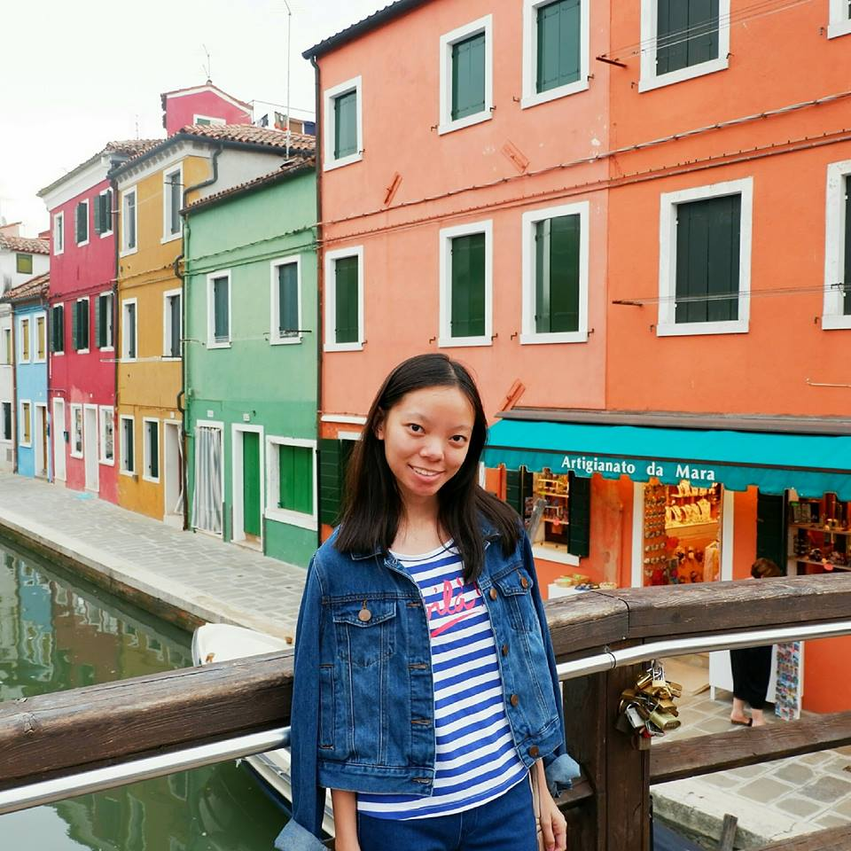
HILLARY L. SY RATUNIL
hillary_syratunil@dlsu.edu.ph
1704 One Archer’s Place
+639167771399

EDUCATION

2018-Present de la salle university
Bachelor of Science degree in Industrial Engineering

2012-2017 SACRED HEART SCHOOL – HIJAS DE JESUS
Senior High School Diploma, May 2018.

CO-CURRICULAR ACTIVITIES

2017 COSTUME, SHS-HDJ MISSION FAIR
Once Upon a Heart Variety Show

RESEARCH PAPERS PREPARED

May 2017 A Case Study On the Sleeping Habits of Grade 11 SY 2016-2017 Students in Sacred Heart School – Hijas De Jesus: Implication for A Lecture On Improved Sleeping Habits for Grade 11 Students

May 2017 Pag-Aaral sa Epekto ng Sosyal Medya sa Tiwala sa Sarili ng mga Estudyante na may Edad 13 Hanggang 18 sa Sacred Heart School – Hijas De Jesus

November 2018 A Correlational Study On Early Morning and Late-Night Study Habits to Short-Term Memory Retention Among Grade 11 Students in Sacred Heart School – Hijas De Jesus SY 2017-2018: Implications On Study Habits

April 2018 Cassava Starch as an Effective Component for Ideal Biodegradable Plastic

PERSONAL BACKGROUND

Fluent in English, Filipino, and Cebuano. Knowledgeable in Microsoft programs and Adobe Photoshop. Interests: Sewing, handicraft and photography. Adaptable, goal-oriented and quality oriented.

REFERENCES

LORAINE MARIE C. BURGOS
Professor
+639868340123; raine.burgos@gmail.com
Sikatuna St., Cebu City

RYLLE C. RIVERA
Thesis Adviser
+6399180038; ryllerivera12@gmail.com
C. Padilla St., Cebu City

