Department | IT-Partners Limited | Response
System Version | PV1.1.4 | Application Date | 13/04/2026
 |  | Deployment Date | Pending
Change Reason | The following production servers need to be updated.  DC6: poxappprd41a，poxappprd41b，poxappprd41c
Expect Result | - Tianji partners .co blacklist issue fixed.  - Squid deny Source IP White list + Tianji Partners blacklist  - Squid deny Source IP Range White list + Tianji Partners blacklist  - Squid access.log log format destination domain IP address added.
After Change | - Tianji partners .co blacklist issue fixed.  - Squid deny Source IP White list + Tianji Partners blacklist  - Squid deny Source IP Range White list + Tianji Partners blacklist  - Squid access.log log format destination domain IP address added.
Changed place | - /opt/nginx/html/transproxy_admin/app/Console/Commands/RemoveDup.php  node_exporter scripts  - /opt/nginx/html/transproxy_admin/app/Http/Controllers/Api/ThreatController.php  - /opt/squid/etc/squid.conf  Before change:  #3.3 Source IP White list + 天际友盟规则  acl source-ip-white src "/usr/nginx/html/transproxy_admin/public/fileData/ip-whitelist.txt"  http_access allow source-ip-white !tianji-blacklist  # Source IP Range White list + 天际友盟规则  acl source-iprange-white src "/usr/nginx/html/transproxy_admin/public/fileData/ip-whitelist-range.txt"  http_access allow source-iprange-white !tianji-blacklist  After change:  #3.3 Source IP White list + 天际友盟规则  acl source-ip-white src "/usr/nginx/html/transproxy_admin/public/fileData/ip-whitelist.txt"  http_access allow source-ip-white !tianji-blacklist  http_access deny source-ip-white tianji-blacklist  # Source IP Range White list + 天际友盟规则  acl source-iprange-white src "/usr/nginx/html/transproxy_admin/public/fileData/ip-whitelist-range.txt"  http_access allow source-iprange-white !tianji-blacklist  http_access deny source-iprange-white tianji-blacklist  - /opt/squid/etc/squid.conf  Before change:  logformat HAsquidlog %>a %ui %un [%tl] "%rm %ru HTTP/%rv" %>Hs %<st %>p "%{Referer}>h" "%{User-Agent}>h" %Ss:%Sh %>Hs  After change:  logformat HAsquidlog %>a %ui %un [%tl] "%rm %ru HTTP/%rv" %>Hs %<st %>p %<a "%{Referer}>h" "%{User-Agent}>h" %Ss:%Sh %>Hs
Update steps | /home/logreader/upgrade/20260413/tianji-party/upgrade.sh  /home/logreader/upgrade/20260413/tianji-party/upgrade-squid.sh  Checking  - Check http://api.vulcanlabs.co/ is allow to visit  - Squid deny Source IP White list + Tianji Partners blacklist  Squid deny Source IP Range White list + Tianji Partners blacklist  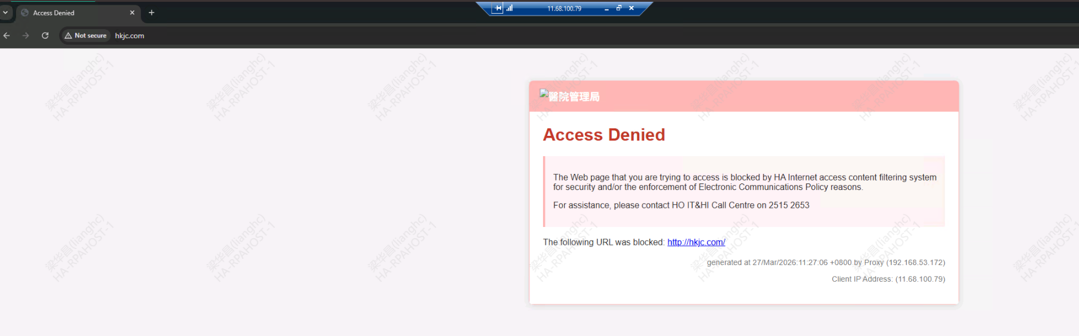  - Squid access.log destination domain IP address added
Remark | Follow the steps one by one to avoid making mistakes.

