Department | IT-Partners Limited | Response
System Version | PV1.1.4 | Application Date | 09/04/2026
 |  | Deployment Date | Pending
Change Reason | The following production servers need to be updated.  DC7: poxappprd52a
Expect Result | - Grafana monitoring dashboard shows the chart of connections (Proxy to Internet) for host poxappprd52a.  - Grafana monitoring dashboard shows the chart of connections (Client to Proxy) for host poxappprd52a.  - Grafana monitoring dashboard shows the chart of number of Python scripts for host poxappprd52a.  - After the system crontab executes squid reload at 2026-04-10 00:00:00, reduce the number of running Python scripts.  - After the system crontab executes squid reload at 2026-04-10 00:00:00, reduce the timeout duration that affects access to websites.
After Change | - Grafana monitoring dashboard shows the chart of connections (Proxy to Internet) for host poxappprd52a.  - Grafana monitoring dashboard shows the chart of connections (Client to Proxy) for host poxappprd52a.  - Grafana monitoring dashboard shows the chart of number of Python scripts for host poxappprd52a.  - After the system crontab executes squid reload at 2026-04-10 00:00:00, reduce the number of running Python scripts.  - After the system crontab executes squid reload at 2026-04-10 00:00:00, reduce the timeout duration that affects access to websites.
Changed place | - /opt/node_exporter/script  node_exporter scripts  - /etc/systemd/system/node_exporter.service  old:  ExecStart=/usr/local/node_exporter/node_exporter --web.listen-address=:9100  new:  ExecStart=/usr/local/node_exporter/node_exporter --web.listen-address=:9100 --collector.textfile.directory=/opt/node_exporter/textfile_collector  - /opt/squid/etc/squid.conf  old:  external_acl_type check_ip_allow_check ttl=604800 negative_ttl=360 children-max=100 %SRC %DST /usr/bin/python3 /opt/py_prod/check_ip_allow.py  external_acl_type check_ip_deny_check ttl=604800 negative_ttl=360 children-max=100 %SRC %DST /usr/bin/python3 /opt/py_prod/check_ip_deny.py  external_acl_type check_iprange_allow_check ttl=604800 negative_ttl=360 children-max=100 %SRC %DST /usr/bin/python3 /opt/py_prod/check_iprange_allow.py  external_acl_type check_iprange_deny_check ttl=604800 negative_ttl=360 children-max=100 %SRC %DST /usr/bin/python3 /opt/py_prod/check_iprange_deny.py  external_acl_type ua_dump ttl=604800 negative_ttl=360 children-max=100 %DST %{User-Agent}>h /usr/bin/python3 /opt/py_prod/check_ua.py  external_acl_type special_user_allow_check ttl=604800 negative_ttl=360 children-max=100 %LOGIN %DST /usr/bin/python3 /opt/py_prod/check_special_user_allow.py  external_acl_type special_user_deny_check ttl=604800 negative_ttl=360 children-max=100 %LOGIN %DST /usr/bin/python3 /opt/py_prod/check_special_user_deny.py  external_acl_type check_user ttl=604800 negative_ttl=360 children-max=100 %LOGIN %URI /usr/bin/python3 /opt/py_prod/check_user.py  new:  external_acl_type check_ip_allow_check ttl=604800 negative_ttl=360 children-startup=2 children-idle=2 %SRC %DST /usr/bin/python3 /opt/py_prod/check_ip_allow.py  external_acl_type check_ip_deny_check ttl=604800 negative_ttl=360 children-startup=2 children-idle=2 %SRC %DST /usr/bin/python3 /opt/py_prod/check_ip_deny.py  external_acl_type check_iprange_allow_check ttl=604800 negative_ttl=360 children-startup=2 children-idle=2 %SRC %DST /usr/bin/python3 /opt/py_prod/check_iprange_allow.py  external_acl_type check_iprange_deny_check ttl=604800 negative_ttl=360 children-startup=2 children-idle=2 %SRC %DST /usr/bin/python3 /opt/py_prod/check_iprange_deny.py  external_acl_type ua_dump ttl=604800 negative_ttl=360 children-startup=2 children-idle=2 %DST %{User-Agent}>h /usr/bin/python3 /opt/py_prod/check_ua.py  external_acl_type special_user_allow_check ttl=604800 negative_ttl=360 children-startup=2 children-idle=2 %LOGIN %DST /usr/bin/python3 /opt/py_prod/check_special_user_allow.py  external_acl_type special_user_deny_check ttl=604800 negative_ttl=360 children-startup=2 children-idle=2 %LOGIN %DST /usr/bin/python3 /opt/py_prod/check_special_user_deny.py  external_acl_type check_user ttl=604800 negative_ttl=360 children-startup=2 children-idle=2 %LOGIN %URI /usr/bin/python3 /opt/py_prod/check_user.py
Update steps | /home/logreader/upgrade/20260409/squid-timeout/upgrade.sh  Backup and upgrade  ### 0. export variable  export BACKUP_DIR=/root/backup/20260409/squid-timeout  export UPGRADE_DIR=/home/logreader/upgrade/20260409/squid-timeout  ### 1. create backup dir  mkdir -p $BACKUP_DIR  ### 2. node_exporter config update  mkdir -p /opt/node_exporter  mkdir -p /opt/node_exporter/textfile_collector  cp -r $UPGRADE_DIR/node_exporter/script /opt/node_exporter/  chown -R logreader.logreader /opt/node_exporter  cp /etc/systemd/system/node_exporter.service $BACKUP_DIR/node_exporter.service  cp -f $UPGRADE_DIR/node_exporter/node_exporter.service /etc/systemd/system/node_exporter.service  systemctl restart node_exporter  ### 3. logreader crontab update  cp /opt/crontab/opp-crontab $BACKUP_DIR/opp-crontab  cp -f $UPGRADE_DIR/crontab/opp-crontab /opt/crontab/opp-crontab  crontab -u logreader /opt/crontab/opp-crontab  crontab -u logreader -l  ### 4. squid config update  cp /opt/squid/etc/squid.conf $BACKUP_DIR/squid.conf  cp $UPGRADE_DIR/squid/squid.conf /opt/squid/etc/squid.conf  /opt/squid/sbin/squid -k parse  Checking  - Grafana monitoring dashboard shows the chart of connections (Proxy to Internet) for host poxappprd52a.  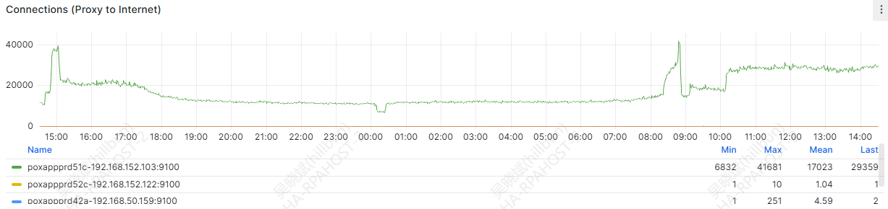  - Grafana monitoring dashboard shows the chart of connections (Client to Proxy) for host poxappprd52a.  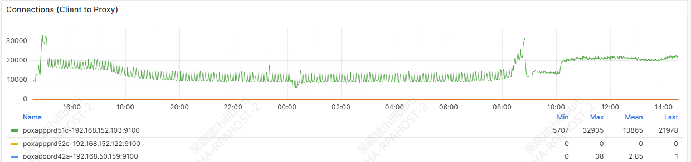  - Grafana monitoring dashboard shows the chart of number of Python scripts for host poxappprd52a.  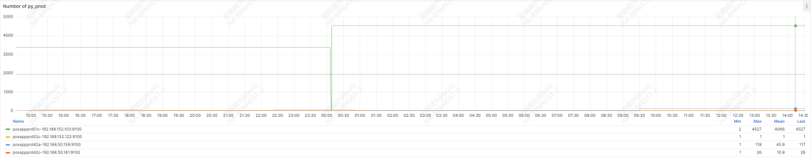  - Before and after the system crontab executes squid reload at 2026-04-10 00:00:00, check the number of running Python scripts.  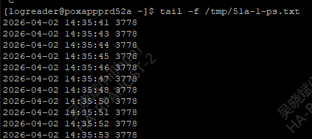  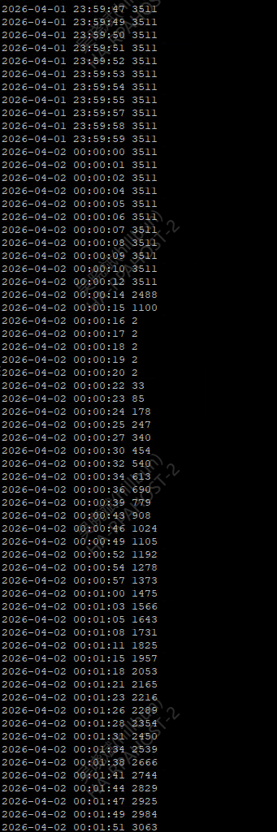  - Before and after the system crontab executes squid reload at 2026-04-10 00:00:00, check the timeout duration that affects access to websites.  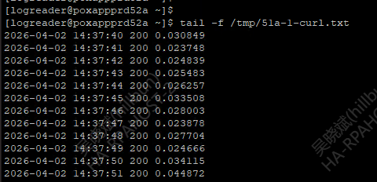  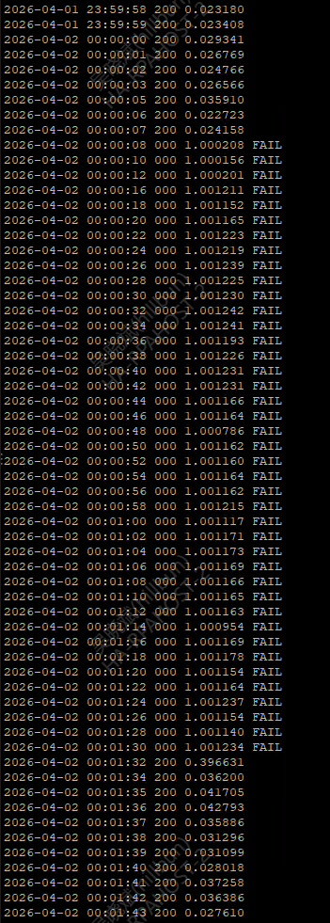
Remark | Follow the steps one by one to avoid making mistakes.

