Experience Builder

You can change the overall theme and customize the text appearance

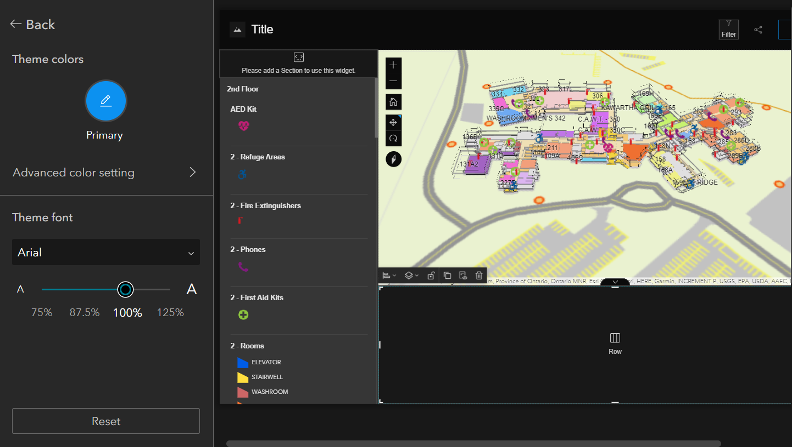

Customize map content

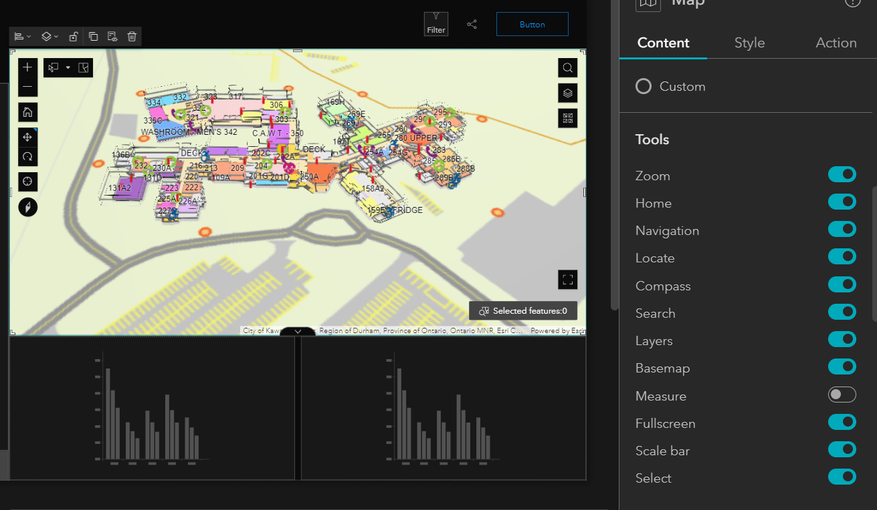

You can add Directions based on the current location to find the desired destination

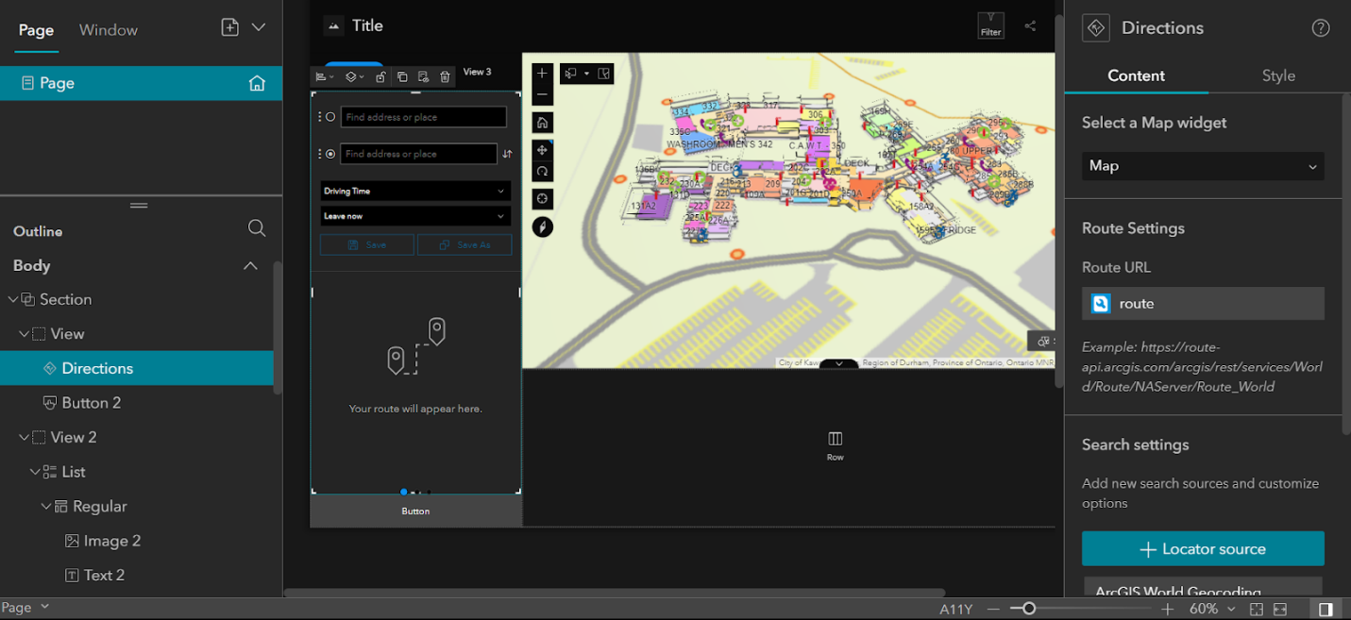

Can customize the surrounding. Ex:  add or remove “pages”/ “views” and can change the names.

Add whatever you like in these. Ex: Images, navigation, legend, charts, etc.

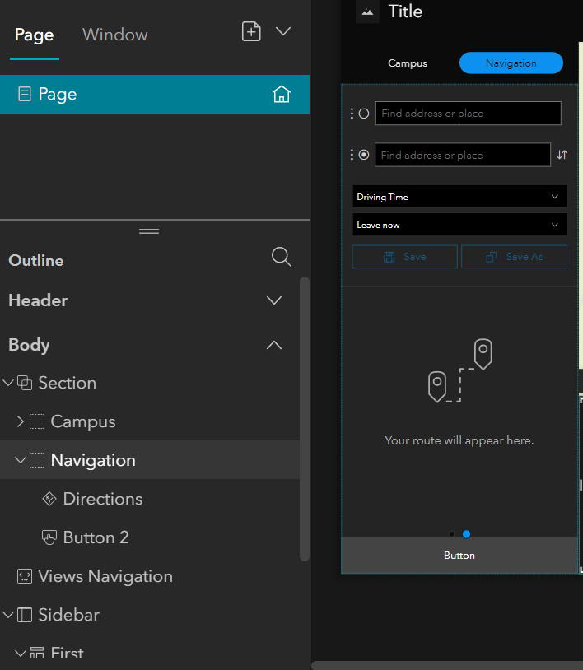

Can add filters to filter results

Ex: room labels or emergency equipment

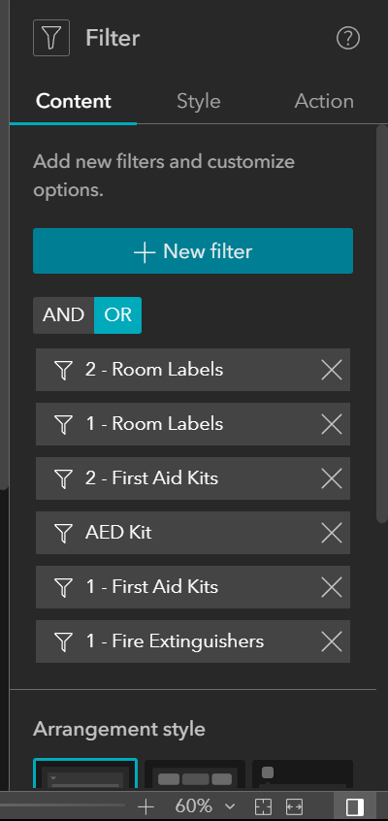

Needs credits (could be an issue)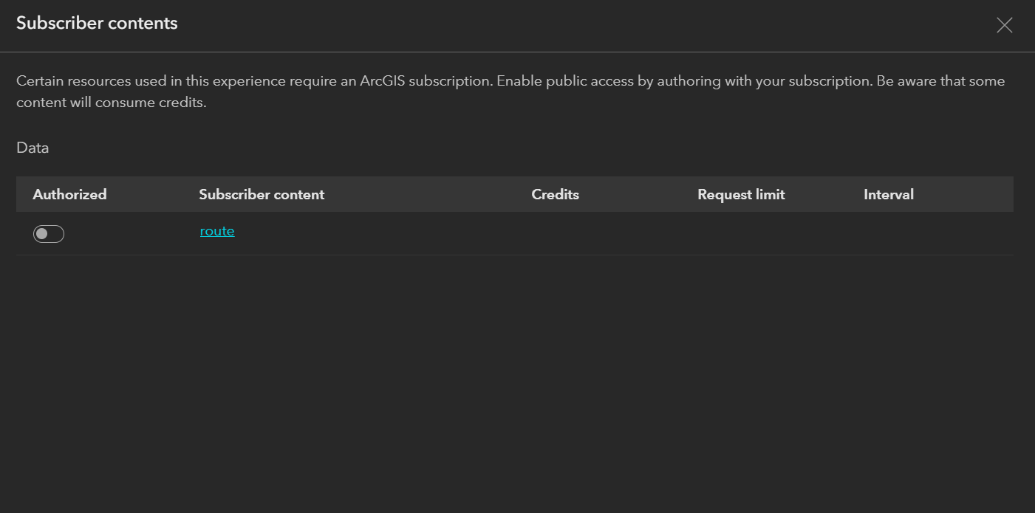

Navigation is cool, but how to get it to find the room numbers (or any info from the data uploaded? Or can only search geocoded addresses?)

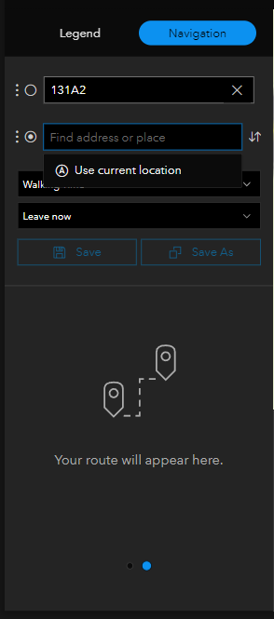

…..

Final Results:

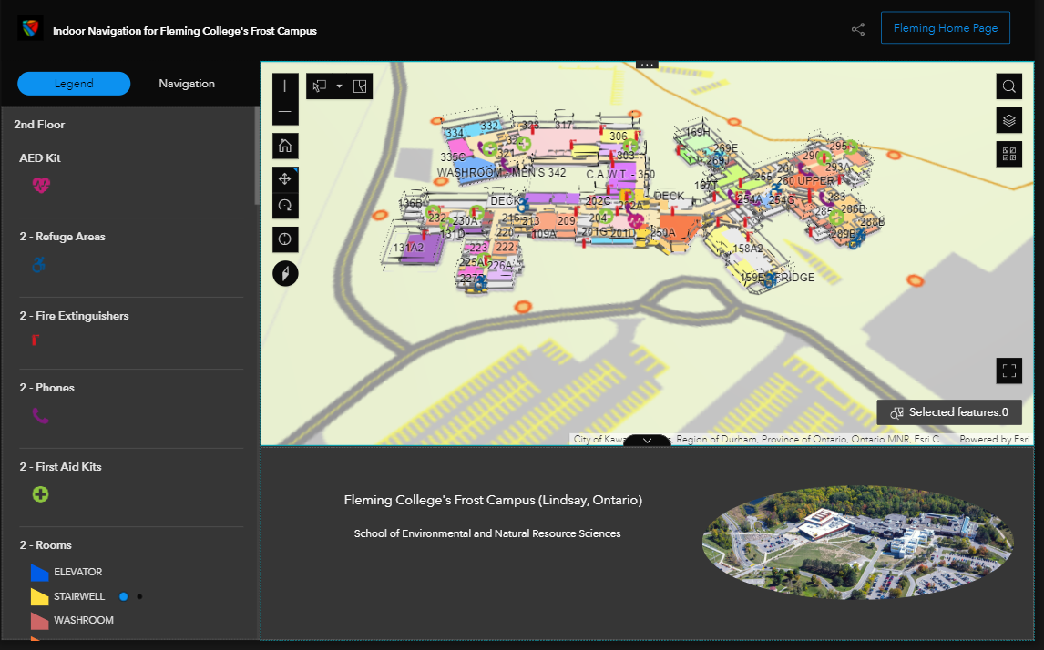

……………………………………………….

Overall limitations:

Geocoding own rooms not possible?

Needs credits for each route request after it is published

Not available offline