**Part 1**

**Clone a GitHub repository to work with in Vscode**

This also works well for collaboration. You can invite GitHub users to collaborate on your repository. They’ll receive an invite link and be able to access, edit, clone, etc.

1. Oppen the Command Palette

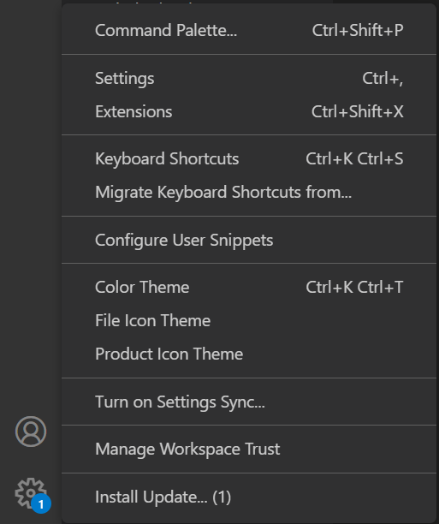

1. Search for Github; choose “Clone from GitHub”

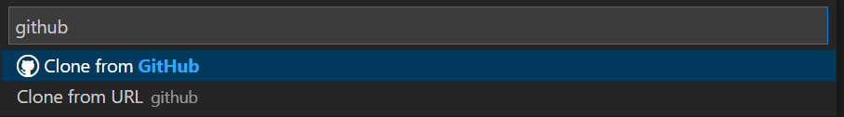

Note: It may redirect you to GitHub and ask you to sign in

1. Copy/ paste the repository you want to clone into the Command Prompt in Vscode

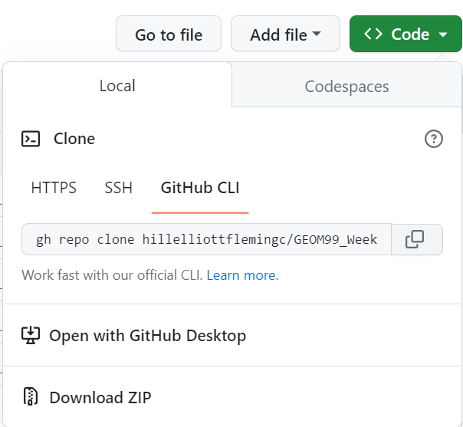

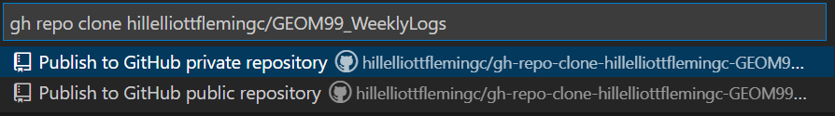

1. Choose local directory to store the copied repository and choose “open” in Vscode when prompted.

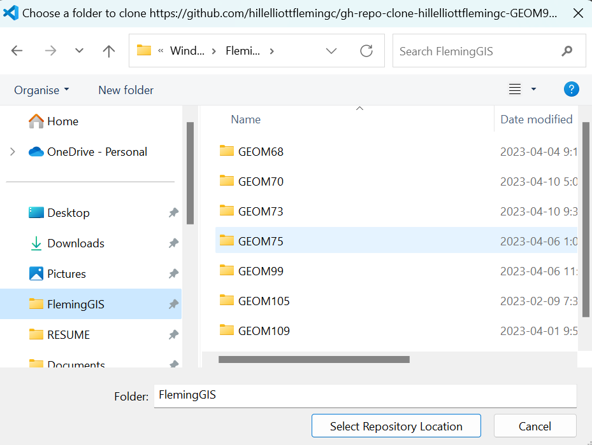

**Part 2**

**Change between repositories you have already cloned**

1. Go to “File” and “Open Folder”:

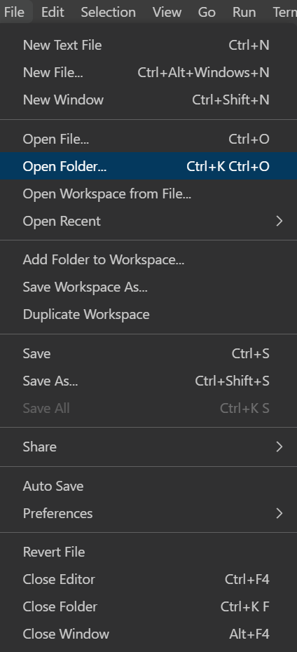

1. Choose the repository/ folder you cloned to your local device

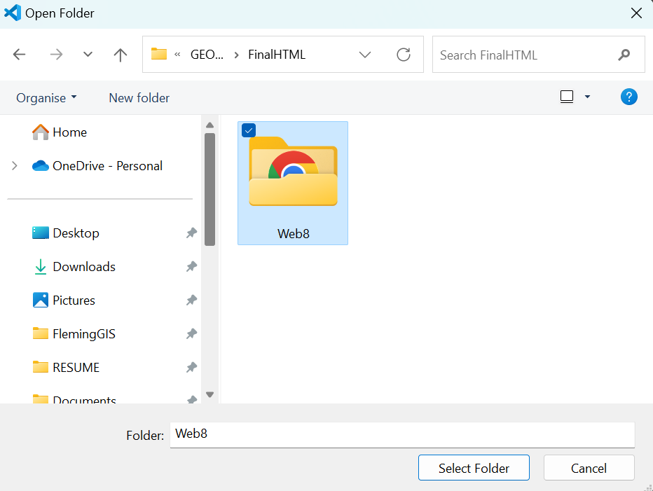

Then in the command prompt, search for github and click it… it’ll rbign you to github page where you sign in, then you are connecting to that repository (or you can clone others)

Note: You cann tell you are connected to GitHub as you have the push/ pull request feature in the bottom left

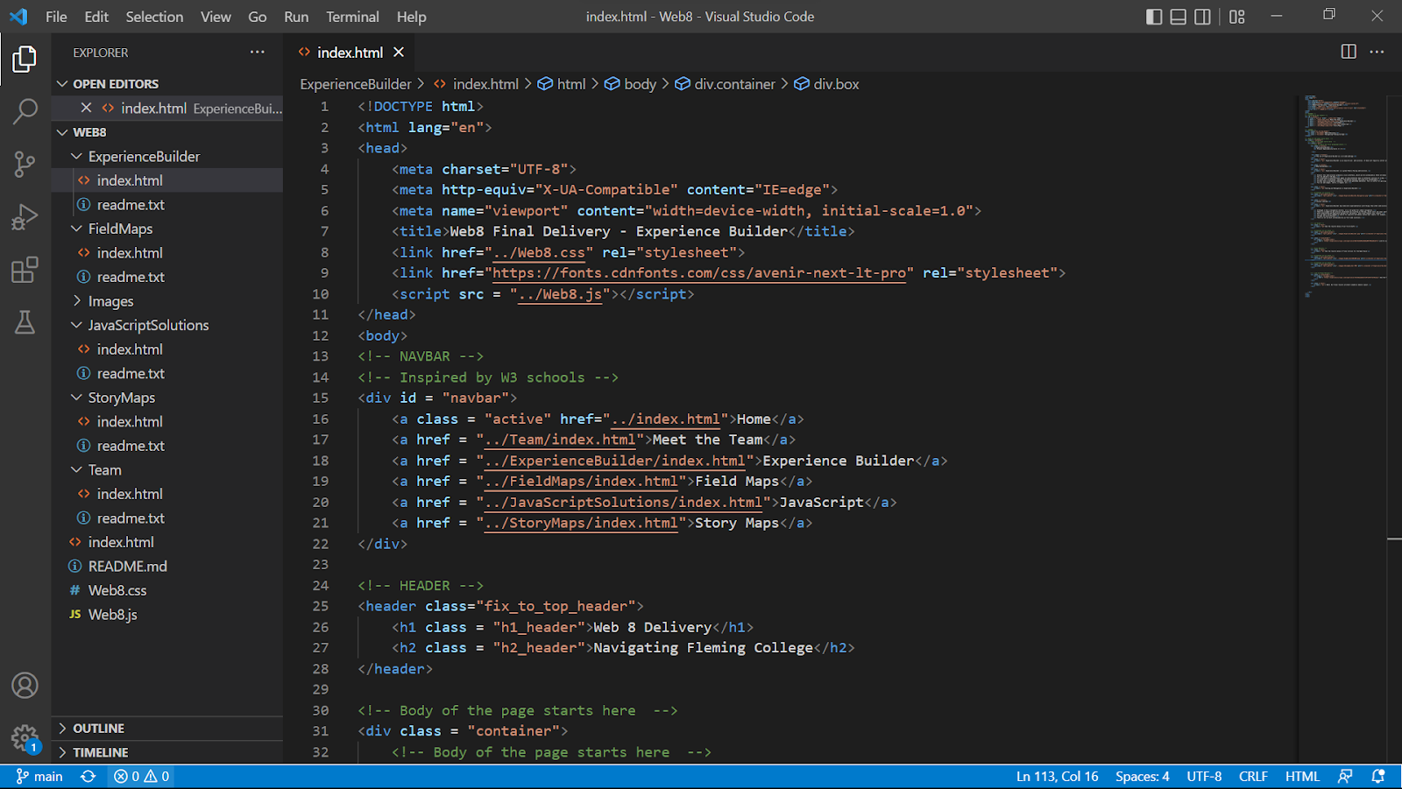

1. Now you are able to make changes and “commit” them to GitHub by pulling/ pushing and syncing changes from the toolbar on the left side.

**Part 3**

**Switch back to the Arcpy extension for ArcPro use**

1. Open the Command Prompt from the settings and search for Python Select Interpreter

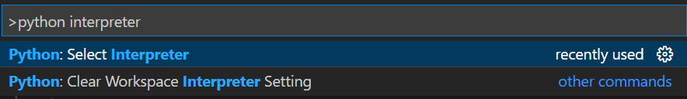

1. Choose the interpreter. For connection with ArcGIS Pro, select the ‘arcgis-py3-clone’ interpreter

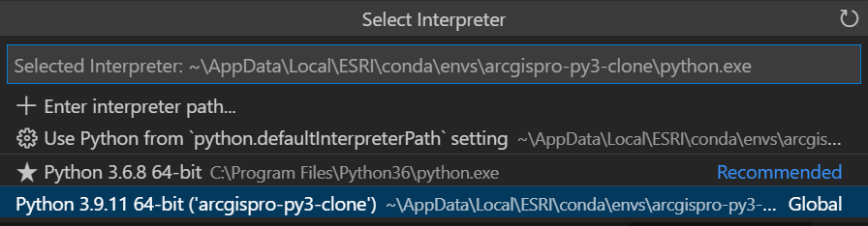

1. Now, open a folder/ file with a normal python script (outside of the GitHub clone) to be used with ArcGIS Pro

Note: You can tell the interpreter you are using in the bottom right corner

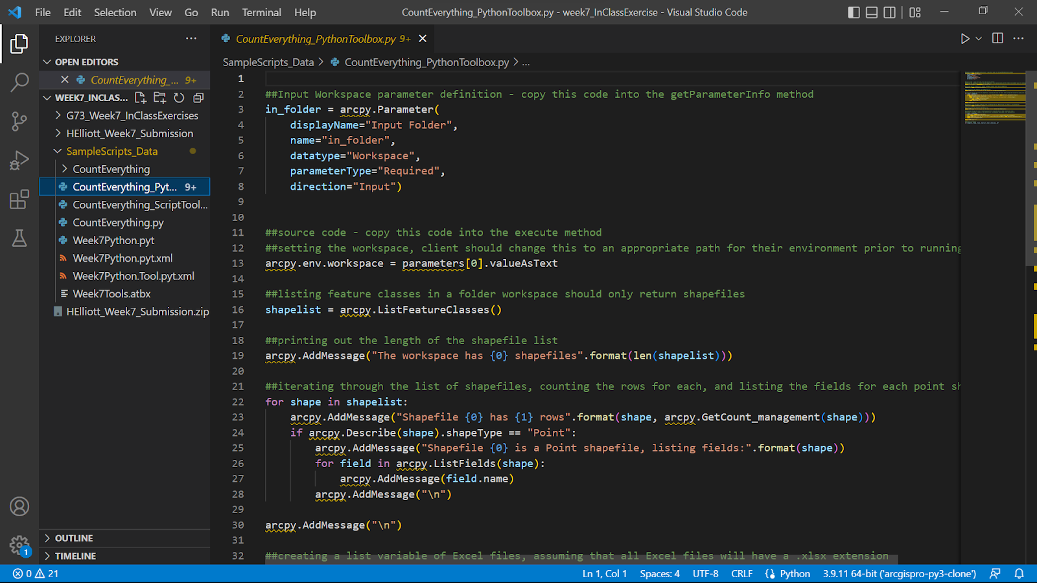

More Tips here: <https://learn.microsoft.com/en-us/azure/developer/javascript/how-to/with-visual-studio-code/clone-github-repository?tabs=create-repo-command-palette%2Cinitialize-repo-activity-bar%2Ccreate-branch-command-palette%2Ccommit-changes-command-palette%2Cpush-command-palette>

**Part 4**

**Configure Vscode with ArcGIS Pro’s Python Environment**

1. Make sure that Vscode has the Python Extension Installed
2. In the Command Prompt, choose “Enter interpreter path”

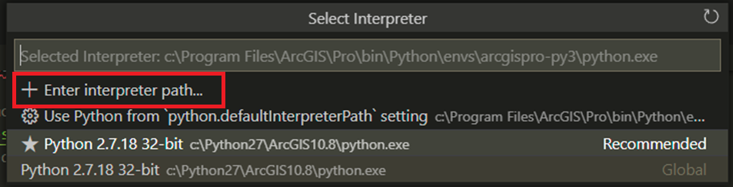

1. Find out your ArcGIS Pro python interpreter

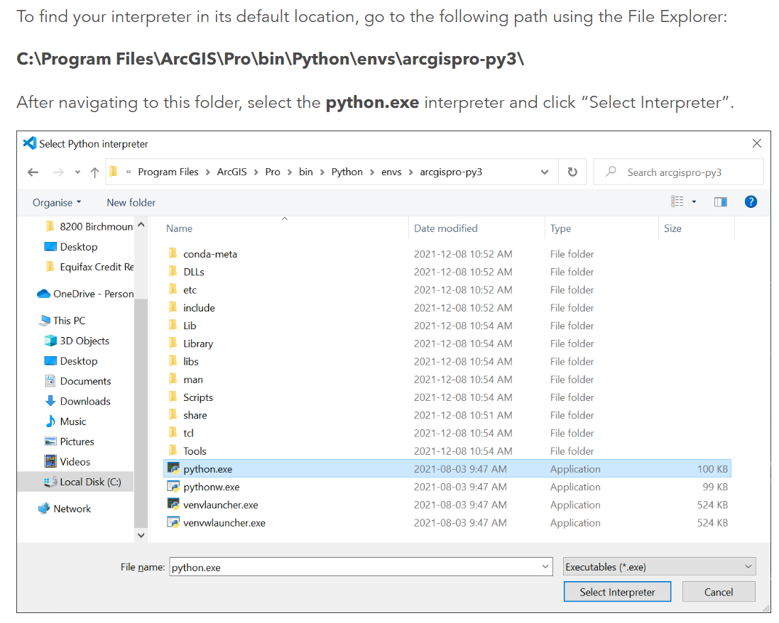

Image source: <https://resources.esri.ca/getting-technical/how-to-configure-visual-studio-code-with-arcgis-pro-s-python-environment>

1. Copy/ Paste the interpreter into the “New interpreter path” in the Vscode