1. Enable virtual machine

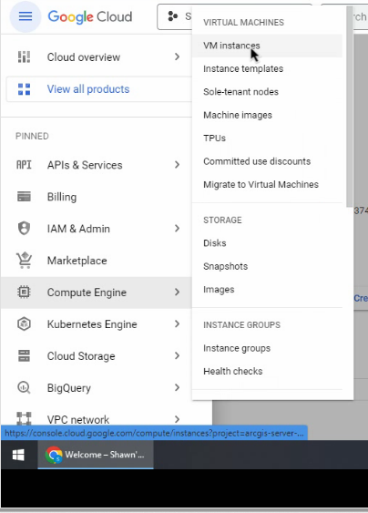

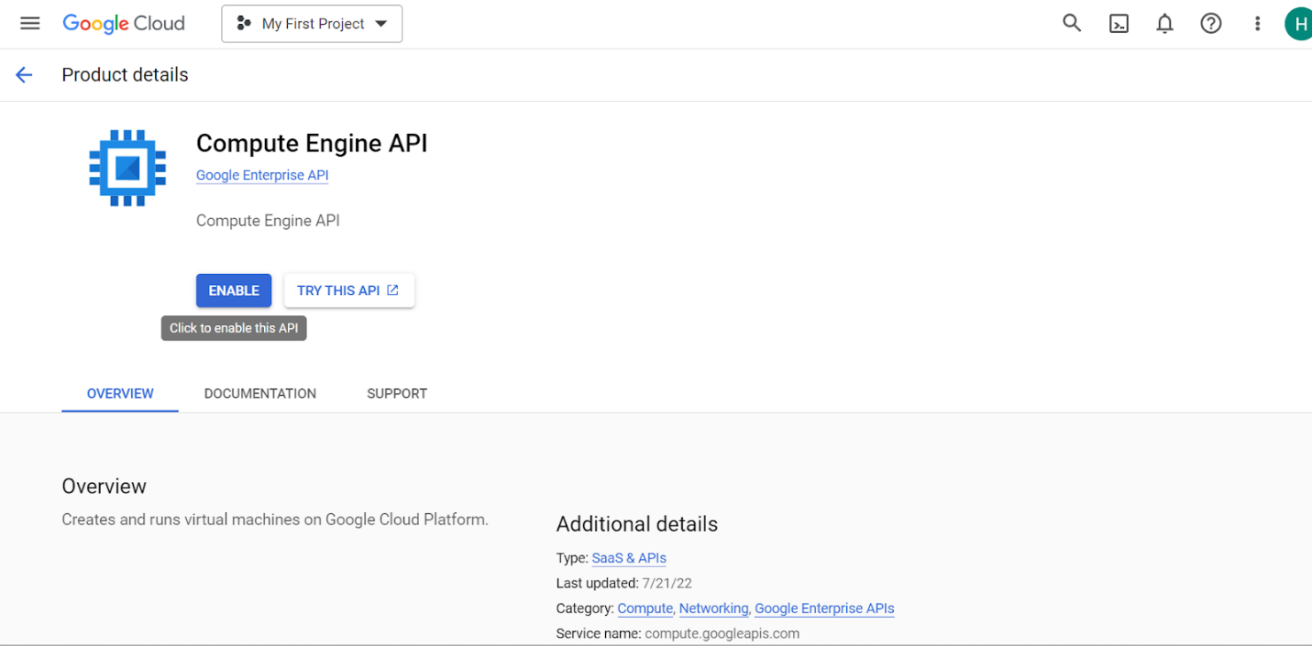

Click “Create instance” (double check what this does again)

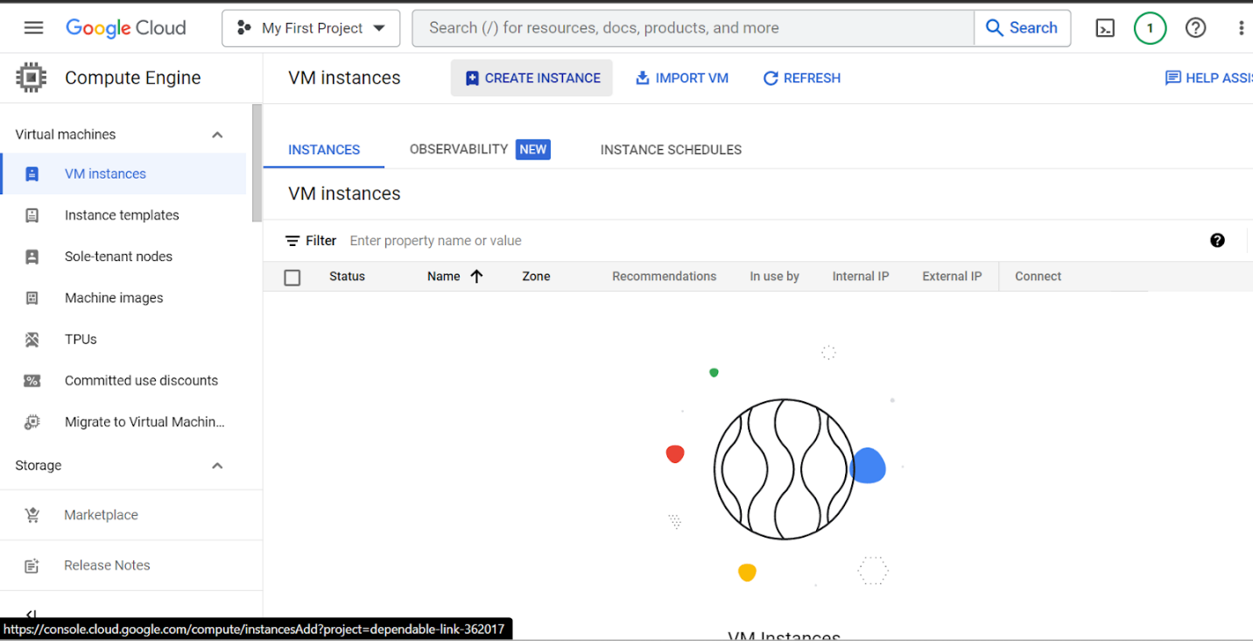

Name it:

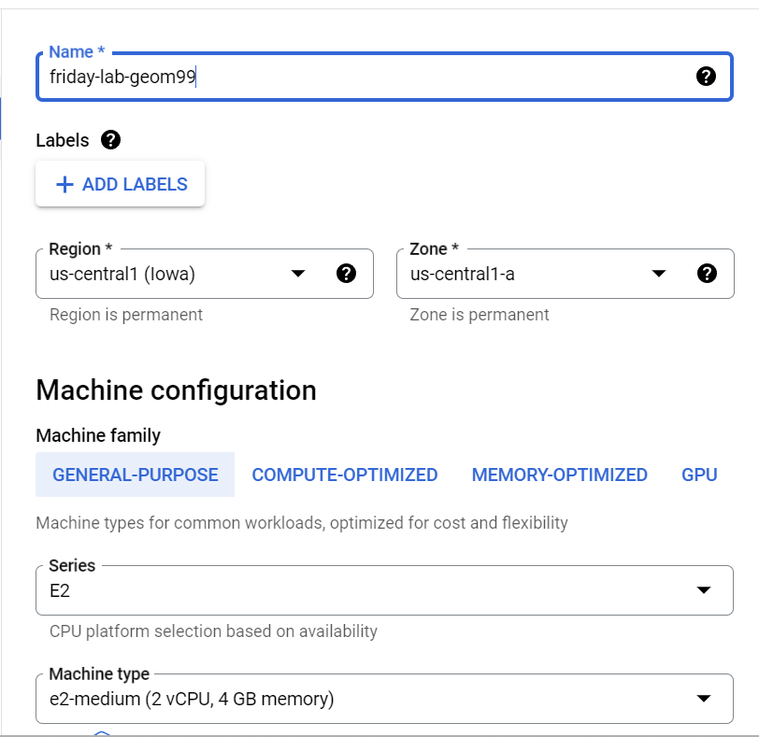

Call “boot disk” something you remember

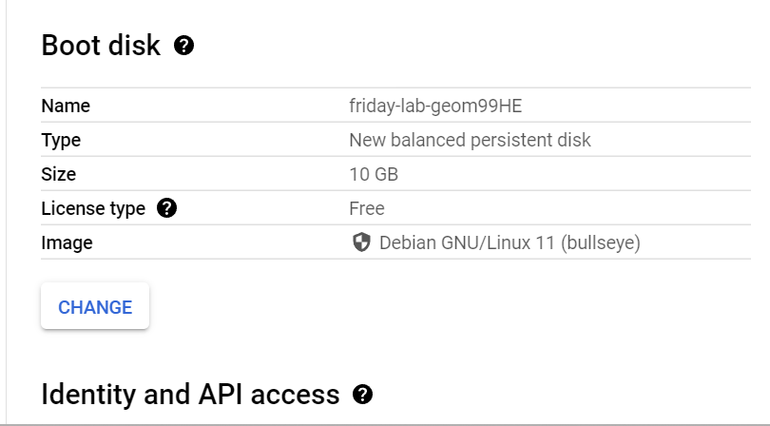

^^ pointign at linux server, BUT we want the virtual machine image Shawn created for us, TF: change this

Choose “custom image” cause from shawn

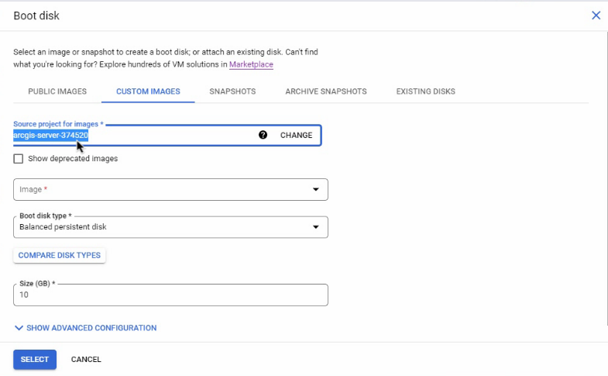

^^ click CHANGE this^^

Go to ALL projects, and choose shawn’s Project that he created (on his google cloud) to see his image/ vm…. TF: his project contains a copy of his Virtual machine/ image/ project with college’s server on it …. Now can paste to our project (make a duplicate of it) to have same access to the vm/ image!

**NOTE: this vm/ image has the college’s server set by Shawn up on this vm

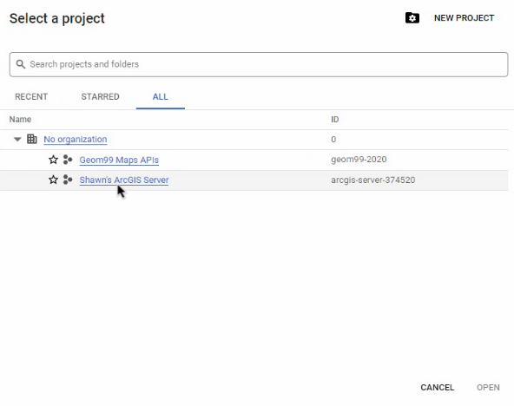

^^^ It will now take copy of the hardrive/ image and move it/ paste it to yours 9create duplicate)

^^^ We had to provide him with our emails for this step so that he could enable each user to see his project, which let’s us see his VM/ image with college’s server so that we could access it/ paste it to ours…. For security reasons, cause not good if anybody could access this and see details about the college’s servers

…Now, change firewal rules:

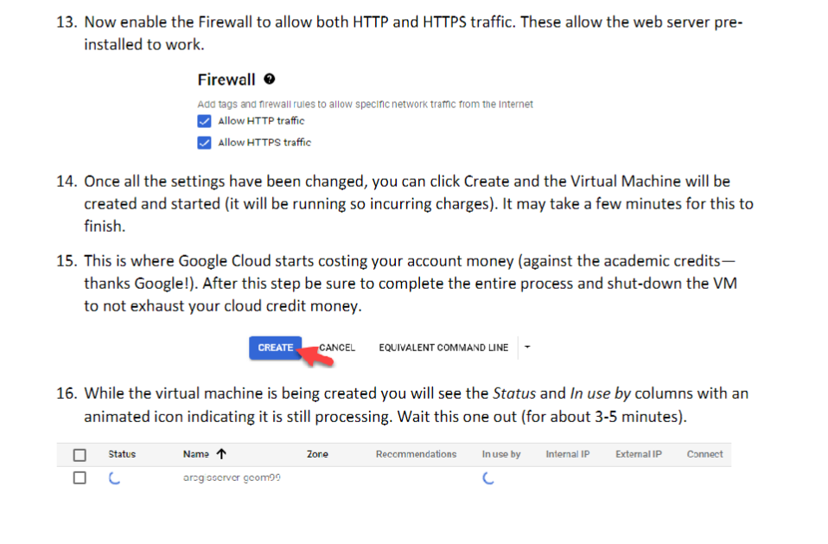

NOW:

Can see what you created:

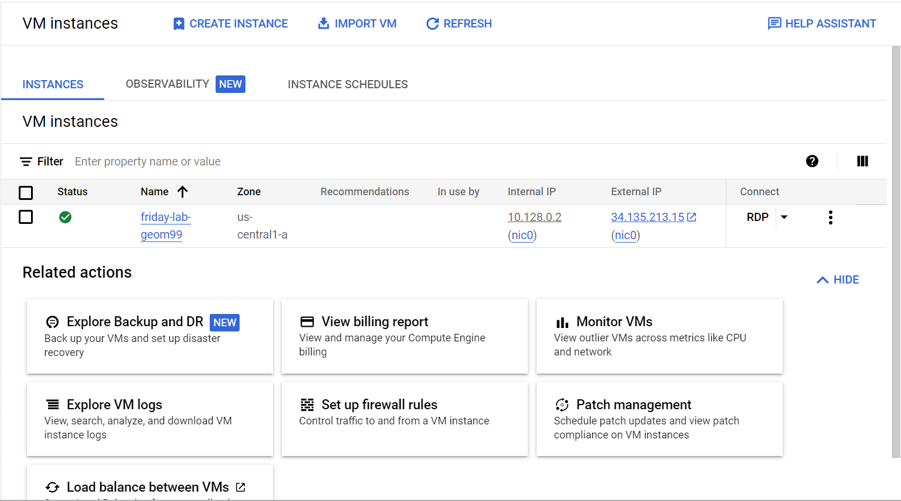

^^ the green checkbox== means your server is open and running (DONT leave it like this)

NEXT: 2 things to do:

1. Enable firewall rules to let **Arcgis server** work and also to let **remote desktop** work

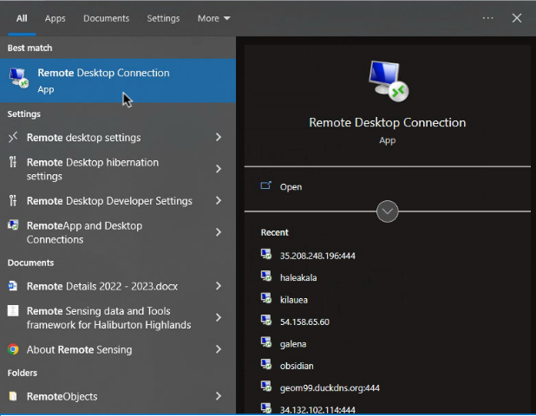

WHY do we set up firewalls next? Because we’re changing the default port of 3389 to 444 and not set up in firewall rules

……….Exaplained (don’t connect to remote desktop just yet, just for info):

TO CONNECT TO REMOTE DESKTOP, by default it uses PORT 3389 to connect == IMPORTANT!!! REMEMBER THIS PORT

BUT

We’re going to be using PORT 444

TF: use cologne then 444

 :444 after whatever external IP you’re using

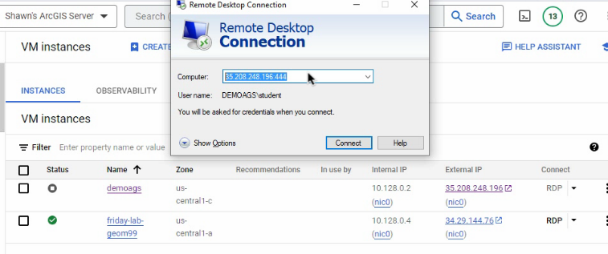

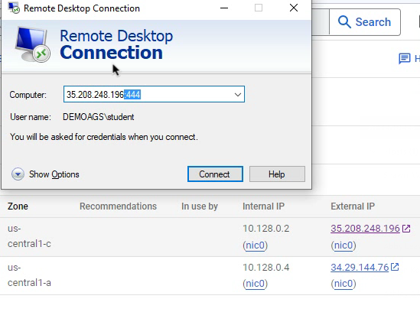

Internal IP== Computer to computer in Ihoa (but we’re not in Ihoa)

Tf: we use the EXTERNL IP^^

**NOTE: everytime you log into VM, it’ll make a NEW IP address^^^** (because it costs money to have these IP address, tf: if it’s not running, they don’t want you to have one)

… tf: we enter this external IP address into the Remote Desktop… but by default, will connect to port 3389… BUT the college BLOCKS this port (the IT at fleming uses port 444)..... TF: we will add :44 at the end to overwrite the default

BUTTTT Port 444 isn’t set up in the firewall rules,,, tf: we need to set this up before changing it

FIrewall rules:

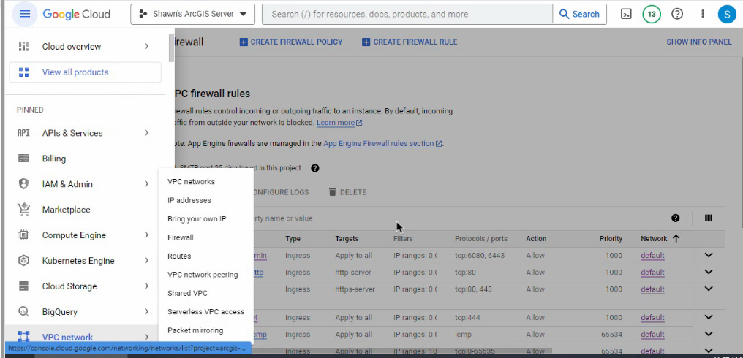

Create firewall rule to allow port 444 to be open

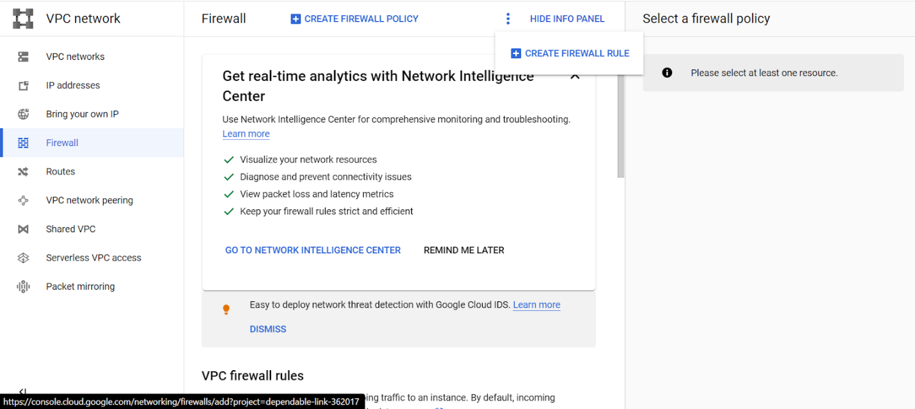

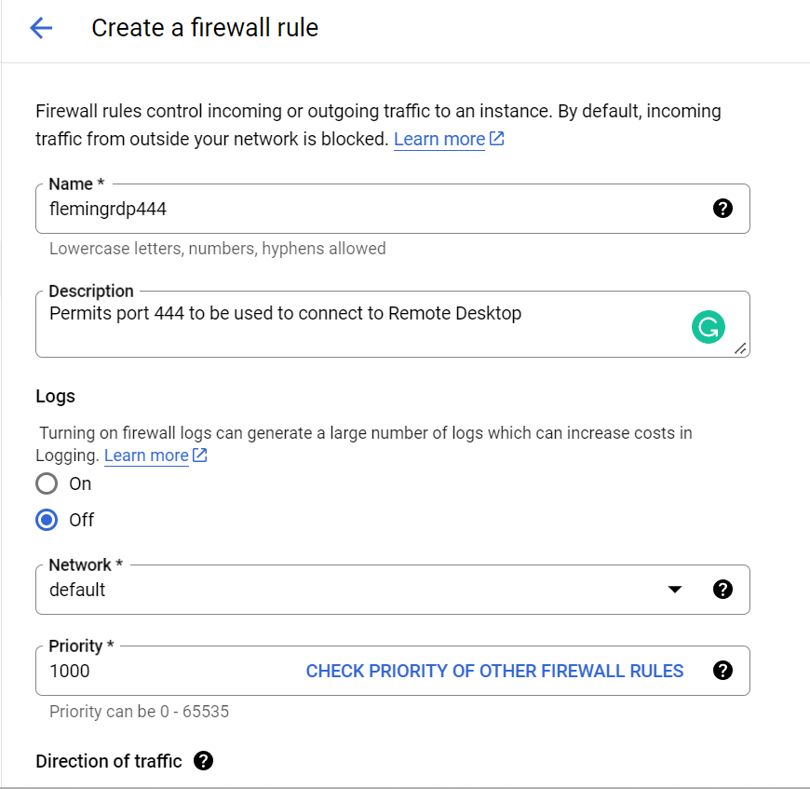

^^ name it

NEXT::

Allow for in-bound/ ingress

TF: choose “all instances in the network”

… this will allow port 444 for ALL of your virtual machines on your computer

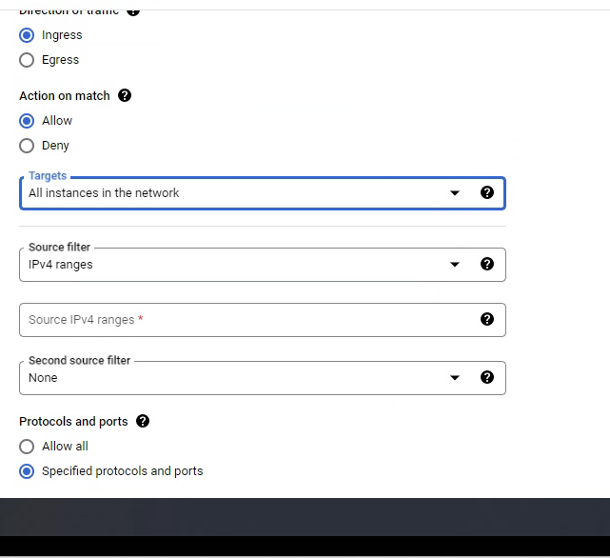

NEXT ^^ “Source IPv4 ranges” == the external IP, tf: your IP address (or whatever you choose), tf: you can set it up so only you can access it

…. IF you change locations, need to update your IP address (can just go edit this firewall rule– don’t need to recreate it)

… NOW allow port 444

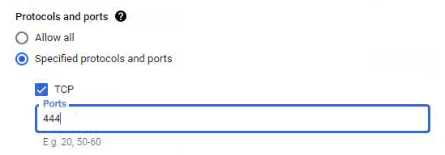

TF: now, ONLY your computer can access 444

NEXT: create firewall rule to allow ArcGIS Server

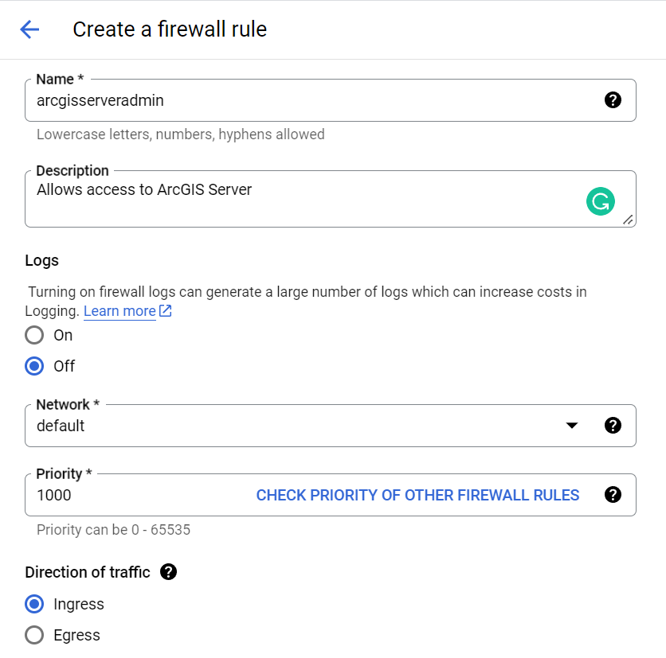

^^ Change name and make sure it is “Ingress”

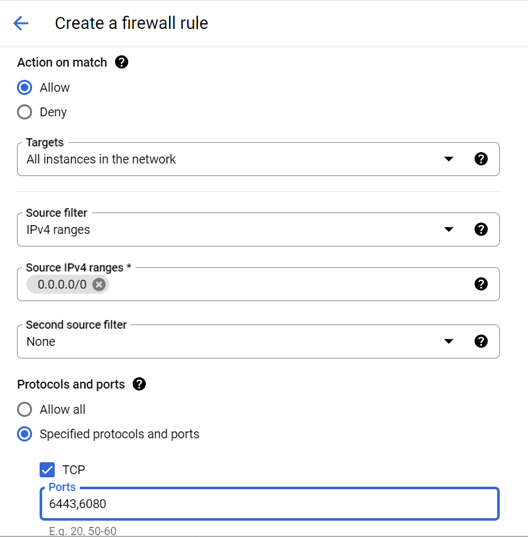

^^ Allow all instances in the network

Allow any IP address to access

Allow ports 6443 and 6080

^^^^^^^^^ You could technically put both firewall rules into one,, but best practice to to separate them so you can control who sees what

NOTE: YOU CAN TEST THIS OUT WITHOUT CONNECTING TO THE SERVER YET:

Take the external IP address and add to start of arcgis/rest/services url

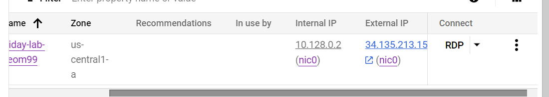

Example:

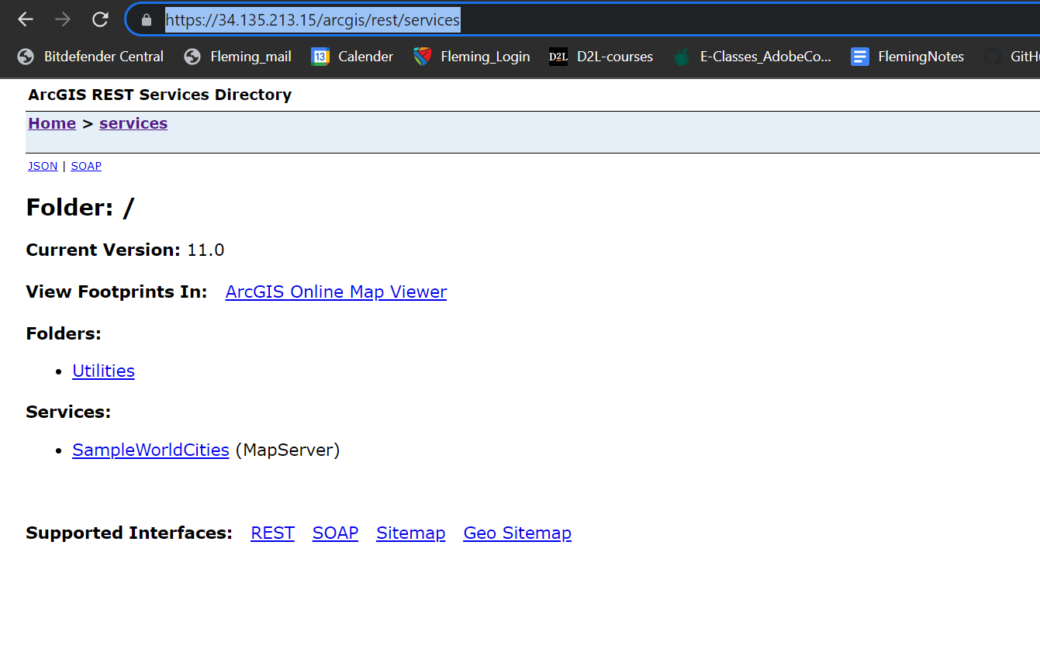

……………………….

**NOW:**

**Set username to “student”** and will generate a password (SAVE this/ write down somewhere to save so you have for next times you’re loggin on to Virtual Machine)

… go to main VM instances page and click drop-down from the RDP to set password:

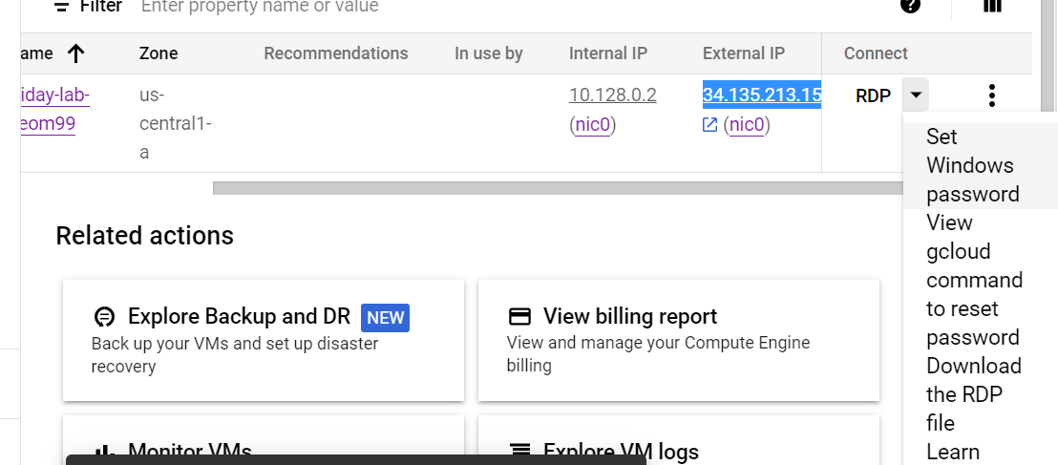

You MUST USE student caus that’s what Shawn has set up for us (or else it’ll create a new user,, but will be blank, tf: can’t really use)

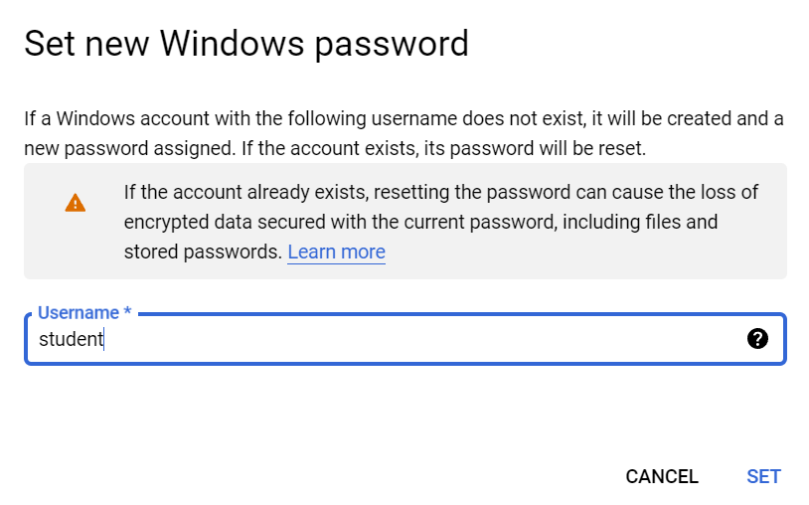

Now– it reaches in and RESETS the password (a popup appears showing it, but this is the ONLY time you’ll see the password– tf: write it down)

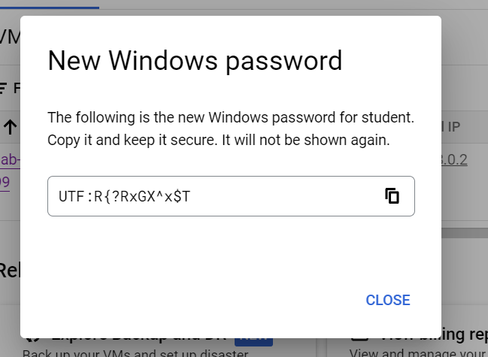

UTF:R{?RxGX^x$T

…..

**NOW you can connect to Remote Desktop….** (because you have password set up and ports set up)

Just search for remote desktop on computer and put in the EXTERNAL IP address (followed by the :444 port)

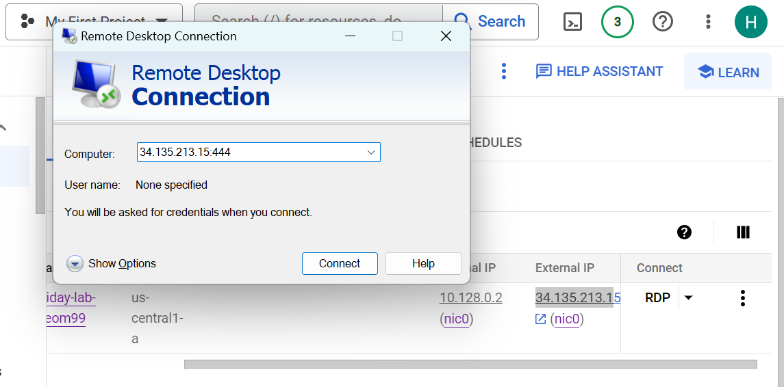

**NOTE: everytime you log into VM, it’ll make a NEW IP address^^^** (because it costs money to have these IP address, tf: if it’s not running, they don’t want you to have one)

NEXT: will ask you for credentials:

Which is student as username and password we saved earlier ^^

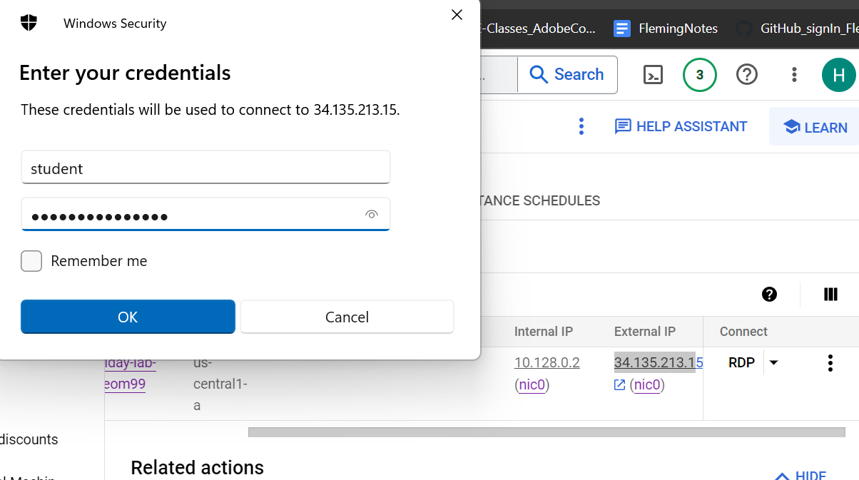

THEN YOU ARE CONNECTED!

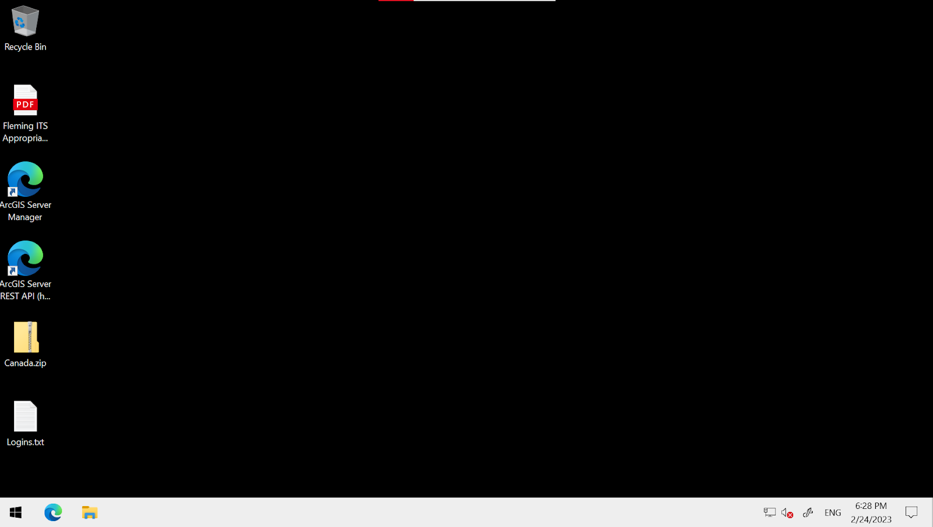

…. To access Server manager site, login with:

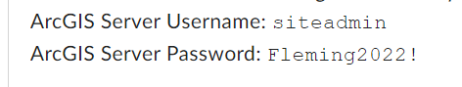

Siteadmin

Fleming2022!

NOW: to actually close it, you can’t just log out or click X to exit the remote desktop,,, you need to actually hit hut down (or else the green check mark is still running/ your server is running and using credits!!)

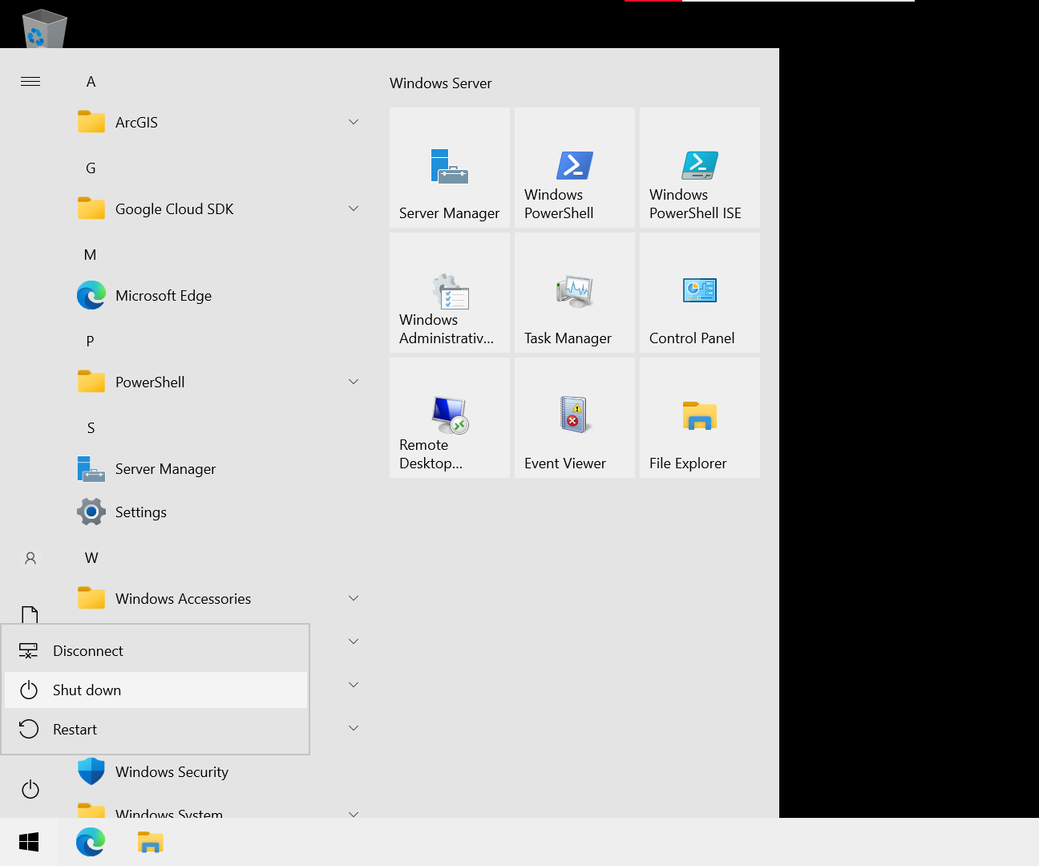

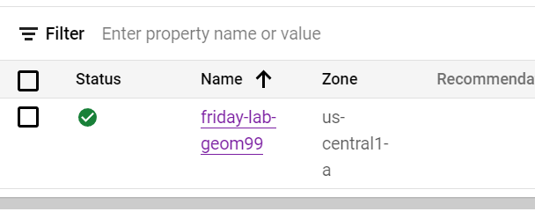

NEXT: choose to STOP the server so not using credits

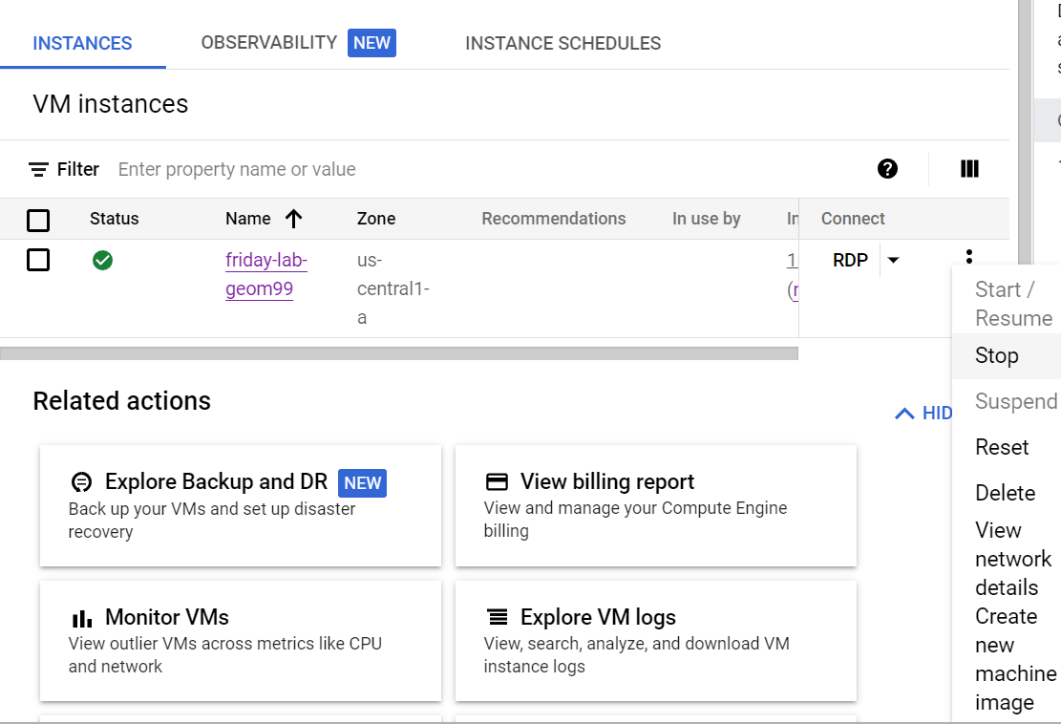

Will look like this (no more green check):

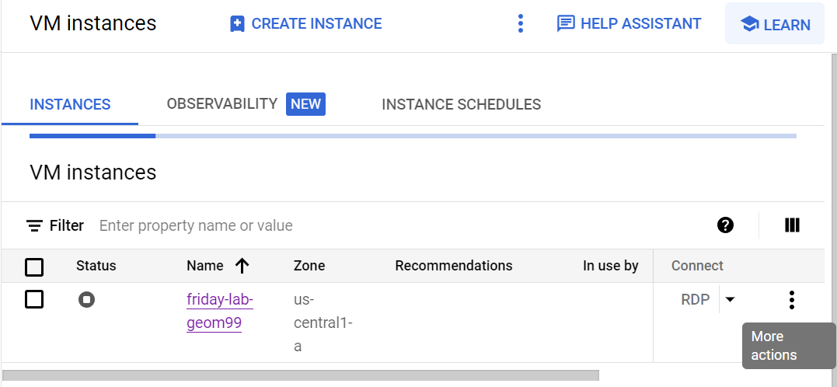

ORRR If can’t log into remote desktop to shut down the server, just clock “Stop” here^^ in the options (but best to shut down the remote desktop first, and then click stop)