Hillel Weintraub

9/22/13

**ECE357-Problem 1**

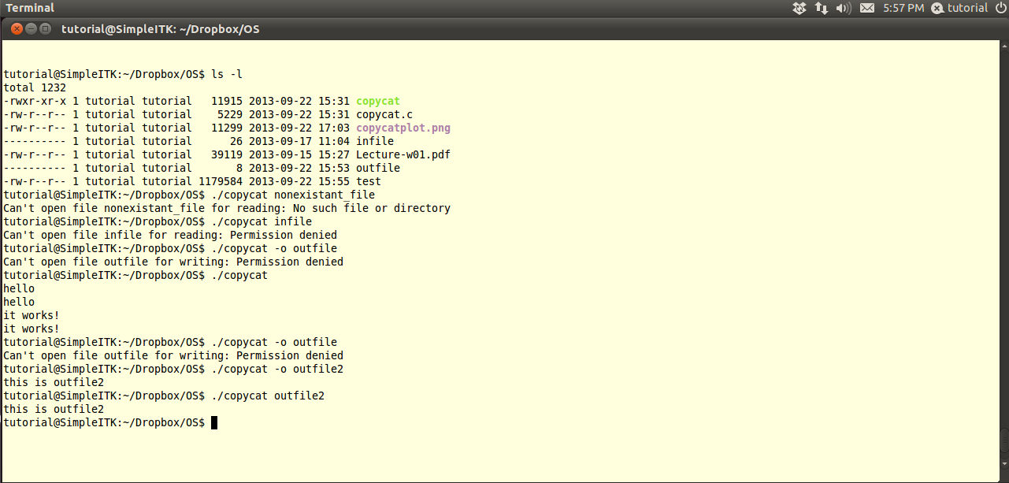The following shows sample runs of my program that demonstrate that my program detects the failure of system calls and makes appropriate error reports to the end user.

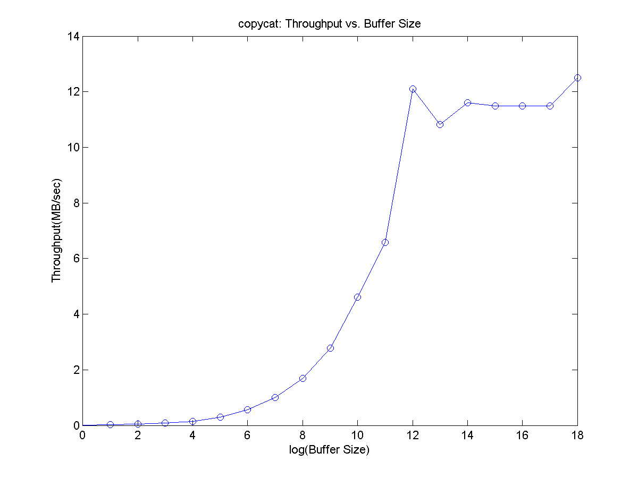The graph shown above displays the results of experimenting with different read/write buffer sizes. The throughput of the program was measured in MB/sec for buffer sizes ranging from 1 byte to 256K in powers of 2. This was done using the UNIX command time(1), and the real time (as opposed to system or user time) was recorded. The graph shows throughput versus buffer size, where buffer size is recorded on a logarithmic scale. From looking at the graph it can be seen that initially increasing the buffer size yields a corresponding increase in the throughput of the program. Keep in mind that since the x-axis is on a logarithmic scale the exponential appearance of the plot actually indicates a linear relationship between buffer size and throughput. This makes sense, because doubling the buffer size means that the program would have to make half as many system calls to read and write all the data. However, we see that at a buffer size of 2^12 or 4K the plot stops its exponential growth and starts to fluctuate. This can be explained by the fact that at this point the buffer size is large enough so that the overhead of making system calls is less significant than other factors. The test file I was using was around 1 MB which means that with a buffer size of 4K it should take 256 system calls to read in the file. Doubling the buffer size would half the number of system calls to 128. This difference is already not enough to dominate all the other random noise from other unstudied factors. This explains the noisy tail of the graph that we see past 4K. Finally, to put these numbers in their proper context, I have included a description of the OS and hardware on which the test cases were run. Note that I ran the program on a virtual machine, and so I describe the specs of both the virtual machine and the actual machine that I used.

**Description of Hardware and OS**

**Virtual Machine:**

OS: Ubuntu

RAM: 1.5 MB

Processor: 1 CPU

Hard Disk:

Virtual Size: 64 GB

Actual Size: 25.51 GB

**Actual Machine:**

OS: Windows 7

RAM: 4 GB

Processor: Intel i5, dual-core

Hard Disk: 500 GB/7200.0 rpm