Hillel Weintraub

11/20/13

**Problem Set 7**

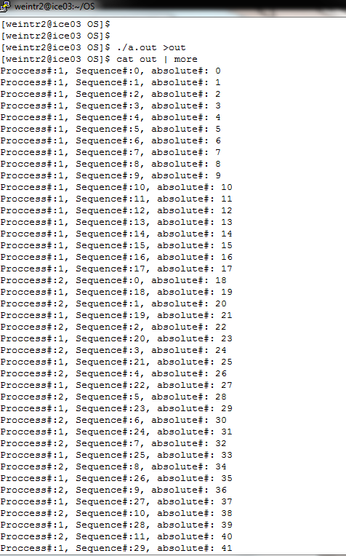Output of the program working correctly:

The output continues for several pages so here I skip and show the final page of output:

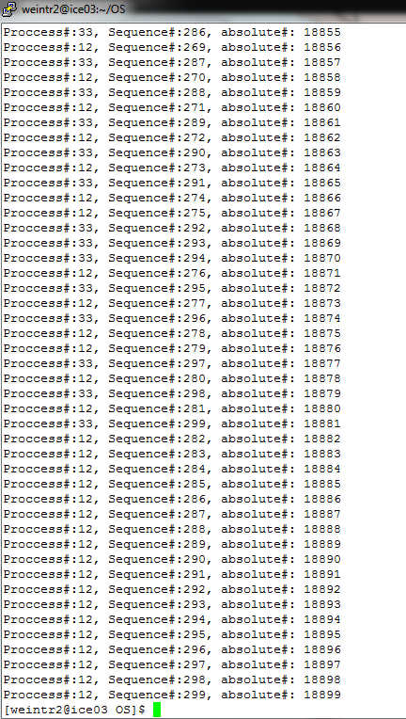

Here I show a modified version of the code that fails. I’ve switched the first two operations in the fifo_wr function , getting the mutex on the FIFO before I call sem_wait. This caused the program to hang because the writer goes to sleep with the mutex preventing anyone else from accessing the FIFO.

