Hillel Weintraub

11/27/13

Problem Set 8

The following is the strace of running my program:

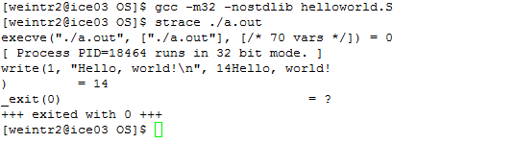

When I comment out the exit system call the following occurs when the program is run:

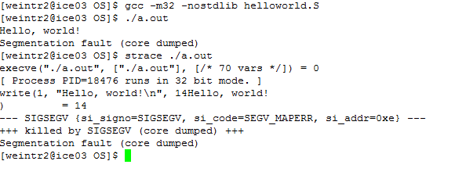

A SIGSEGV was received. This is probably because without the exit call the program keeps running instructions and goes into an invalid memory region.

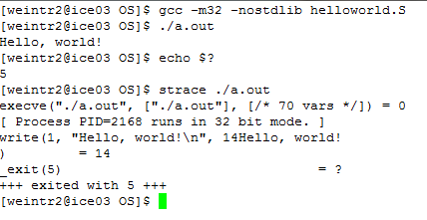Here I show what happens when I changed the code so that the program exits with a return code of 5:

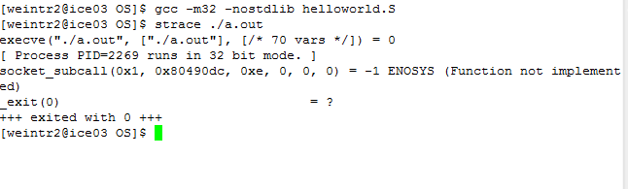The following occurs when an invalid system call number (400) is used:

The following is the output of my syscost.c function.

