PROJECT REPORT:
TrackMile (Smart Delivery System)

Project Title: TrackMile: AI-Powered Smart Delivery & Logistics System
Technology Stack: Java Spring Boot, React.js, MongoDB, Leaflet Maps, Artificial Intelligence (Groq/Llama 3)
Submitted By Team: Tejas Thakor, Ayush Kale, Harshvarthini, Subhashini Kandasamy and Mehek Fatima Shaik
Date: 29th December 2025

TABLE OF CONTENTS
- Abstract
- Chapter 1: Introduction
  - 1.1 Problem Statement
  - 1.2 Proposed Solution
  - 1.3 Key Features
- Chapter 2: System Analysis & Technology
  - 2.1 Technology Stack
  - 2.2 Hardware & Software Requirements
- Chapter 3: System Design
  - 3.1 System Architecture
  - 3.2 Database Design (MongoDB Schema)
  - 3.3 Module Description (Admin vs. Driver)
- Chapter 4: Implementation Details
  - 4.1 Live Tracking Algorithm
  - 4.2 AI Performance Reporting
  - 4.3 Frontend UI Design & Implementation
6.Chapter 5: Conclusion & Future Scope

ABSTRACT
The "TrackMile" Smart Delivery System is a comprehensive web application designed to streamline logistics and last-mile delivery operations. Traditional delivery systems often suffer from delayed updates, lack of real-time visibility, and inefficient driver management. TrackMile solves these issues by integrating Real-Time GPS Tracking, Automated Driver Assignment, and AI-Driven Performance Analytics.
Built using a robust tech stack (Spring Boot for backend, React.js for frontend, and MongoDB for data storage), the system allows Administrators to track active orders on a live map, while Drivers use a dedicated dashboard to manage deliveries and update their status via simulated checkpoints. A unique feature of this project is the integration of Generative AI (Llama 3 via Groq), which analyzes driver history to generate performance reviews automatically.

CHAPTER 1: INTRODUCTION
1.1 Problem Statement
In the logistics industry, managing a fleet of drivers and ensuring timely deliveries is complex. Common challenges include:
- Lack of Visibility: Admins cannot see where drivers are in real-time.
- Manual Assignment: Assigning orders to drivers manually is slow and error-prone.
- Communication Gaps: Drivers often struggle to update their status (Picked Up / Delivered) instantly.
- No Performance Metrics: It is difficult to evaluate which drivers are performing well without analyzing data manually.
1.2 Proposed Solution
TrackMile provides a centralized platform with two distinct interfaces:
- Admin Dashboard: For fleet managers to create orders, assign drivers, and view live locations on a map.
- Driver Console: A mobile-friendly interface for drivers to accept jobs, navigate via checkpoints, and mark deliveries as complete.
1.3 Key Features
- Live Map Tracking: Uses Leaflet.js and a polling mechanism to update driver coordinates on the Admin map every 5 seconds.
- AI Analytics: Generates text-based performance reports for drivers using Large Language Models (LLMs).
- Order Management: Full lifecycle tracking (Created -> Assigned -> Accepted -> Picked Up -> In Transit -> Delivered).
- Simulated Navigation: Drivers simulate travel through "Checkpoints" to demonstrate real-time location updates without needing physical movement.

CHAPTER 2: SYSTEM ANALYSIS & TECHNOLOGY

2.1 Technology Stack
Component | Technology Used | Description
Frontend | React.js | Dynamic user interface for Admin and Driver dashboards.
Backend | Java Spring Boot | REST API architecture for handling logic and security.
Database | MongoDB | NoSQL database for flexible storage of Orders and Drivers.
Mapping | Leaflet.js & OpenStreetMap | Open-source libraries for rendering maps and routes.
AI Engine | Groq API (Llama 3) | Generates natural language summaries of driver performance.
Build Tool | Maven | For dependency management and building the Java application.

2.2 Hardware & Software Requirements
- OS: Windows 10/11, Linux, or macOS.
- IDE: IntelliJ IDEA or VS Code.
- Runtime: JDK 17 or higher, Node.js 18+.
- Browser: Google Chrome or Microsoft Edge (for map rendering).

CHAPTER 3: SYSTEM DESIGN
3.1 System Architecture
The project follows a Client-Server Architecture:
- Client (Frontend): React.js sends HTTP requests (GET/POST) to the backend. It uses setInterval to poll for live location updates.
- Server (Backend): Spring Boot Controllers receive requests, process business logic, and interact with MongoDB.
- Database: Stores three main collections: users, drivers, and orders.
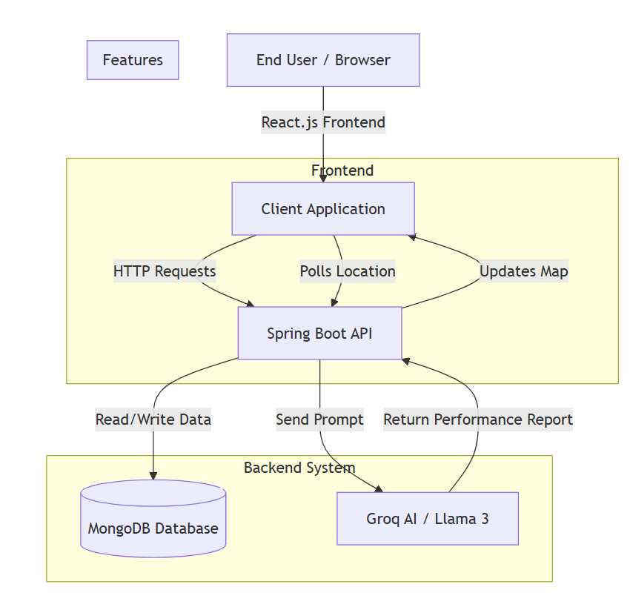

3.2 UML Design Diagrams
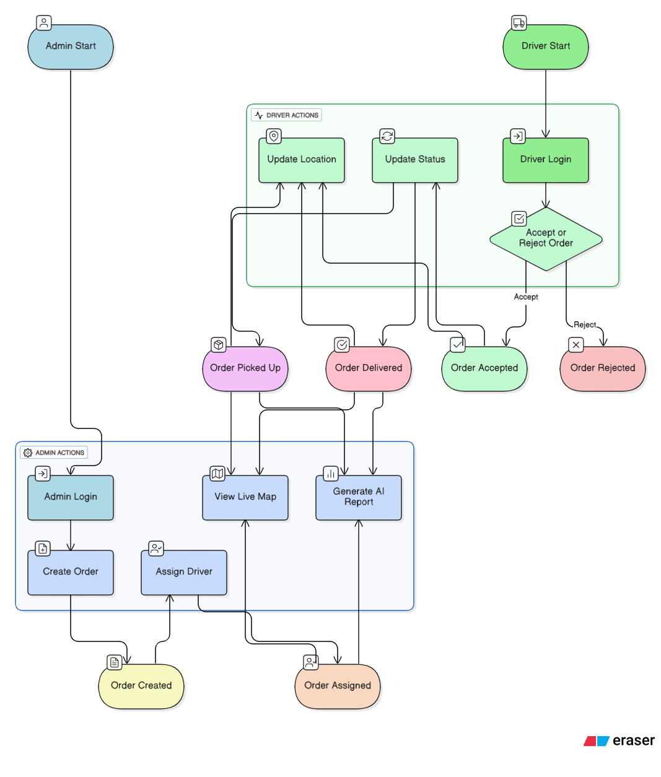

3.3 Database Design (MongoDB Schema)
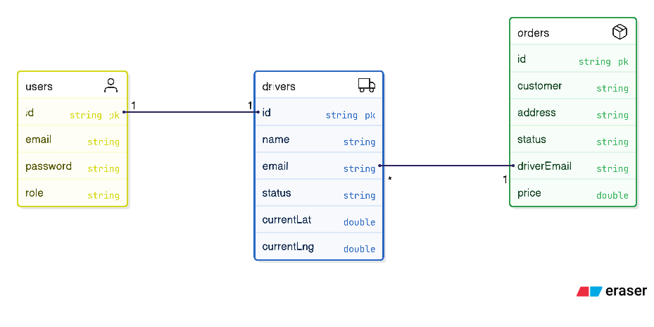
Collection: drivers
{
"_id": "unique_id",
"name": "John Doe",
"email": "john@example.com",
"status": "Available",
"currentLat": 23.0225,
"currentLng": 72.5714,
"vehicle": "Scooter"
}

Collection: orders
{
"_id": "unique_id",
"customer": "Alice Smith",
"location": "123 Main St",
"destLat": 23.0300,
"destLng": 72.5800,
"status": "In Transit",
"driver": "john@example.com",
"price": 150.0
}

3.4 Module Description
A. Admin Module
- Dashboard: View total drivers, active orders, and revenue stats.
- Assign Driver: Select a driver from a dropdown list to assign pending orders.
- Live Tracking: Click "View Map" to see a specific driver's movement on a map.
- AI Report: Click "Generate Report" to fetch an AI analysis of a driver.
B. Driver Module
- Job List: View assigned orders.
- Action Buttons: Accept or Reject jobs.
- Navigation: A simulated GPS interface where the driver clicks "Reach Checkpoint 1" and "Reach Checkpoint 2" to update their location on the server.

CHAPTER 4: IMPLEMENTATION DETAILS

4.1 Live Tracking Algorithm
Real-time tracking is achieved using a Polling Mechanism:
- Driver Action: When a driver clicks "Reach Checkpoint", the frontend calculates new coordinates (midpoint between start and destination) and sends a POST request to /api/driver/update-location.
- Database Update: The backend updates the currentLat and currentLng fields in the Driver document.
- Admin Polling: The Admin Dashboard has a useEffect hook that runs every 5 seconds. It calls /api/admin/driver-location.
- Map Refresh: When the Admin receives new coordinates, the React state updates, causing the Leaflet map marker to move instantly.

4.2 AI Performance Reporting
The system integrates with the Groq API to provide intelligent insights.
- Process: The backend fetches all "Delivered" orders for a specific driver.
- Prompt Engineering: A prompt is constructed: "Analyze the following delivery data for driver X. Calculate average speed, reliability, and give a performance review."
- Result: The Llama 3 model returns a paragraph (e.g., "Driver John is highly reliable with a 100% completion rate..."), which is displayed on the Admin dashboard.

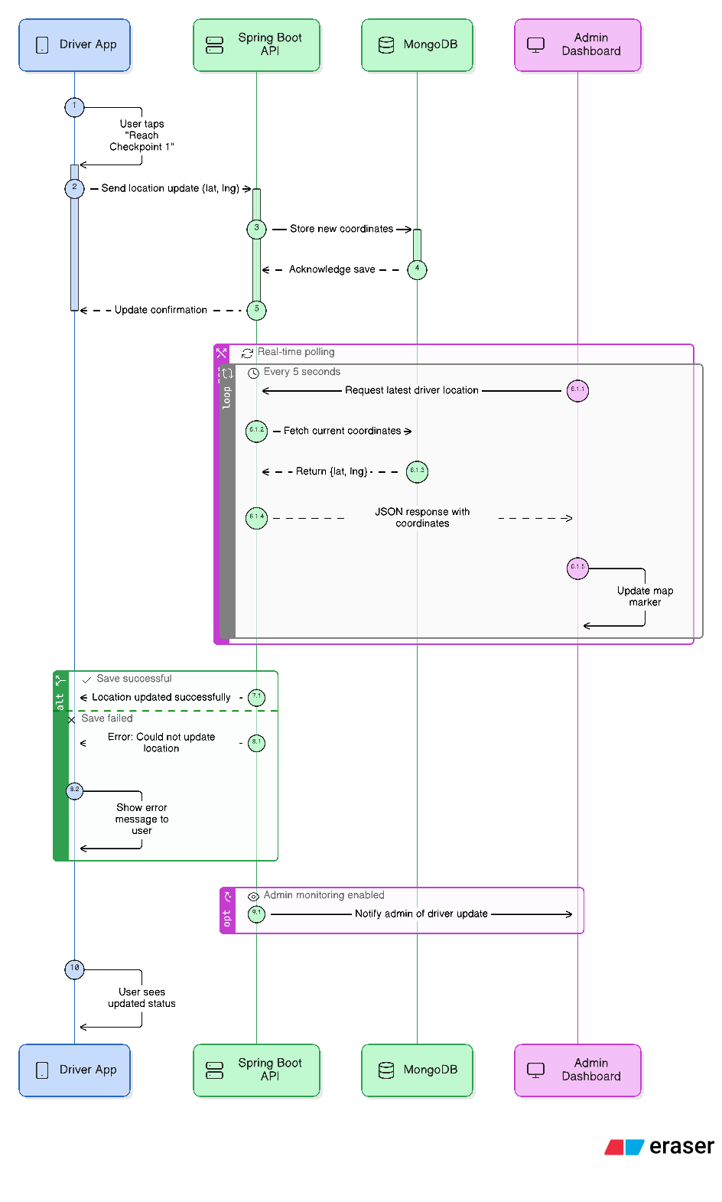

4.3 Frontend UI Design & Implementation
The frontend of the TrackMile system is developed using React.js and serves as the primary interface for user interaction. It is responsible for rendering dynamic UI components, handling user inputs, managing application state, and communicating with the backend through REST APIs.
The frontend is designed with a role-based approach, providing separate interfaces for Admin users and Driver users, ensuring clarity, usability, and security.

4.3.1 Frontend Pages & Navigation Flow

1. Login Page
- Allows users to log in by selecting their role (Admin or Driver)
- Validates credentials by sending requests to the backend
- Redirects users to their respective dashboards after successful authentication

2. Admin Dashboard
- Displays system statistics such as:
  - Total drivers
  - Active deliveries
  - Completed orders
- Allows admins to:
  - Assign drivers to orders
  - View live delivery locations
  - Generate AI-based performance reports

3. Live Tracking Page (Admin)
- Integrated with Leaflet Maps
- Displays real-time driver movement on a map
- Location data is updated automatically at regular intervals using polling

4. Driver Dashboard
- Displays assigned delivery orders
- Provides action buttons to:
  - Accept or reject delivery requests
  - Update delivery status
- Includes simulated navigation using checkpoint buttons

4.3.2 Frontend Component Structure
src/
├── components/
│ ├── Login.jsx
│ ├── AdminDashboard.jsx
│ ├── DriverDashboard.jsx
│ ├── LiveMap.jsx
│ ├── OrderList.jsx
├── services/
│ └── api.js
├── App.js
└── index.js

4.3.3 Frontend–Backend API Integration
- The frontend communicates with the backend using REST APIs
- API calls are implemented using Axios / Fetch
- Important API endpoints include:
  - /api/login
  - /api/admin/assign-driver
  - /api/driver/update-location
  - /api/admin/driver-location
The frontend uses React hooks (useEffect) to:
- Fetch data on page load
- Poll the backend for live driver location updates every few seconds
- Update the UI dynamically without page refresh

4.3.4 Frontend Responsibilities
The frontend is responsible for:
- Rendering responsive and interactive UI
- Role-based routing and access control
- Sending real-time location updates to the backend
- Displaying live tracking maps and AI-generated reports
- Improving user experience through clean layout and navigation
4.3.5 Frontend Team Contribution

Frontend Member 1 – UI Structure & Navigation
- Designed the overall frontend structure using React.js
- Created core pages such as Login, Admin Dashboard, and Driver Dashboard
- Implemented page routing and role-based navigation
- Integrated dashboard views with live map components

Frontend Member 2 – API Integration & Application Logic
- Connected the frontend with backend REST APIs using Axios / Fetch
- Implemented authentication flow and role-based access handling
- Managed real-time data fetching for live tracking using polling mechanisms
- Handled state management and dynamic UI updates based on backend responses

Frontend Member 3 – Styling & User Experience (CSS)
- Designed and implemented responsive layouts using CSS
- Styled dashboards, buttons, forms, tables, and map containers
- Ensured consistent color themes and spacing across all pages
- Improved user experience through clean, readable, and professional UI design

CHAPTER 5: RESULTS & SCREENSHOTS

5.1 User Authentication
The system provides role-based login security. Users must select their role (Admin or Driver) to access their respective dashboards.
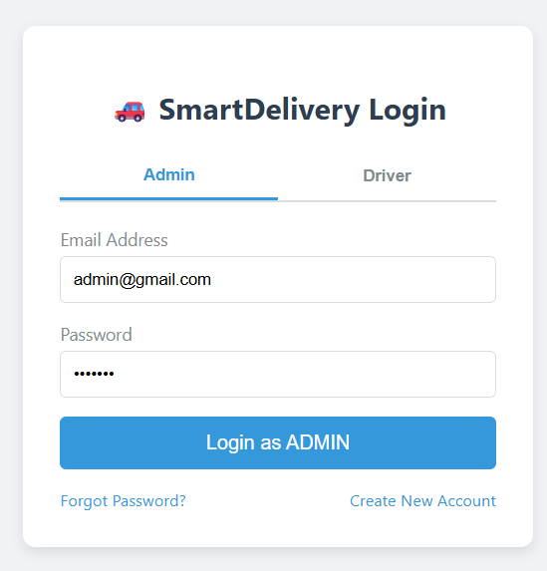

5.2 Admin Dashboard
The Admin Dashboard serves as the control center. It displays real-time statistics including total drivers, active orders, and deliveries completed today.
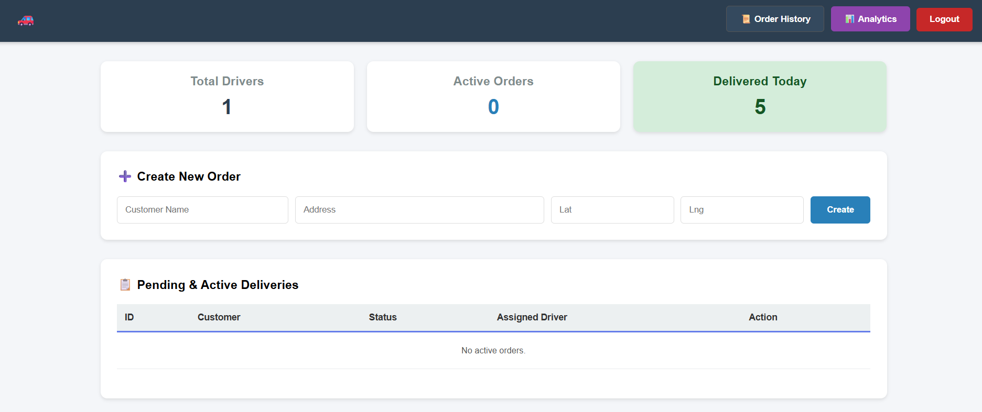

5.3 Live Map Tracking
This is the core feature of TrackMile. When a driver updates their location using the simulated checkpoints, the Admin map updates instantly without refreshing the page. The blue line represents the active route between the driver and the customer.
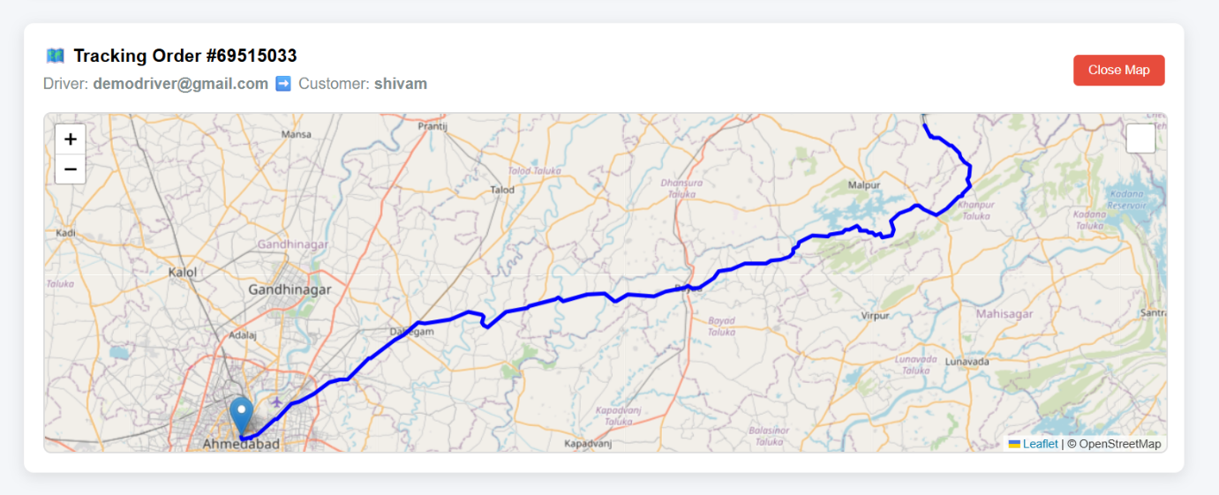

5.4 Driver Console & Navigation
The Driver Console allows drivers to manage their deliveries. It includes a simulated navigation system where drivers can click "Reach Checkpoint 1" and "Reach Checkpoint 2" to send location updates to the server.
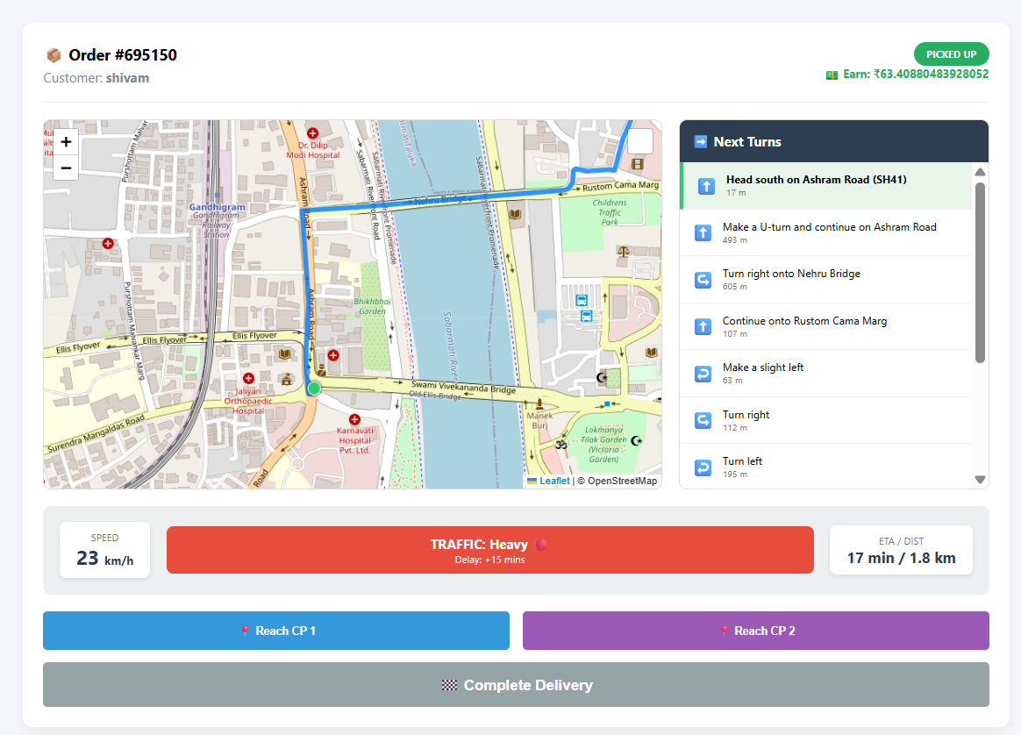

5.5 AI Performance Report
The system uses the Llama 3 model (via Groq) to generate text-based performance reviews. The Admin can view these reports to assess driver reliability and efficiency.
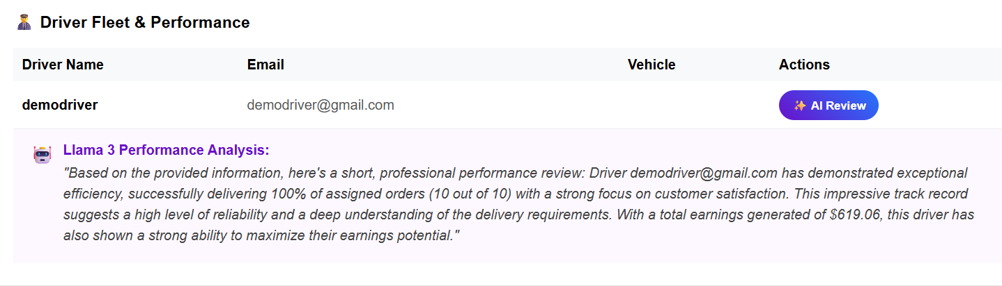

CHAPTER 6: CONCLUSION & FUTURE SCOPE

6.1 Conclusion
TrackMile successfully demonstrates how modern web technologies can modernize logistics. By combining Spring Boot's reliability with React's interactivity and AI's analytical power, the system provides a holistic solution for managing deliveries. The key achievement is the seamless synchronization between the Driver's actions and the Admin's live view.
6.2 Future Scope
- Mobile App: Converting the React frontend into a React Native mobile app for real GPS access.
- Route Optimization: Implementing an algorithm to automatically suggest the shortest path for multiple deliveries.
- Push Notifications: Replacing polling with WebSockets for instant alerts without page refreshes

