check_missingness()

Function Category - Data preparation

Purpose
To summarise missing data patterns for selected variables.
When handling data it is important to not only understand the data you have, but also the data you don’t. The output of this function allows you to see if there are any variables that are disproportionately lacking data entries.
This may happen when questions in measures are of a sensitive topic and participants feel uncomfortable answering (even if anonymous), or if the questionnaire consists of a large number of questions the participant may experience fatigue.

Argument required
check_missingness(data.frame)

or, for specific variables

check_missingness(
data = data.frame,
variables = c(“v1”, “v2”, “v3”)
)

Inputs
data
variables

Return
n_missing = number of missing entries for each variable
ptc_missing = percentage of missing entries for each variable

Table output:
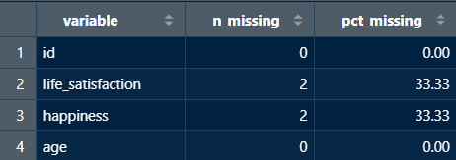

Outputs
Numeric vector

New user guide
check_missingness is great to use for whole datasets as well as specific measures. It can be used in tandem with other data preparation functions, such as recode_missing(). Once you understand how much of your data is missing and where it is missing, you can make an informed decision on how you want to handle it.

Avoiding Errors
- When inputting the data frame you want to pull from it, make sure not to put “” around the data frame name.
- However, when inputting the variables, each needs to be encapsulated in “” and separated by a comma.
- Ensure variable names and data frame titles are spelled correctly and include any special characters.
- Lastly, make sure each line is separated by a comma.

