label_to_factor()

Function Category - Data preparation

Purpose
To convert labelled survey variables to factors.
When using various survey platforms often when exporting the data, demographic measures that appeared as female, male, non-binary, other - for example - will show up in the data set as 1, 2, 3, 4 which isn’t helpful for any demographic analysis.
label_to_factor() changes these variables back to their descriptive form.

Argument required
factor_data <- label_to_factor(
data = data.frame,
variables = c(“v1”, “v2”, “v3”)
)

Input
data
variables
*you can also put the results into their own dataframe using <-

Data beforehand:
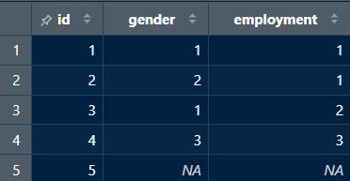

Return
Converts numerical labels in variables to descriptive factors.

Data afterward:
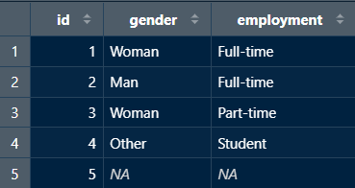
New user guide
This is useful when developing descriptive statistics and is often used when converting demographic information (e.g., gender, employment status). When exporting data from various survey platforms, descriptive variables often get translated into numbers. When handling data and performing any descriptive analyses it is much easier when your demographic variables have descriptive titles.

Avoiding Errors
- When inputting the data frame you want to pull from it, make sure not to put “” around the data frame name.
- However, when inputting the variables, each needs to be encapsulated in “” and separated by a comma.
- Ensure variable names and data frame titles are spelled correctly and include any special characters.
- Lastly, make sure each line is separated by a comma.

