loop_countries()

Function Category - Cross-national Analysis

Purpose
To loop analyses across countries.

Complementary Functions
plot_cross_national()

Argument required
missing_by_country <- loop_countries(
data = data,
country_var = "country",
analysis_function = check_missingness_simple,
variables = c("v1", "v2")
)

Inputs
data
variables (country variable separate)
analysis function
*you can also put the results into their own dataframe using <-

Return
country = input country variable
variable = input variables
*analysis function outputs = the outputs of whatever function you chose, in this example - missingness

missing_by_country table:
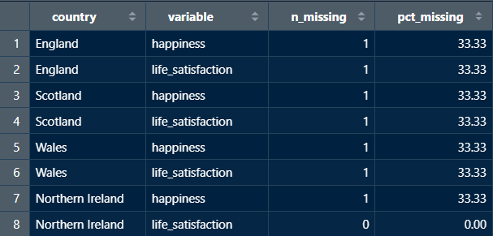
*table output is dependant on the analysis function chosen in input

outputs
Numeric vectors

New user guide
loop_countries() is a great tool to perform analysis across countries and have the outputs in one place, grouped by countries. The analysis_function input is key here, this is where you can choose what analysis you want to perform across the dataset.

Analysis function key:
__________

Avoiding Errors
- When inputting the data frame you want to pull from it, make sure not to put “” around the data frame name.
- The analysis function also shouldn’t have “” encasing it.
- However, when inputting the variables each needs to be encapsulated in “” and separated by a comma.
- Ensure variable names and data frame titles are spelled correctly and include any special characters.
- If listing variables make sure to encase them in c(...).
- Lastly, make sure each line is separated by a comma.

