plot_cross_national()

Function Category - Cross-national Analysis

Purpose
To compare [wellbeing] scores across countries.

Complementary Functions
loop_countries()

Argument required
plot <- plot_cross_national(
data = data,
country_var = "country",
outcome_var = "happiness",
plot_title = "Mean happiness by country",
y_label = "Mean happi"
)

Inputs
data
country variable
outcome variable (score of measure made using score_scale())
title and labels
*you can also save the plot to your environment using <-

Return
Outputs
Plot:
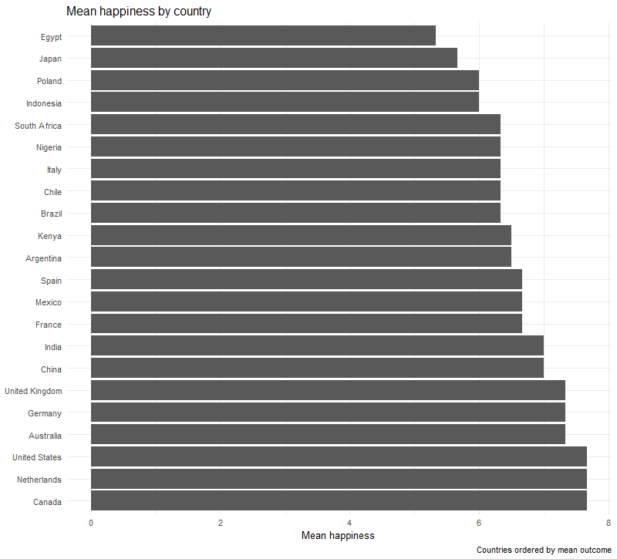
New user guide
plot_cross_national() is a great and easy way to visualise the outcomes of a measure across countries. Having plots represent findings provides a clear picture that can be more easily digestible than just describing the findings.

This function requires you to choose the data frame you want to pull variables from, as well as name the outcome variable you want to include.
All variable titles need to be encapsulated within “”.

The outcome variable is the mean score of a measure or item, in this example it is happiness. This can be found using the score_scale() function within the Flourish package.

Avoiding Errors
- When inputting the data frame you want to pull from it, make sure not to put “” around the data frame name.
- However, when inputting the country and outcome variables each needs to be encapsulated in “”
- Ensure variable names and data frame titles are spelled correctly and include any special characters.
- Lastly, make sure each line is separated by a comma.

