plot_longitudinal()

Function Category - Longitudinal analysis

Purpose
To plot wellbeing trajectories across waves.
Many wellbeing studies or studies that include wellbeing scores are longitudinal, meaning participants' measures are recorded multiple times over a specified period of time, or in waves. plot_longitudinal() is a function that can help visualise the trajectories of scores across these waves.

Argument required
Code Input:
plot <- plot_longitudinal(
data = data,
id_var = "participant_id",
wave_var = "wave",
outcome_var = "happiness",
plot_title = "Mean happiness over waves",
y_label = "Mean happiness"
)

Inputs
data
variables - id, wave, outcome
labels
*you can also save the plot to your environment using <-

Return
Outputs
Plot:
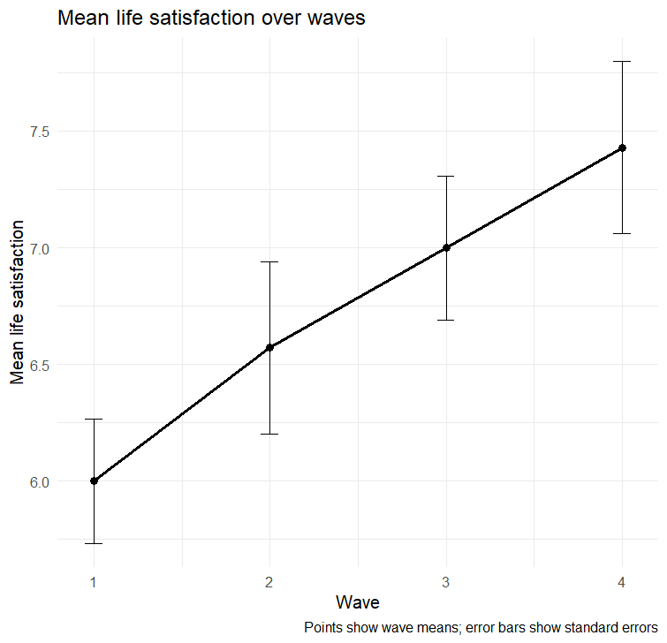
The points on the graph are the wave means
The error bars represent show standard errors

New user guide
plot_longitudinal() is a great and easy way to visualise the scores of an item across time or waves. Having plots represent findings provides a clear picture of trajectories that can be more easily digestible than just describing the findings.

This function requires you to choose the data frame you want to pull variables from, as well as name each variable you want to include.
These consist of the participant id, the wave variable (this could also be a year), and the outcome variable. All variable titles need to be encapsulated within “”.

The outcome variable is the mean score of a measure or item, in this example it is happiness. This can be found using the score_scale() function within the Flourish package.

Avoiding Errors
- When inputting the data frame you want to pull from, make sure to not put “” around the name of your dataframe.
- However, when inputting the variable names, make sure to encase each of them with “”.
- Ensure the spelling of everything is correct and each line is separated by a comma.
- Lastly, ensure the correct amount of brackets are their placement is correct.

