recode_missing()

Function Category - Data preparation

Purpose
To recode survey-specific missing values to N/A.
When prepping data, deciding what to do with missing data is vital. If you are going to do anything with it - make it cohesive. This makes it easier to analyse and supports further data handling. recode_missing() changes all missing data to N/A.

Argument required
Code Input:
recoded_data <-recode_missing(
data = data.frame,
variables = c(“v1”, “v2”, “v3”)
)

Inputs
data
variables

Data beforehand:
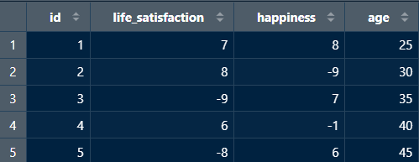
*missing data is often represented as negative numbers - which may complicate analysis

Return
Recodes any missing data to N/A.

Data afterward:
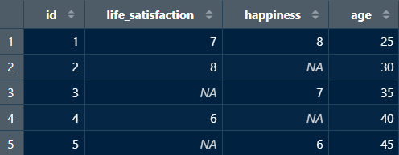

New user guide
recode_missing() is a useful tool to change all missing data entries to N/A. Different survey platforms and open-source data sets may use different ways of noting missing data based on input type (i.e., -9, 99, NaN, NA, NULL, etc.). Analysing data without cohesive missing data notation can cause issues.

Unlike check_missingness(), recode_missing() needs variables in order to work - as it is essentially scanning through all points in these variables to check for and change any missing data to show N/A.

Avoiding Errors
- When inputting the data frame you want to pull from it, make sure not to put “” around the data frame name.
- However, when inputting the variables, each need to be encapsulated in “” and separated by a comma.
- Ensure variable names and data frame titles are spelled correctly and include any special characters.
- Lastly, make sure each line is separated by a comma.

