score_scale()

Function Category - Scale Scoring

Purpose
To Score multi-item scales with documented missing-data rules.
It supports consistent scoring across different wellbeing measures.

Complementary Functions
score_swebwbs()
recode_missing()

Argument required
Code Input:
scored_dataframe <- score_scale(
data = data,
items = c("item.1", "item.2", "item.3", "item.4"),
prefix = "scale",
min_items = 3,
valid_range = c(1, 5)
)

Inputs
data
items
prefix
minimum items
range
*you can also put the results into their own dataframe using <-

Return
scale.n.valid = how many items have a valid response (i.e., not NA)
scale.mean = mean score
scale.sum = total sum of responses
scale.prorated = the prorated score

scored_dataframe:
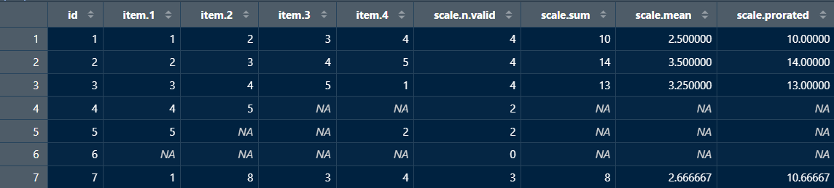
outputs
Numerical vectors

New user guide
score_scale() is used to scale a variety of measures, all you need in this function is the dataframe you are pulling from, the individual item names within the measure in your dataframe, a prefix, and the range.

The prefix is naming what your output titles will be.
In this example - the prefix is ‘scale’ so the output table will have the titles ‘scale.n.valid’, ‘scale.sum’, ‘scale.mean’, and ‘scale.prorated’.
This gives you the opportunity to name the scored outputs after the measure or the sub-score within the measure - i.e., ‘anxiety’ or ‘life.sat’.

The valid_range input is the minimum and maximum numbers an answer can be. For example, many measures scales are likert scales - 1 = strongly disagree; 7 = strongly agree, in this case, the valid_range will be (1,7) as a participant can’t answer anything outside this range. It is important to preface the range in this code as often survey platforms code missing or invalid data as numbers (e.g., 99) and may cause issues when scoring. recode_missing() could also help here.

min_items denotes the absolute minimum amount of answers a participant could answer and still be included in the analysis. It is important to decide this before analysing data to avoid any bias changes. The output ‘scale.prorated’, this is a score when the participant has missing answers but still meeting the minimum number of answers - an estimated total if all items had been answered.

Avoiding Errors
- When inputting the data frame you want to pull from it, make sure not to put “” around the data frame name.
- The range values are also not put in “”, but make sure to separate them by commas.
- However, when inputting the variables each needs to be encapsulated in “” and separated by a comma - the prefix also needs to be in “”.
- Ensure variable names and data frame titles are spelled correctly and include any special characters.
- Lastly, make sure each line is separated by a comma.

