Telemetry map

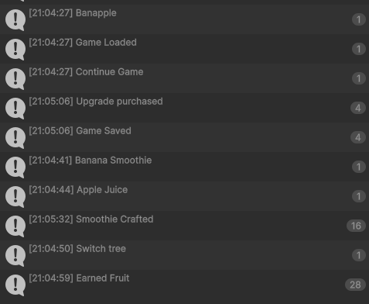

Game Loaded : On game data loaded
Continue Game: When clicking continue game button
Smoothie crafted: When a smoothie is crafted with fruits
Switch tree: When arrows at top of main game are used to navigate between trees
Upgrade purchased: When the player spends coins to buy upgrades for their trees.
New Game Started: When starting a new game with no save data.
Game Reset: When all game save data is deleted.
Apple juice etc: The recipe name is logged when the player selects a recipe to craft.

