President University

Report of Programming Assignment 12

Polygon Clipping: Weiler Atherton

Computer Graphics and Animations

Hilman Revanda (001201500038)

Nikita Chrissandha M (001201500031)

Predrika Br Ginting (001201500032)

CIT 2 2015

# Introduction

The program is about drawing and clipping polygon/polygons. The Weiler – Atherton Algorithm for polygon clipping is fully implemented in this program. Other than those, user can also refresh the screen, delete, and save the polygon/polygons.

This program was created using Visual Basic programming language. The report includes basic theory, how to use the application, design of the application, evaluation of the main features, work log, and conclusion and remarks.

# Basic Theory

Clipping is procedure that identifies those portions of a picture that are either inside or outside of a specified region of a space. Clipping is the extraction of data/primitives inside a region of “interest” window. The primary use of clippimg is to remove objects, lines, or line segments that are outside the window.

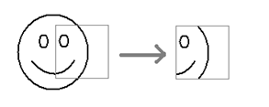

The Cyrus–Beck algorithm is a generalized line-clipping algorithm. Cyrus–Beck is a line-clipping algorithm that can be used with any convex region as a clipping window, which is can be used also on a rectangular clipping area.

## Point Clipping

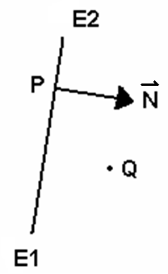E1E2 = window edge

F(Q) = (Q – P) **.** **N**

P = a point on the line

**N** = normal vector of E1E2 pointing inside the window   
 . = dot product

F(Q) determines whether the angle between **PQ** and **N** is greater than or less than 900.

F(Q) > 0 🡪 Q is “inside” the line

F(Q) < 0 🡪 Q is “outside” the line

F(Q) = 0 🡪 Q is on the line

## Line Clipping

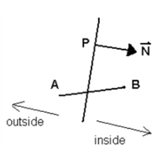Window edge : F(Q) = (Q – P) . **N**  
 Line segment :  
 L(t) = A + t (B – A)  
 a. Trivial reject :  
 F(A) < 0 and F(B) < for   
 at least one edge of  
 the clipping region.  
 b. Trivial accept :  
 F(A) ≥ 0 and F(B) ≥ 0   
 for all edges of the clipping region.  
  
Find t :

t = (A – P) . **N** - (B – A) . **N**Let D = (B – A) **. N**

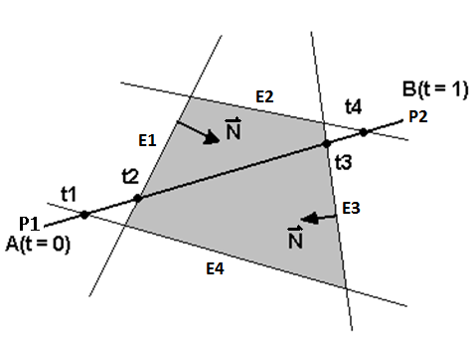 If D > 0, then the angle between  
 (B –A) and **N** is less than 90o.

Label t as tE (entering).

t1 and t2 are “entering”.

If D < 0, then the angle between (B – A)  
 and **N** is more than 90o.  
 Label t as tL (leaving).  
 t3 and t4 are “leaving”.

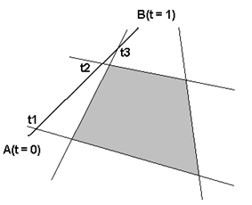t of interest:  
 Largest tE (tEmax)  
 Smallest tL (tLmin)  
 Large/small here refers to the index of t, not the value.  
 In this case, t2 and t3 are selected.

Reject :  
tEmax > tLmin

t1 = entering  
t2 = leaving  
t3 = entering

## Line Intersection

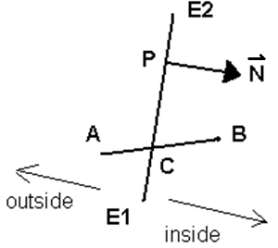AB intersects window at C  
F(C) = 0  
C = L(t) = A + (B – A) t

Thus:  
F(C) = 0  
(C – P) **.** **N** = 0  
(A + t (B – A) – P) **.** **N** = 0  
(A – P) **.** **N** + t (B – A) **.** **N** = 0

t = (A – P) **.** **N** `

(A – B) **.** **N**

= (A – P) **.** **N** `

– (B – A) **.** **N**

Polygon can be defined as set of points or set of vectors. Polygon clipping is procedure that identifies those portions of a polygon that are either inside or outside of a specified region of a space. An algorithm that clips a polygon must deal with many different cases. Each edge of the polygon must be tested against each edge of the clipping window; new edges must be added, and existing edges must be discarded or divided.

The Weiler-Atherton is a polygon clipping algorithm. The Weiler-Atherton algorithm is based on the Cyrus-Beck and Liang-Barsky algorithm. While most clipping algorithms are optimized for a rectangular clipping region, the Weiler-Atherton algorithm can use simple polygons for both the subject of the clipping as well as the actual clipping region itself. In this algorithm, the clipping window must be convex, but the polygon to be clipped can be convex or non-convex. A clipped polygon may result in more than one polygon. There are no degenerate lines in this polygon clipping algorithm.

The algorithm of Weiler-Atherton polygon clipping :

1. Initialize the polygon and clipping window as separate circular lists of vertices (CLP and CLW). The elements of CLP and CLW are sorted based on order of vertices.
2. Traverse each edge of the polygon; find intersections with the clipping window. Insert each intersection into CLP and CLW. Mark each intersection as “entering” or “leaving”.
3. Start at an entering vertex.
4. If you encounter a leaving vertex swap to clipping window loop.
5. If you encounter an entering vertex swap to polygon loop.
6. A loop is finished when you arrive back at start.
7. Repeat until all entering vertices have been processed.

There are 4 (four) main cases in Weiler-Atherton polygon clipping algorithm.

Case 1   
Polygon edge is entirely inside the clipping window.

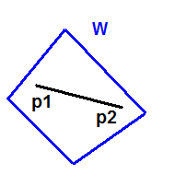No action

Case 2  
Polygon edge crosses the clipping window going out

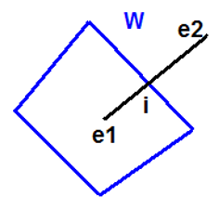 Find i.  
 Add i to both CLP and CLW.   
 Mark i as “leaving”.

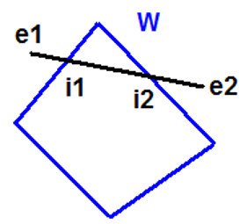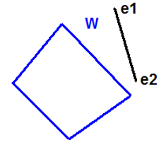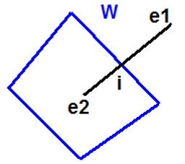Case 3  
Polygon edge crosses the clipping window edge going in  
   
 Find i.  
 Add i to both CLP and CLW.  
 Mark i as “entering”.  
  
  
  
  
  
  
Case 4  
Polygon edge is entirely outside the clipping window edge.  
Find intersections.  
There are two possibilities :  
  
  
  
There are no intersections(i).  
  
No action  
  
  
  
  
  
  
  
  
  
  
  
There are exactly two intersections.  
  
Find i1 and i2.  
  
Determine the correct order between i1 and i2.   
  
Add i1 and i2 to both CLP and CLW.  
  
Mark i1 as “entering” and i2 as “leaving”.

The main limitation of Sutherland-Hodgman algorithm

* The clipping window must be rectangle.
* Clipping certain polygons may result in degenerate edges.
* In general, degenerate edges may be irrelevant.
* The result can be only 1 polygon.

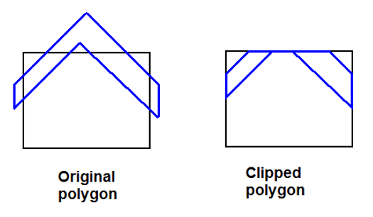

# Implementation

## Main interface

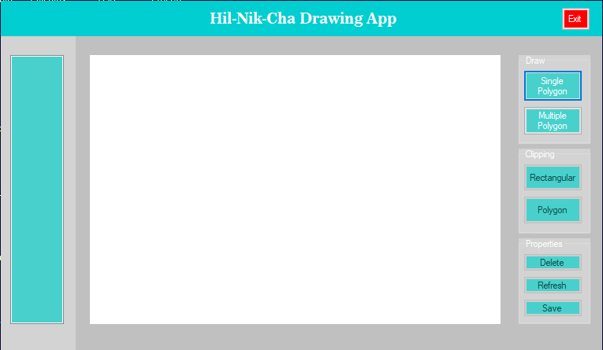

The application is named Hil-Nik-Cha Drawing App which was named after the developers. With color palette of silver, brown, dark turquoise, black and white, the user interface looks flat and modern. The features of the app include draw single and multiple polygon, Clipping the polygon with rectangle and polygon, delete polygon, refresh the screen, save polygon, and showing the list of polygon and clipping.

## Canvas/Picture Image

The picture box is used as canvas to draw polygons. After selecting the draw button, the user could click anywhere on the canvas to create polygon. Right click is used to finish the polygon.

## List Box

List box is where the points of all polygons and clipping showed.

## Draw

Single Polygon and Multiple Polygon are both in the Draw group box. Single Polygon is used to draw a single polygon. When the user use this button, the previous polygon will be deleted.

## Clipping

In the Clipping group box, there are Rectangular and Polygon Clipping. The rectangular clipping is used to clip with a rectangle. On the other hand, Polygon button is used to clip with a free and multiple angles(polygon).

## Properties

In the properties, there are Delete, Refresh, and Save button. Delete button is used for deleting line or polygon. Refresh button is used for clearing the screen and the list box. And Save button is used for saving the canvas into bitmap.

## Exit

Exit button is used to exit the app.

# Design

## Explain the main data structures (if any) used in the program.

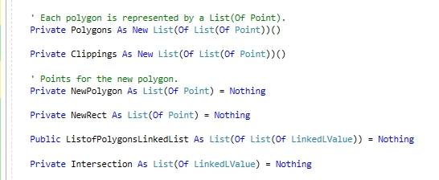

The point is represented as list and the polygon is represented as list of lists of point.

* Polygons to store the list of lists of point.
* Clipping as list of lists of point to store the points of point of the clipped polygon.
* NewPolygon to store the points of the new polygon.
* NewRect to store the points of the rectangular clipping.
* ListofPolygonLinkedList to store the polygon in linked list.
* Intersection to store the intersection of the polygon and the clipping in the linked list.

### How are the points and polygons represented in the program?

### How is the clipping window represented in the program?

### How are the CLP and CLW represented in the program?

## Explain the main/global variables used in the program.

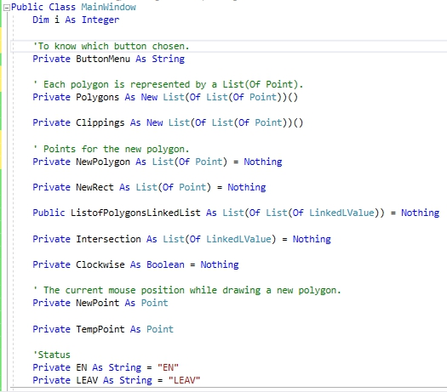

The variables:

* i is index and declared as integer.
* ButtonMenu is declared as string. It is declared to know which button is chosen.
* Clockwise is declared as Boolean to determine whether the clipping is clockwise or not.
* New point is the current position of the mouse while drawing a new polygon.
* TempPoint is to store the temporary point.
* En is declared as string and a line is assigned to “En” if the line is entering the clipping.
* Leav is declared as string and a line is assigned to “Leav” if the line is entering the clipping.

## Implementation of Bonus

### List Box of Polygon and Clipping

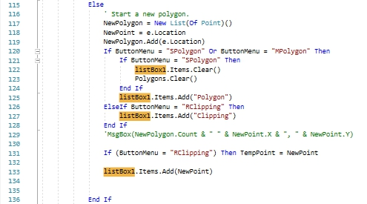

When starting a new polygon, the program will check whether it’s polygon or clipping. If it is polygon, then “Polygon” will showed in list box, then the next line will be followed by the first point of the polygon. If the polygon chosen is Single Polygon, then the previous list box will be deleted.

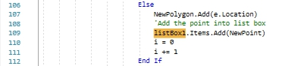

And then, the other points will be added after clicks from the user.

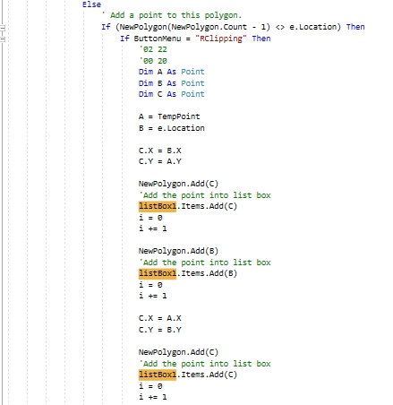

For rectangular clipping, the next point of polygon will be calculated first because the user only needs to click on two points and then the clipping will become rectangular.

### Refresh the Screen

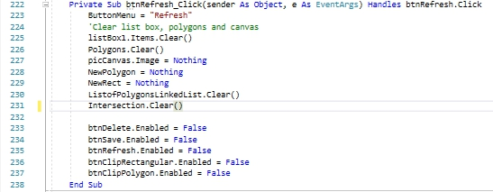

When the button is clicked, polygons, the list box, list of polygons linked list, intersection will be emptied. New polygon, new rectangular clipping, and the canvas will be set to be nothing.

### Save Polygon into Bitmap and Text File

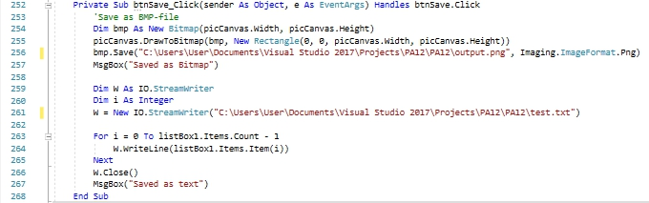

The polygon drawn on the canvas will saved as text and bitmap when the user click the Save button.

### Enable and Disable Button

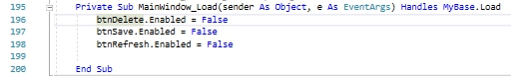



When there’s still nothing on the canvas, the Delete, Save, and Refresh button will be disabled.

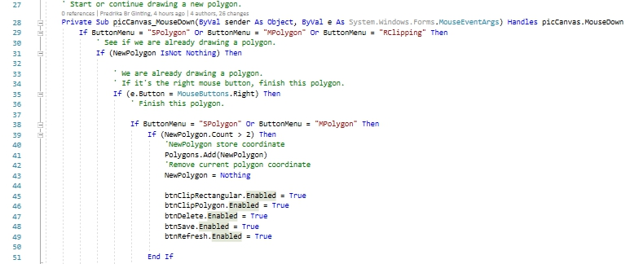

After a polygon is drawn, the Clipping and all the Properties Buttons will be enabled.

### Delete the Line

# Evaluation

## Adding a Polygon into the Screen

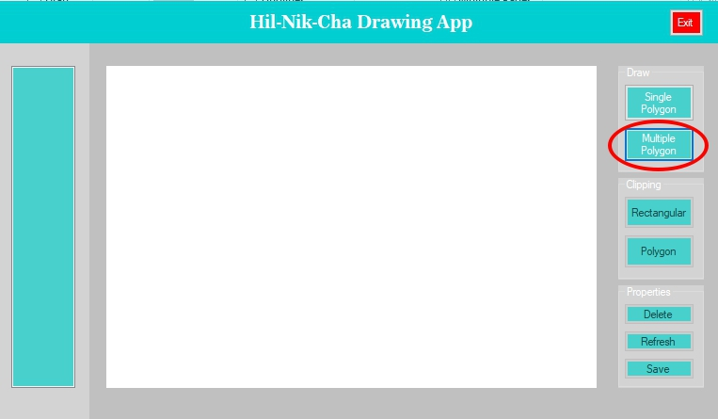First, select button from Draw Group Box, which one the user wants to draw. click The Single Polygon button for one polygon only or Multiple Polygon button for multiple polygon.

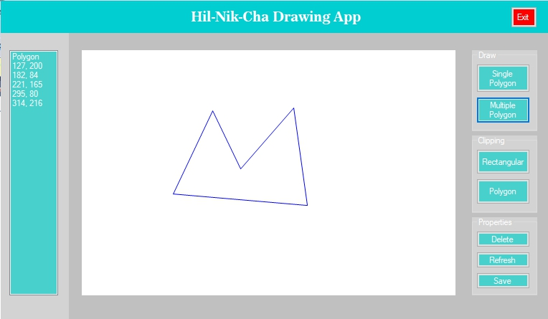Then click in the picture box to draw the polygon. Right click to finish the polygon.

## Adding Another Polygon into the Screen

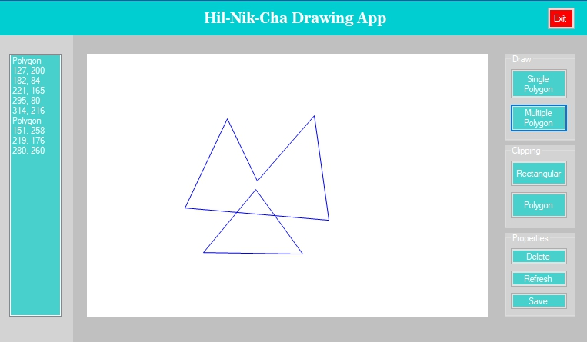When the user wants to add another polygon, the user just needs to clicks on the picture box to determine the points of the polygon and then right click to finish the polygon. Do the same if the user wants to add more.

## Clipping

#### A polygon partially inside the clipping window resulting in no degenerate lines.

#### A polygon partially inside the clipping window resulting in degenerate lines.

#### A polygon entirely inside the clipping window.

#### A polygon entirely outside the clipping window.

#### A polygon entirely covering the clipping window.

## List Box of Polygon and Clipping

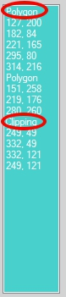The list box will show the list of point of polygons and clipping.

## Refresh the Screen

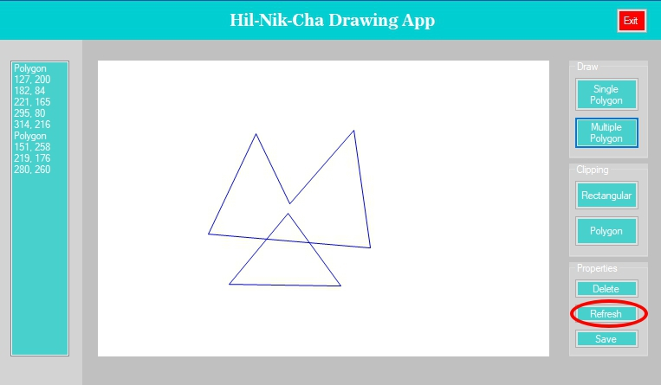When the user wants to clear the screen, he/she only needs to click the Refresh button.

## Save Polygon into Bitmap and Text File

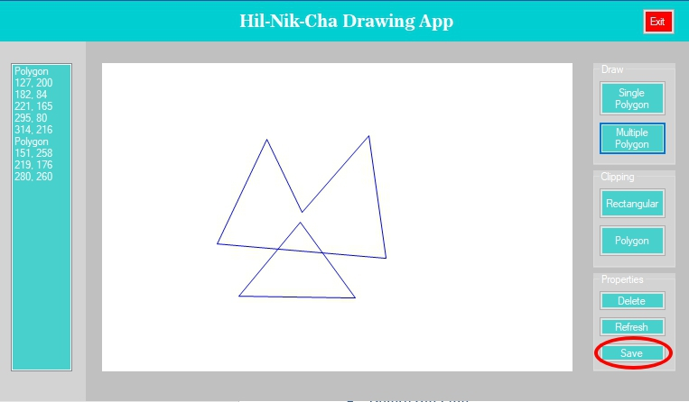If the user wants to save the polygons which he/she has drawn, he/she only needs to click the Save button, then the app will save it into bitmap and text file.

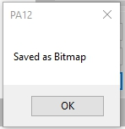This means, the drawing is already saved as bitmap file.

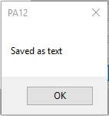And this means, the drawing is already saved as text.

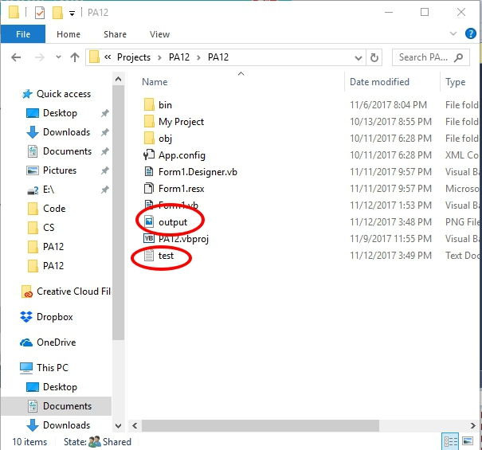If the user checks the folder, the bitmap and text is already there.

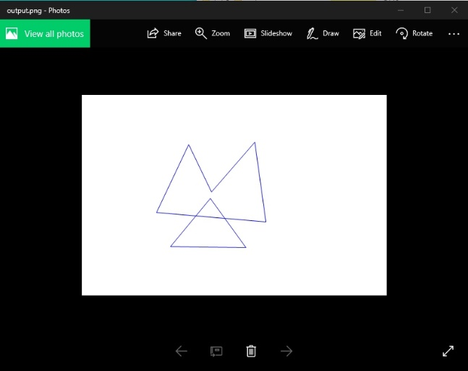

This is the output of bitmap file.

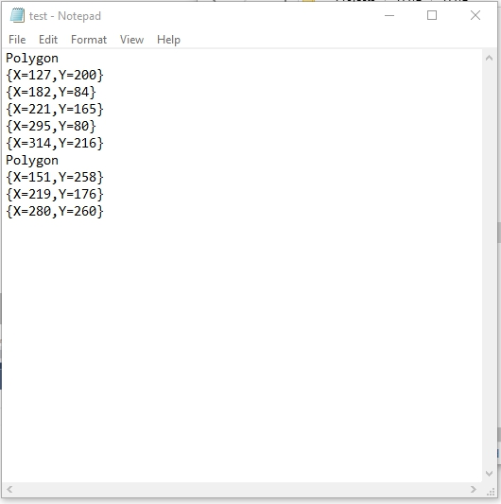

And this is the output of text file.

## Enable and Disable Button

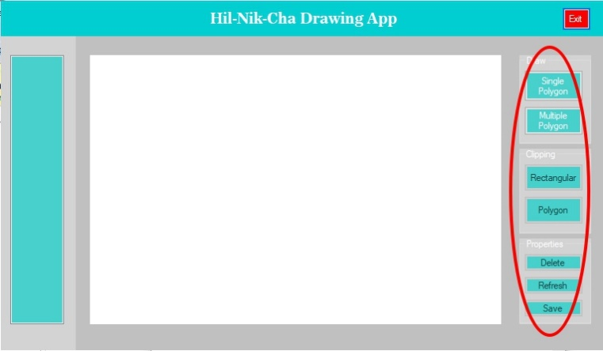When there’s no polygon drawn yet, the Clipping and Properties buttons will be disabled to prevent user clip or delete something that’s not exist yet.

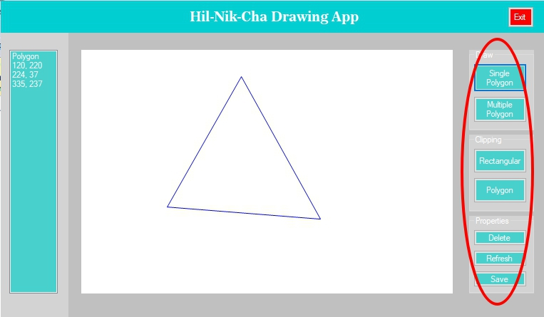After the user drawn something on the picture box, All the buttons in Draw, Clipping, and Properties will be enabled.

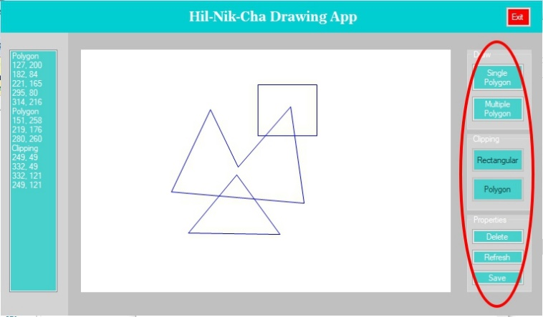After there’s a clipping, the Clipping buttons will be disabled.

## Delete the Line

# Work Log

The work log is extracted directly from Visual Studio’s Git Log History, which is also available publicly at <https://github.com/ichapredrika/PA12/commits/master>

|  |  |  |  |  |
| --- | --- | --- | --- | --- |
| No | Author | Date | Time | Commit Message |
| 1 | Nikita | 11/10/2017 | 20:04:59 | Create Basic Theory in Report |
| 2 | Predrika | 13/10/2017 | 19:16:12 | User interface |
| 3 | Predrika | 15/10/2017 | 18:35:37 | Draw multiple polygon |
| 4 | Hilman | 15/10/2017 | 22:13:00 | Add ButtonMenu variable for SPolygon and MPolygon buttons |
| 5 | Hilman | 16/10/2017 | 00:06:28 | Differentiate draw single and multiple polygon |
| 6 | Predrika | 16/10/2017 | 14:53:21 | From Single Polygon button, when we draw the second polygon, the first will disappear |
| 7 | Predrika | 27/10/2017 | 15:22:09 | Delete item on list box |
| 8 | Predrika | 27/10/2017 | 15:43:14 | Adding polygon's point into list box and refresh canvas |
| 9 | Hilman | 30/10/2017 | 01:31:01 | Determine whether the clipping is convex or not |
| 10 | Hilman | 30/10/2017 | 22:30:27 | If polygon clipping is not convex, don’t draw the polygon |
| 11 | Predrika | 31/10/2017 | 11:53:29 | Determine whether the clipping is convex or not (correcting) |
| 12 | Predrika | 31/10/2017 | 12:03:45 | Determine whether the clipping is clockwise or anticlockwise |
| 13 | Predrika | 3/11/2017 | 17:04:53 | Rectangular Clipping (not finished yet) |
| 14 | Hilman | 3/11/2017 | 03:12:29 | Add insidepoint function and clippingpoint funtion |
| 15 | Hilman | 3/11/2017 | 23:02:58 | Draw rectangle clipping with 2 points |
| 16 | Hilman | 3/11/2017 | 23:30:47 | Rect bug fixed |
| 17 | Nikita | 4/11/2017 | 17:20:21 | Correcting the point clipping in the listbox |
| 18 | Hilman | 4/11/2017 | 07:29:42 | Test in and out |
| 19 | Hilman | 6/11/2017 | 11:42:33 | Inside - outside (Fixed) |
| 20 | Hilman | 7/11/2017 | 10:42:26 | linked list using lis of object(not finished yet) |
| 21 | Predrika | 8/11/2017 | 15:53:56 | Better user interface |
| 22 | Hilman | 8/11/2017 | 01:34:21 | Initialized all polygon into linked list after rectangular clipping is drawn |
| 23 | Predrika | 8/11/2017 | 16:57:06 | Disable properties button when there's no polygon |
| 24 | Hilman | 9/11/2017 | 06:15:14 | Linkedlist update |
| 25 | Predrika | 9/11/2017 | 21:52:14 | -Disable clicks on the picture box when the button to draw polygon has not been clicked  - Disable clipping and properties after the user click refresh |
| 26 | Predrika | 10/11/2017 | 20:43:21 | Implementation and edit introduction in report |
| 27 | Predrika | 11/11/2017 | 17:54:33 | -Save to bitmap  -Save into txt |
| 28 | Hilman | 11/11/2017 | 05:32:22 | Clipping (still has bug) |
| 29 | Predrika | 12/11/2017 | 13:23:57 | Refresh (also delete the linked list) |
| 30 | Predrika | 12/11/2017 | 13:46:36 | The second Single Polygon will delete all the previous polygon along with the listbox |
| 31 | Predrika | 12/11/2017 | 19:42:20 | -Evaluation  -Design  -Worklog |
| 32 | Nikita | 12/11/2017 | 22:23:14 | Basic Theory in report |

# Conclusion and Remarks

## Does the program work as expected?

## If some parts of the program do not work as expected, explain why.

## What are your comments about this assignment

The program work as expected. The assignment drains all the energy that the developers have.