Pratama Aditya Zicky Kencana S.Ikom  Jl Mesran Raya M17/B5 Ciputat  Tangerang Selatan 15412  (+62) 87771998099  adit.zicky@gmail.com  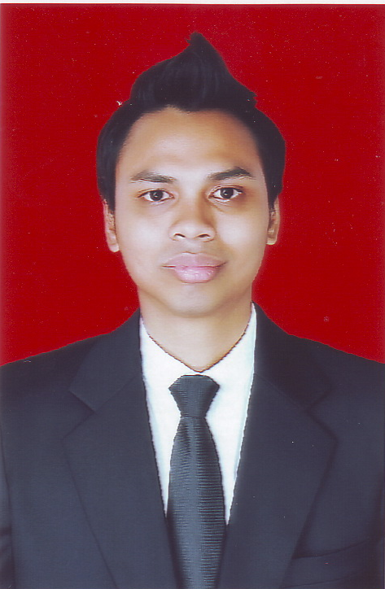 | Summary  A young, dynamic and talented person who seek an opportunity to work and expand his skills and career in the workforce. As a worker, I am ready to work in a dynamic and fast paced environment. Graduated as Bachelor of Science Communication, I’m possess a solid understanding about Public Relations and Mass Media. As a person, I’m a passionate learner who has a good attention to details. I also have a big curiosity that leads me to have a strong analytical and critical thinking.
 | Employment History

PT Lintec Jakarta
PT Lintec Jakarta is a trading company that established to achieve a higher market share of PT Lintec Indonesia’s product in South East Asia, West Asia and Middle East region. The product itself is a Pressure-Sensitive Adhesive material for printing and laminating such as sticker and label for automotive, electronic and construction.
Sales Executive
13 April 2015 – now
- Maintain local and export sales
- Checking and calculate Purchase Order from customer
- Looking for new local customer
- Handled the technical inventorying of products
- Check and control the quality of products
- Maintain the application of products
- Handled the delivering of products to customer so it running smoothly

JKTGO.com
JKTGO.com is an online media which a website directory of restaurants, places and events in Jakarta region. It consists of the newest, the best and the most talk restaurants, places and events in Jakarta region. Our goal is to help and guide you to decide what and where to eat, what to do and where to hang out in a big, dynamic and busy city, Jakarta.
Content Coordinator
2 December 2013 – 1 December 2014
- Acquiring new data such as restaurants, activities and events in Jakarta region for website's content
- Responsible to create and update the website's database
- Maintaining a good relationship with clients
- Handling secretarial function such as filing, correspondence, monthly report and incoming/outgoing letters
- Call existing clients to become a merchant on Jakarta Pass project
I also contributed as Sales Promotion in JKTGO booth in some Bazaars:
- Pop Up Market “Shibuya” at Kuningan City 11 – 13 April 2014
- I Love Bazaar Jakarta at Grand Indonesia Shopping Town 8 – 11 May 2014
- Jakarta Culinary Passport at Grand Indonesia Shopping Town 5 – 8 June 2014
- WTF Market “The Graffiti Wood” at Grand Indonesia Shopping Town 31 October – 2 November 2014
 | Education
Year | School/University | Concentration
2008 – 2013 | University of Prof. Dr Moestopo (Beragama) | Public Relations
2004 – 2007 | Kolese Gonzaga | Social Science
 | Skills
- Good English both spoken & written
- Computer Literate (Microsoft Word, Microsoft Power Point, Microsoft Excel)
- Strong analytical and critical thinking
- Detailed oriented
- Negotiation
- Public Speaking
- Fast Learner
 | References
 | Will be sent upon request

