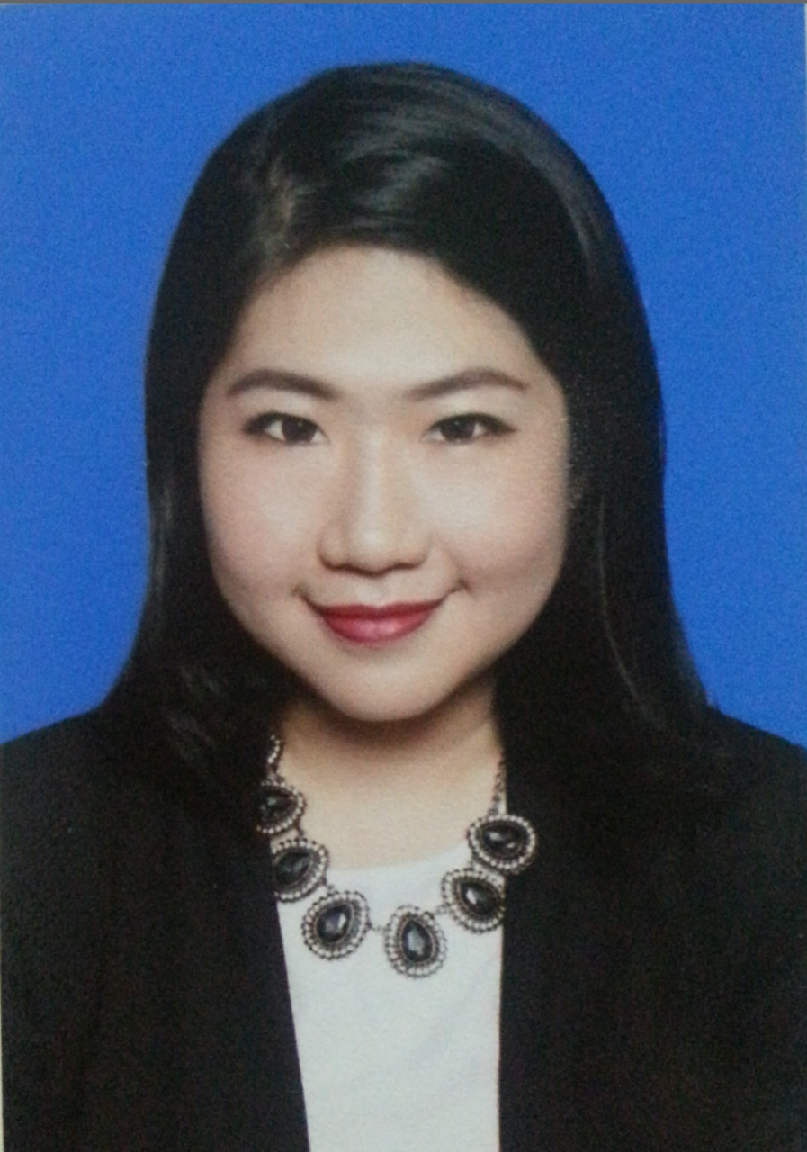
GITTA NYDIA WIJAYA
Citra 6 blok G6/56, Kalideres, Jakarta 11820
+6282113983530
christinagitta@gmail.com

Personal Skills
Languange : Indonesian, English (proficient), Chinese (proficient),
Korean (beginner)
Computer : Proficient Microsoft Office, Photoshop, Illustrator, InDesign,
Final Cut Pro, Bloomberg terminal (Data mining and research)

Personal Value
Enthusiastic, hardworking, keen to learn, committed and well motivated, flexible team player, dependable, high attention to details.

Educational Background
2012.08 – 2014.07 : Tsinghua University, Beijing, China
Master of Art in Global Business Journalism.
Major Courses:
1. Multimedia Business Journalism 2. News and Business Writing
3. Mass Communication 4. Corporate and Cross Cultural Communication
2012.02 – 2012.07 : Tsinghua University, Beijing, China
Chinese Language Program (Advanced)
2011.03 – 2011.12 : Beijing Union University, Beijing, China
Chinese Language Program (Basic)
2006.08 – 2010.07 : Universitas Pelita Harapan, Indonesia
Bachelor degree in Visual Communication Design.

Working Experience
2013 CCTV (China Central Television/ 中国中央电视台)
Beijing, China
CCTV Multimedia News Department
Social media specialist
Managed social media post for China related news to Twitter and Weibo, Chinese to English/ English to Chinese editing for Weibo posts.
2009.09 – 2009.12 PT.Surya Citra Televisi
SCTV Tower, Senayan City, Jakarta-Indonesia.
Creative On-Air & Presentation Division (COAP)
Graphic Presentation Department
Internship as Graphic Designer
- Designed on air program and event promotional items and promotional campaigns which are sponsored and aired on SCTV. (Miss Celebrity, Usaha Anda, Playlist)
2009.06 – 2009.09 MRA Media Group, Jakarta-Indonesia
PT. HIGINA ALHADIN
COSMOPOLITAN MAGAZINE
Marketing and Communication Department
Internship as Graphic Designer
- Managed promotional items and magazine ads design for several events which was held by Cosmopolitan and Bazaar magazine (Cosmopolitan Fun Fearless Female, L’oreal Road show event, Harper’s Bazaar Wedding event, Bazaar Art Jakarta 2009 (Harper’s Bazaar).
Other Activities
2012 Committee of AICE (Association of International Cultural Exchange) Tsinghua University
2013 Committee of Tsinghua New Year Gala Night 2014, Beijing, China
2013 Bloomberg Terminal training session by Bloomberg

Other Achievements
1998-2000 Scholarship from PT. Kalbe Farma

Hobby and interest
Reading, traveling, writing, art and craft, foreign language and culture.

