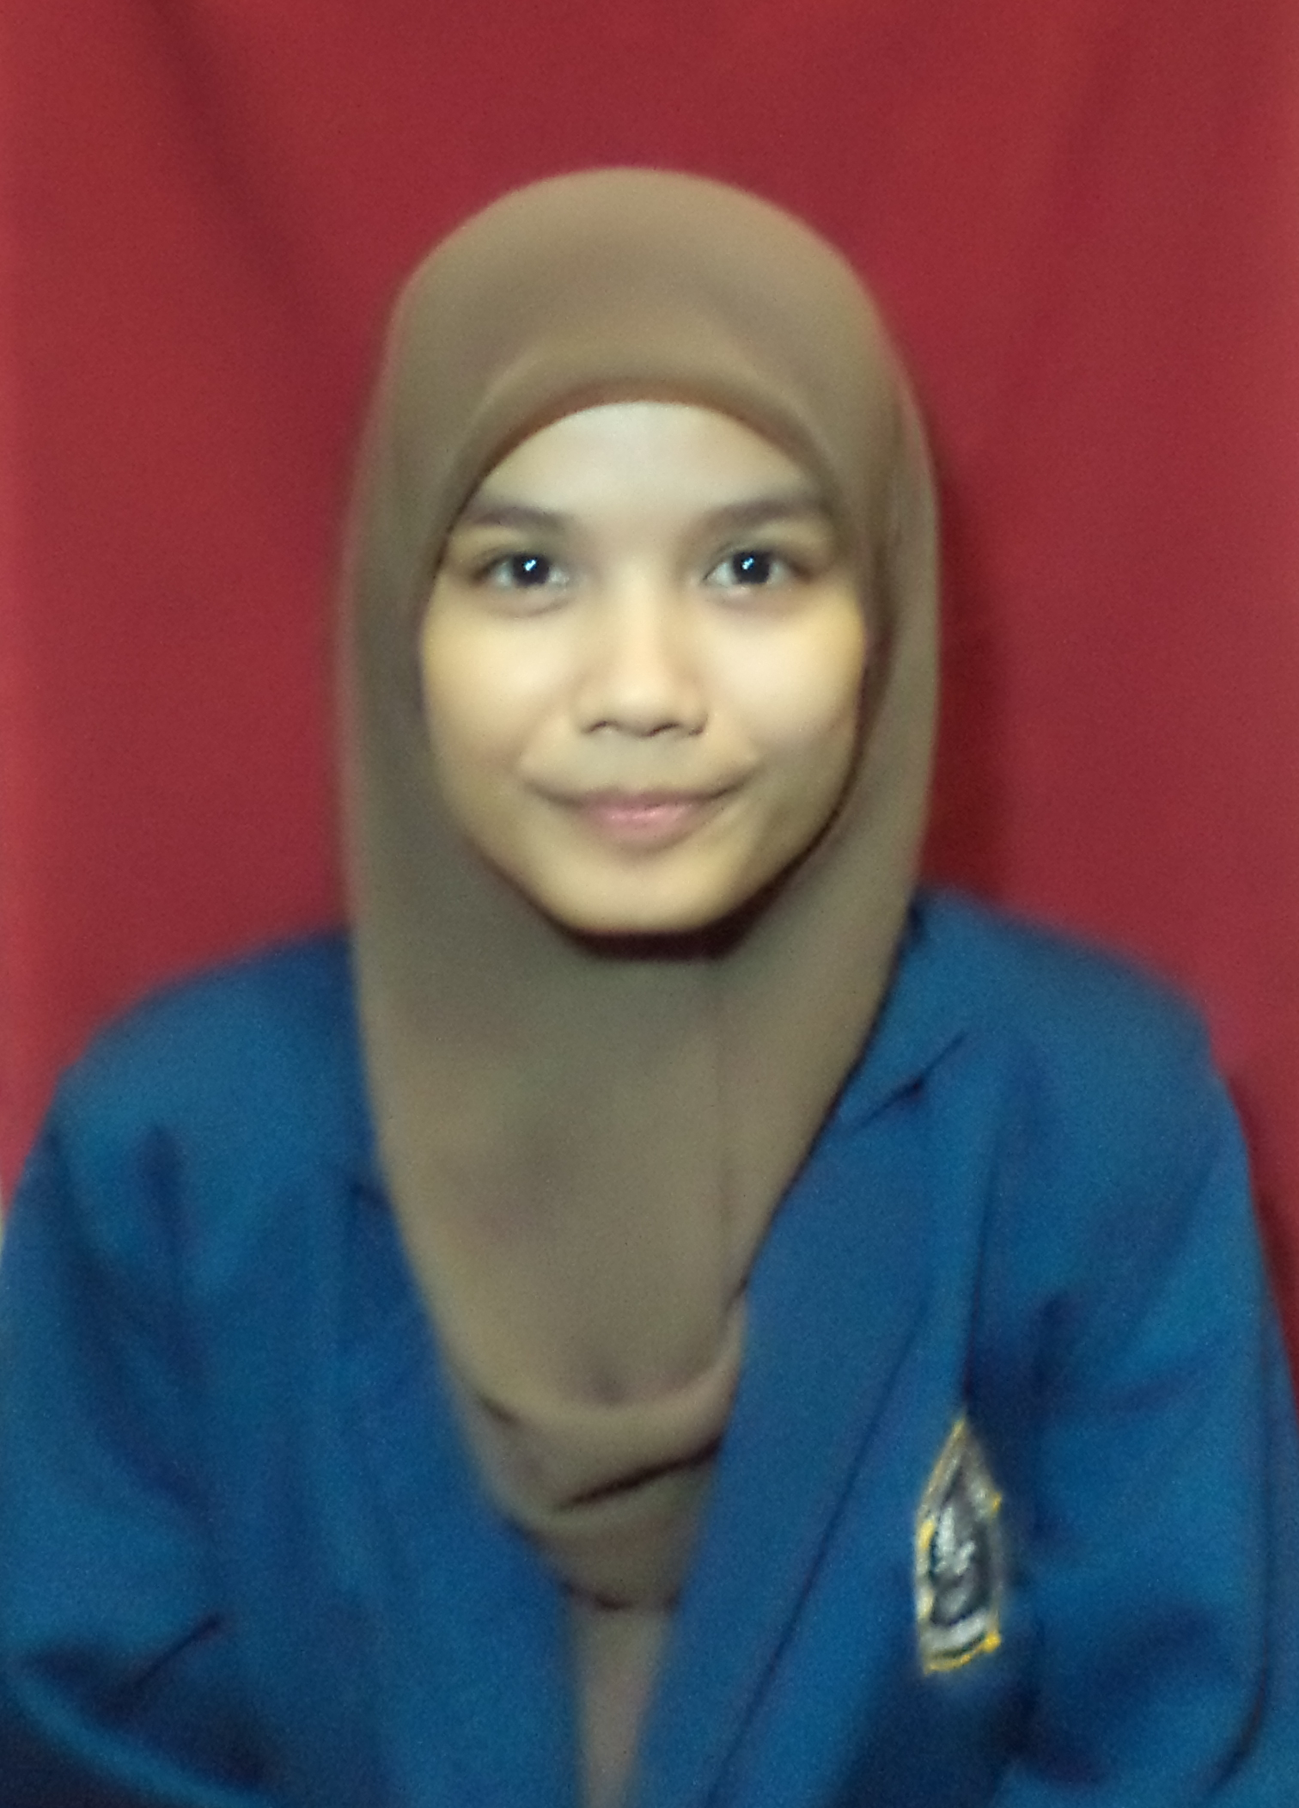
C U R R I C U L U M V I T A E
Biodata

Name : FADILATUN MUHARRAM
Address : Jalan Dasa Darma Raya No 31, Rawa Lumbu, Bekasi 17115
E-mail Address : dilaharra@gmail.com
Birth of date : Jakarta, July 18th, 1992
Gender : Female
Marital : Single
Phone No. : 0856-9725-1682
Nationality : Indonesian
Religion : Moeslem
Hobbies : Reading, Travelling, and Writing.
Interest : Digital Marketing, Books, Music, and Outdoor Activity.

Education Background

Academic : Diponegoro University (2010 - 2014)
Strata I (Bachelor)
Concentration : English Department
GPA 3.15 of 4 scale

Senior High School : SMA Pusaka Nusantara 2, Bekasi (2007-2010)

Junior High School : SMP IT TASHFIA, Bekasi (2004-2007)

Summary of Qualification

Language : Mother Tongue : Indonesian
Other : English. Listening(7) Speaking (7) Writing (8)

Digital Marketing : SEO (8), SEM (7), Keyword Planner (8), Google Analytic (8)
Strengths : With my ability that I have, I’m willing to give all my ability for the
good of the company. I am a responsible, willing to learn and able to work in team or individual. I’m a believer. I believe there are different ways to accomplish something problem. I’m not afraid to try new things because fault is the best teacher for me.

Course

2008 – 2010 : English Course at LIA (Basic 1 – Upper Intermediate 4)

2014 : English Course at ASPAC

Organization Experience

2011 – 2013 : EDSA, Diponegoro University
Secretary
2011 – 2012 : Matrapala, Diponegoro University
Public Relation
2012 – 2013 : Matrapala, Diponegoro University
Lead of Environment Division

2007 – 2010 : KPSN Nusantara, Pusaka Nusantara Senior High School
Leader

Working Experience
November 2012 – October 2014 : PT. Imelda Kartikasari, Tembalang, Semarang
Announcer

January 2015 : PT. Think Digital
Content Writer & SEO

Colege Project
2011 : Sharing and Planting at Simpang Lima Semarang
Share 250 seeds in Simpang Lima and Plant in Campus,
Tembalang

