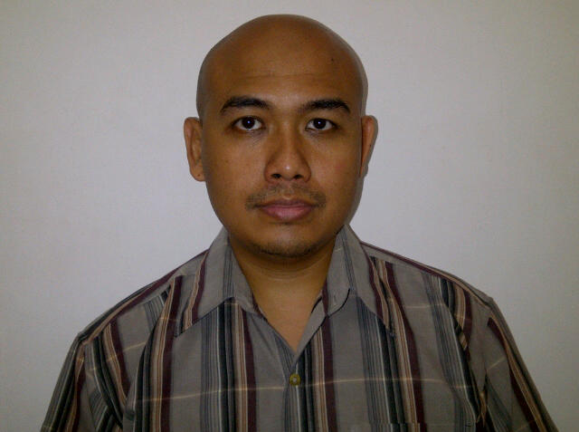

AREAS OF EXPERTISE

Test Management which comprises of software test analysis and hardware (IT Infrastructure) analysis
IT management
Managing crisis situations
Resource vendor management
Project Delivery
Integration
Application development
Experience in IT Research and Development (R&D) abroad

PROFESSIONAL

CCNA (Cisco Certified Network Associate)
Brainbench UNIX Administrator
Microsoft 2000 Professional and Server

PERSONAL DETAILS

Full Name: Doni Andri Cahyono
Address: Perumnas I, JL. Papandayan Raya no. 55, Tangerang, Banten, Indonesia

Place, Date of Birth: Sidoarjo, 02 September, 1978
Cell Phone: +6281249652118
E-mail: doni.andricahyono@gmail.com
Nationality and Citizenship: Indonesia

PERSONAL SKILLS

Decision making
People skills
Leadership skills

LANGUAGE PROFICIENCY

Bahasa Indonesia (Mother Tongue)
English (Advance Level)
German (Fair Level)

ACADEMIC QUALIFICATIONS

- Bachelor of Engineering (ST) Electrical Engineering study program: Telecommunication
Bandung Institute of Technology (ITB), Indonesia 1997-2002

- Master of Science Computer Engineering (until final year, unaccomplished for family reason)
University of Duisburg Essen, Germany

PERSONAL SUMMARY

A multi-skilled IT leader with good all-round supervisory and technical expertise with international experience and cross sector exposure. Good strategic appreciation and vision, able to build and implement sophisticated plans with a proven track record explicitly supporting business needs. Very capable with a proven ability to ensure the smooth running of ICT systems and to provide IT services that will improve the efficiency and performance of a company. Extensive practical knowledge of complex systems builds, hardware and software testing, software testing automation development, application development, network system administrator and system engineer.

WORK EXPERIENCE

- Telecommunications Solution Provider Telogic Pte Ltd Headquarter: Singapore
SOFTWARE ENGINEER October, 2012 - Present

Duties :

- Strengthening the IT infrastructure through to implementing new technologies.
- Responsible for hardware and software installation and maintenance.
- Developing & maintaining the company IT systems, software and databases.
- Recommending and implementing improvements and efficiencies.
- Reporting to the IT Director and Superior.
- Having excellent time management, confidentiality & communication skills.
- Management of server software (Unix/Linux environment) and associated backup routines.
- To evaluate, test, advise, and support I.T. related projects.
- Developing software application with particular languages with (but not limited to) Java, JSP/JSTL, and Java Script (JQuery and JSON).
- Writing documentation for ICT manuals and user acceptance test (UAT).

Clients :
- M1 - Singapore
- AIS - Thailand
- Robi - Bangladesh

- IT Solution Provider PT Samz Solution Headquarter: Jakarta
QA TEAM LEADER May, 2011 – October, 2012 Placement: PT. Telekomunikasi Selular (TELKOMSEL)

Duties:
- Manage a QA team of over 15 test executors and test analysts.
- Analyze test case and test scenarios as well as enhance them.
- Developing new test cases and test scenarios to new software products
- Manage a team for middleware (ESB-SOA) application testing
- Improving quality of standard of testing with extensible testing for (but not limited to) load test, soak test, integration test, system integration test, unit test, user acceptance test, pre-acceptance test, boundary value analysis, dynamic test, static test, stress test, and security test. An outstanding performance on TERADATA data center bug test.
- Developing auxiliary automation script in PERL.

Client:
- PT. Telekomunikasi Selular (TELKOMSEL)

- IT Trainer Telematics Research Group (TRG) Headquarter: Bandung
2000 – 2002

Duties:
- Prepare training documents and give training to several state-owned telecommunication companies.
- Research and Development on several IT related stuffs.

Clients:
- PT. Telekomunikasi Indonesia, Tbk Divisi Regional I
- PT. Telekomunikas Indonesia, Tbk Divisi Regional III
- PT. Telekomunikasi Indonesia, Tbk Divisi Regional VI
- PT. Lintas Artha (c/q BPPT)

INTERNATIONAL ENVIRONMENTAL EXPERIENCE

- Telogic Pte Ltd (2012-Current) as a Software Engineer.
- Nokia GmbH, R&D Business Unit (2005-2006), Düsseldorf, Germany as a Corba Script Developer for AXC (ATM Cross Connect) automation testing software kit.
- PT Motorola Indonesia (2003) as a Cellular Field Engineer (CFE) Coordinator.

KEY SKILLS AND COMPETENCIES

Extensive knowledge of: Microsoft Windows Server 2000, 2003, Microsoft Office (Word, Excel, PowerPoint), OpenOffice, Unix (FreeBSD), Linux (Ubuntu, Knoppix, CentOS), wired and wireless networking skills, desktop and server hardware and antivirus and remote support products, C,C++, Java, JSP/JSTL, Java Script (JSON, JQuery), PHP, gateway/router system administrator, dns administrator, database administrator, BIND, QMail, SendMail, MySQL, Oracle, ClearCase, SVN, Linux KVM

ORGANIZATION EXPERIENCE

Member of Electrical Engineering Students Body of ITB (HME-ITB)
Head of Computer Division of HME-ITB
Technical Director of Ganesha TV (GTV) of ITB (Campus TV)
Member of Amateur Radio Club (ARC) of ITB

REFERENCES

Available on request

