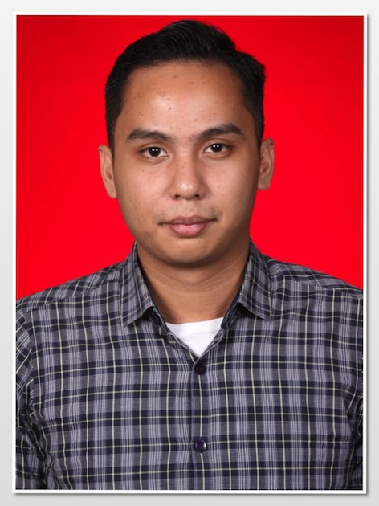

( KOM)

Garyanes Wahyu
Jl.Kipas Angin II Perumahan Lembah Hijau Blok C23
No.8 RT 03/ RW 13
Mekarsari, Cimanggis, Depok
Mobile Phone : 08118814999
Email : garyanes.wahyu@gmail.com

Dear Sir/Madam,
My name is Garyanes Wahyu, I’m finished my study in The London School of Public Relations with major Marketing Communication as my education on 2013. I am cooperative to work both as individual or with team, interest to know people in personality.
I feel sure that I can give you complete satisfaction and loyal service to this company. Along with this letter, I give you my curriculum vitae as my further information.
I highly appreciate if you could consider invite me for the interview at anytime at your convenience. Thank you for your kindly attention.

Yours Faitfully,

( Garyanes Wahyu )

CURICULLUM VITAE

PERSONAL DATA
Date of Birth : December 19 1989 Age : 24 years old
Place of Birth : Jakarta
Civil Status : Single
Religion : Protestan

EDUCATIONAL BACKGROUND
2007- 2013 The London School of Public Relations Jakarta
Majoring in Marketing Communication
Latest GPA 2.40 (range of 4,00)
2004-2007 SMA N 4 Jakarta

COURSES
2006-2007 English Course in LIA Jakarta

Language Skills
- English : Both in written and spoken

Special Trainings : June 2009
- Seminar on “Public Relations VS Entrepreneur Talk Show “ in STIKOM LSPR – Jakarta
January 2009
- Seminar on “The Power of Power of PR in Crisis Management “ in STIKOM LSPR – Jakarta
October 2010
- Seminar on “ Presentation Skills Techniques”
June - August 2012
- Double Deer Audio Digital Production Course
April 2013
- KAPPA Software Course
Work Experience :
2009 – 2012 Worked at 303 Event Organizer as Project Manager & Talent Cordinator
2010 – Have been working in Jakarta Future Exchannge as Trader for 8 months
2010 till now – Part Time DJ
2012 – Have been working in PT ENCO KARYA INDONESIA as Human Resource Departement For 4
months
2012 – event planner for departemen kesehatan campaign for HIV/AIDS
2013- january till april intership at PT Ananda Bintang Trans as marketing
2014- Desember 2013 till June 2014 PT WELACO INDONESIA (Oil & Gas MANUFACTURE) as
Business Development
Computer Skills

Excellent : MSWord and Power Point
Good : MS Excel
Good : Adobe Photoshop

Interest

Writing,Communication, Human Resource, Youth Activities, and Culture Learning, Urban Lifestyle,Digital Music

