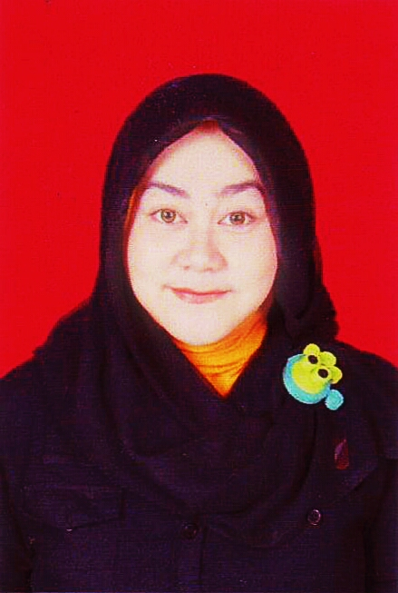
Tiara Kusuma Wardani  (Tiara) |  | Jl. Cendana III,L1 No.37. Komp.Duta Indah, Pondok Gede, Jatimakmur, Bekasi 17413
 |  | Phone: 081289616406 - 0218465018
Date & Birth:  Manado, July 20th, 1987 | E-mail :  jengtiara@gmail.com  tkw87@yahoo.co.id  Twitter :  @jengtiaraaa |  | Nationality: Indonesian  Marital Status:  Married

FORMAL EDUCATIONAL BACKGROUND

SDN Duta Indah , Pondok Gede 1993 -1999
Primary school

SLTP PUTRA I ,Jakarta 1999 - 2002
Junior High School

SMUN 113, Jakarta 2002 – 2005
Senior High School, Majoroing in Social Science

Communication Faculty, University Of Sahid 2005 – 2010
Student of Communication Faculty, majoring Journalist (GPA 3.25 scale 4)

WORKING EXPERIENCES

Regional Coordinator Feb 2009 – Ags 2012
PT. Cipta TPI
Responsibilities:
- Editor Contributors Script
- Counting salary, for contributors every months
- Create Payroll Report
- Records for the incoming new headline
- Wait a visual image for the news will be on air
- Counting and make report of payment
- Choose to broadcast news worthy

Creative Ags 2012 – Ags 2013
PT. Cakrawala Andalas Televisi
- Making a program content
- Provide new ideas for content
- Looking for a good talent
- Improving existing programs
Program I've ever made:
- PPI (Putri Pariwisata Indonesia)
- MELS UPDATE (Regular)
- Aku Bisa Sembuh (Regular)
- Jakarta ‘WOW’ 2013 – New Year Eve
- 70th Bakrie “Karya Anak Negeri”
- Viva La Vida ANTV
- LLM (Love Life Music) SIMPLE PLAN (Regular and Specialis)
- Campur – Campur ANTV

Guest Relation (Public Relation Staff) Sep 2013 – Now
PT. Berita Satu News Channel
- Planning, developing and implementing PR strategies
- Liaising with colleagues and key spokes people
- Liaising with and answering enquiries from media, individuals and other organisations, often via telephone and email
- Researching, writing and distributing press releases to targeted media
- Collating and analysing media coverage
- Writing and editing, case studies, speeches, articles and annual reports;
- Preparing and supervising the production of publicity brochures, handouts, direct mail leaflets, promotional videos, photographs, films and multimedia programmes
- Sourcing and managing speaking and sponsorship opportunities and also make a dealing for advertising in television
- Commissioning market research
- Managing the PR aspect of a potential crisis situation
- Arrange the schedule for agenda tv shows
- Making relation with sources

ORGANIZATIONAL EXPERIENCES

Member of Himpunan Mahasiswa Jurnalistik (HMJ) Universitas Sahid 2005 - 2009
as development interests and creativity
Member of Badan Eksekutif Mahasiswa Universitas Sahid. 2006 - 2008
Member of OSIS SMU 113 , Jakarta Timur as Sport division and Creative division. 2003 - 2005
Member of Karang Taruna RT 10/ RW 15 Perum Duta Indah, Pondok Gede. 2000 - 2009

SKILL AND ABILITY

Field Of Interest | Description
Language : | Good understanding in English, both oral and written.
Full capability : | - MS Office 2003, 2007 (MS Word, MS Excel, MS PowerPoint)  - Internet Application (Internet Explorer, MS Outlook)  - Microsoft Access  - Social Media
Personality : | - Able to work effectively individual & teamwork  - Comunicative  - Confident  - Good analitical thinking  - Fast Learner  - Commitment  - Highly–motivated person  - Eager to learn  - Optimistic  - Positive Thinking  - Sociable and Friendly
Hobbies | - Travelling  - Reading  - Cooking  - Socialing  - Watching  - Window Shopping  - Photography

Additional Information
Expected Salary : Rp. 8.000.000 (Negotiable)

Current Salary : Rp. 6.000.000

Availability : 1 Month Notice

Nationality : Indonesia

Tiara Kusuma Wardani
Alamat : Komp. Duta Indah, Jl.Cendana 3 Blok L1 no.37
Pondok Gede, Bekasi
E-mail : jengtiara@gmail.com
Contact number : 081289616406/0218465018

Dear Sir or Madam,

My name Tiara Kusuma Wardani, S.I.Kom and i’m 27 years old. I am graduated of Sarjana (S-1) of Universitas Sahid Majoring in Journalism. My GPA is 3.25 (Scale 4.00).
Base on information I received, i want to apply my CV and application letter to be employee in your company. I’ve been working in Media, and for sure i have a lots of connections out there. And now i'm still working at Berita Satu TV as a Guest Relation Officer. I am hard working punctual and reliable with a great sense responsibility. I am a quick learner and I love to learn very well. I can adapt any job requirement that may be expected of me and I can work with team.
I believe that my skills would be a valuable asset to your company. I appreciate your time and look forward to your positive response for your consideration.
Thank you for your attention and I hope that I can take this opportunity for a better mutual relationship in the future. Thank you.
Sincerely,
Tiara Kusuma Wardani , S.I.Kom

