Personal information
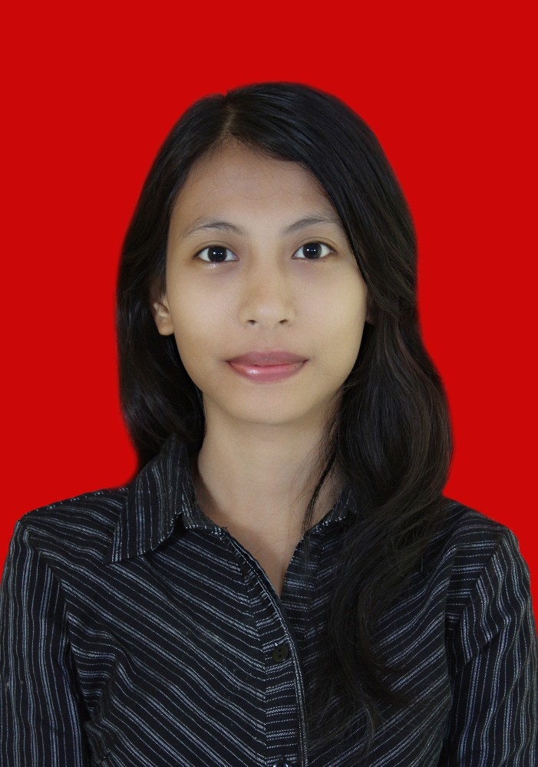 |  | Juwita March Astuti, S.Hum  Russian Studies, Universitas Indonesia, GPA: 3.79,  Bachelor of Art, Cum Laude, 2nd highest GPA in Faculty of Humanity
 |  | Taman Narogong Indah, JL Anggrek Blok D 94 No 2, Bekasi Timur, 17115
 |  | (+62) 857 1093 3206
 |  | juwita.march@gmail.com
10 Mar 1991
Female
Work/ Organisational experience |  | - CV. Desembris Cipta Media, Depok (November 2014 - Now)  Founder, Editor in Chief  - Starting up business in publishing book  - Selected manuscript that suitable to publis in Ruchkabooks  - Proofreading and editing manuscripts  - Created ideas and theme for our website and social media accounts suitable with our vision alongside with director and creative team  - Astra International Tbk. Daihatsu, Sunter & Karawang (June 2014-January 2015)  Administrator  - Managed STNK & BPKB for customers  - Arranged invoice for BBN  - Managed new stock units for Branch  - Arranged documents for BPKB and STNK purposes  - Slavic Festival 2013, Universitas Indonesia (8-9 Oct 2013)  Fund Raising Committee  - Raised capital fund for the event  - Public Seminar Republic of Belarus, Universitas Indonesia (May 2012)  Secretary  - Filed and Archieved documents related to the event  - Booked and arranged venue for seminar  - Arranged Invitations for honorary guests, e.g: Dean of University, Dean of Faculty, and Republic of Belarus Ambassador
Education and training  Personal Skills  Language  English  Russian  Computer Skill  Aditional Information |  | - Leadership Training (Sep 2012 - January 2014)  Yayasan International Goodwill Scholarship  - Provided several softskill materials related to self-improvements such as time management, mind management, public speaking, presentation skill, negotiation, marketing and so on.  - Good command of Office Suite (Word processor, spread sheet, presentation software)  - Good command using mind-mapping software (mind-jet software)  - Good command using CAT Tools Translation (Omega Translation)  Publication  - ‘Sastra Rusia, tak Sekedar Tulisan’. (2011) Nadezhda e-Magazine  - ‘Perayaan Martinje di Kroasia’. (2011) Nadezhda e-Magazine  - Several short stories in teen magazines (2008-2012)
  Understanding |  | Speaking |  | Writing
  Listening | Reading | Spoken Interaction | Spoken Production | Writing
  Good | Good | Good | Good | Good
  Fair | Good | Fair | Fair | Good

