CURRICULUM VITAE
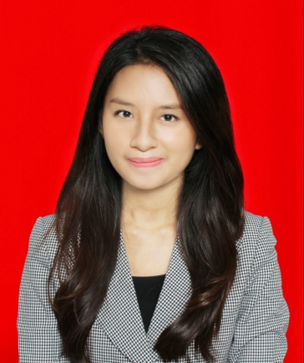

Personal Details
Full Name : Like Chairunnisa Utami
Place, Date of birth : Jakarta, 07th June 1993
Address : Villa Bintaro Regency, Jl.Bangka blok H2/8 Tangerang Selatan –
Banten 15226 Indonesia
Sex : Female
Religion : Moeslem
Marital Status : Single
Height / Weight : 165 cm / 45 kg
Phone Number : (021)-7452280 – 081280268461 - 081381378810
Email : like_chairunnisa@yahoo.com
Nationality : Indonesia

Formal Education
- SD Islam Al – Mubarak Tangerang Selatan 1999-2005
- SMP Islam Harapan Ibu Jakarta 2005-2008
- SMA Islam Harapan Ibu Jakarta 2008-2011
- Binus University Jakarta 2011-2015

Informal Education
- Kursus bahasa inggris LIA 2004-2008
- Seminar International Media Converge oleh Binus University 2012
- Seminar karir di dunia iklan oleh Binus University 2013

Professional Certification

- Yoga Septa Professional Makeup Artist Course 2015

Working Experience (Internship)

- PT Arwuda Indonesia as Community Manager February – March 2015

Part-time Experience
- Usher Launching Jungleland High Park Sentul, Jawa Barat 2011
- Usher HUT PERTAMINA ke 56 Ancol, Jakarta 2011
- Usher SHARP koten Senayan City, Jakarta 2012
- Usher Happy Holiday Jiexpo Kemayoran, Jakarta 2013
- Usher Hari Tata Ruang Nasional Kementrian PU Taman Menteng, Jakarta 2013

Organization Experience
- Bendahara OSIS SMP Islam Harapan Ibu Jakarta 2007-2008

Non-academic Achievement
- Semifinalis Gadis Sampul 2008
- Unggulan Gadis Sampul 2009

Language Skill
- Indonesia
- English (Listening, Speaking & Writing)

Computer Skill
- Microsoft Office
- Microsoft Excel
- Microsoft Power Point
- Microsoft Word
- Email, Internet, Website, Blog

Interest
- Music
- Movie
- Makeup & Art
- Fashion
- Travelling
- Cooking
- Book
- Hiking
- Photography

Soft Skills
- Teamwork skills
- Creative
- Good Communication
- Quick learner
- Adaptability
- Positive Attitude
- Organize
- Confident

