Curriculum Vitae (CV)

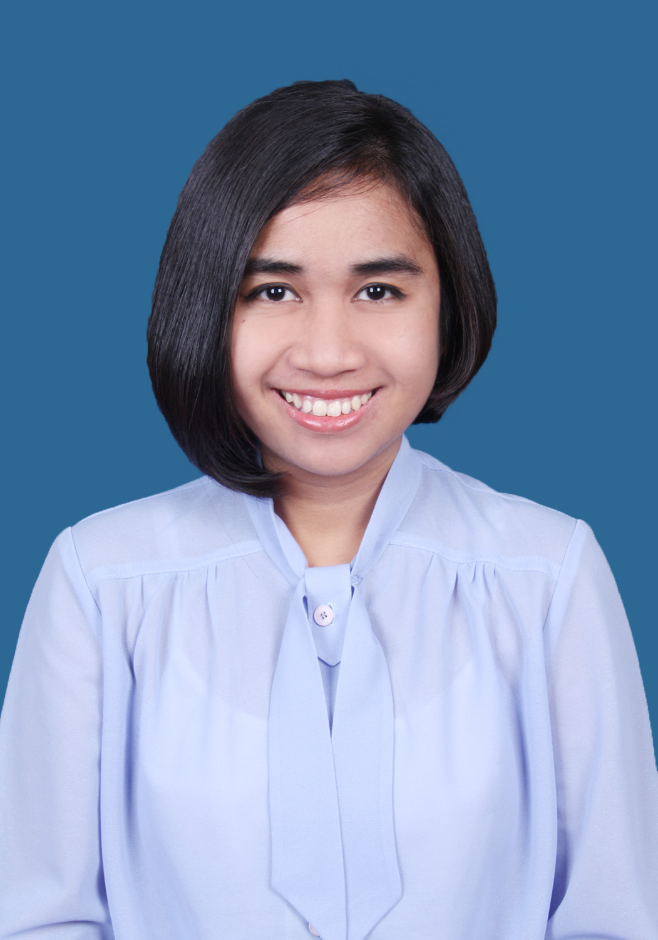

- Personal Data

Name : Bernadette Wahyu Kristianti Larasati
Nick Name : Laras
Sex : Female
Place, date of birth : Jakarta, 04 November 1988
Religion : Catholic
Marital Status : Single
Citizen : Indonesia
Address : Komplek Bukit Pamulang Indah A1/11. Pamulang 15417
Email address : namakuularas@gmail.com
Mobile number : 0817 6600 322
Interest : Music, dancing , architecture & interior, travelling

- Education Background

FORMAL

- 2007 – 2012 : Architecture Department, Faculty of Civil Engineering and Planning, Trisakti University, Jakarta
- 2004 - 2007 : SMAN 46 Jakarta
- 2001 - 2004 : SLTPK Mater Dei, Pamulang
- 1995 - 2001 : SDK Mater Dei, Pamulang

INFORMAL

- 2010 – 2012 : Gigi Art of Dance (Traditional Dance)
- 1995 – 2006 : Yamaha Music School ( Piano & Organ)
- 2004 – 2005 : ILP (English Course)

- Qualification

SOFTWARE DESIGN
- AutoCAD
- Sketch Up & Vray
- Adobe Photoshop

COMPUTER LITERACY
- Microsoft Office Word
- Microsoft Office Power Point
- Microsoft Office Excel

- Organization Experience

- 2012 : Volunteer at LIVAS, International Architecture Seminar, Architecture Department, Faculty of Civil Engineering and Planning, Trisakti University
- 2011 : Committee of Metamorfosa Arsitektur 2011
- 2010 – 2011 : Public Relation of Himpunan Mahasiswa Arsitektur Adhisthana, Architecture Department, Faculty of Civil Engineering and Planning, Trisakti University
- 2009 – 2010 : Leader of Kajian Studi Ilmiah (KSI), Department Architecture, Trisakti University
- 2009 : Volunteer at Jakarta Architecture Trienale (JAT)
- 2009 : Public Relation of Adhisthana Cup committee
- 2008 – 2009 : Member of Badan Eksekutif Mahasiswa (BEM)

- Working Experience

- 2015-2016 : Account Executive at PT Jakarta Interactive
- 2015 : Crew for United Live Jakarta 2015
- 2013 - 2015 : Project Coordinator at PT Hint Inti Tetra
- 2012 - 2013 : Junior Lighting Designer at PT Kreasi Mustika
- 2011 : Internship as Junior Architect at PT Kenchiku Imaji Design
- 2010 : Job Training at PT Tiara Metropolitan Jaya for Central Park Ballroom Project

