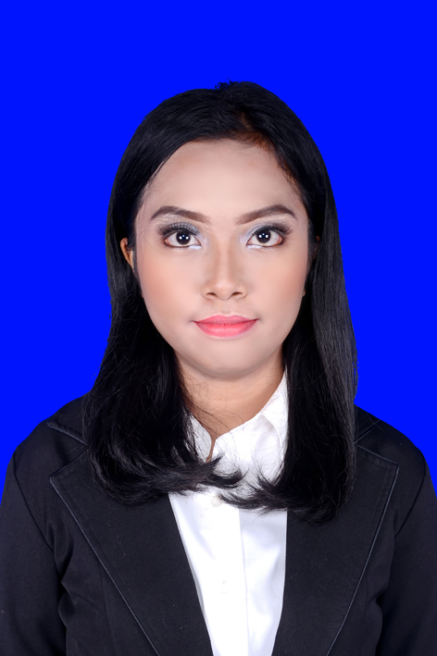

Personal information

Name |  | Neltji Steffany Noya
Address |  | Sampan ID No. 25 Kelapa Dua, Tangerang 15810
Telephone |  | -
Fax |  | -
E-mail |  | noyasteffany@gmail.com
Nationality |  | Indonesia
Date of birth |  | 15th July, 1993

Work experience

• Dates (from – to) |  | 1 July – 31 July, 2015
• Name and address of employer |  | pt taman wisata candi BOROBUDUR, PRAMBANAN & RATU BOKO (UNIT BOROBUDUR)
• Type of business or sector |  | Tourism
• Occupation or position held |  | Internship – Customer Service
• Main activities and responsibilities |  | Welcoming international and local tourist, explaining about Museum Borobudur and Museum Kapal to the tourists.

Educational Background

Formal Education Universitas Brawijaya
Bachelor Degree of Arts
Majoring English Literature
GPA: 3.68/4.00

Training and Workshop

• Dates (from – to) |  | 17th May, 2014
• Name and type of organization providing education and training |  | Workshop English for Future “Speak Up Your Mind and Write Down Your Feeling”  held by English Student Association
• Principal subjects/occupational  skills covered |  | Competent in public speaking skills: discussing in a group, giving speech, using good language.  Competent in writing skills: poem, short story.
• Title of qualification awarded |  | Participant
• Dates (from – to) |  | 25th April, 2015
• Name and type of organization providing education and training |  | Training Organization and Public Speaking  held by Kementerian PSDM BEM FIB Universitas Brawijaya 2015
• Principal subjects/occupational  skills covered |  | Competent in organization skills: leading and managing people, communicating with the staff of faculty, communicating with vice dean and dean, managing deadlines.  Competent in public speaking skills: discussing in a group, giving speech, using good language
• Title of qualification awarded |  | Participant
• Dates (from – to) |  | 20th May, 2016
• Name and type of organization providing education and training |  | Microsoft Desktop Application  held by Trust Training Application
• Principal subjects/occupational  skills covered |  | Competent in Microsoft Office Programs: Ms. Word, Ms.Excel and Ms. Power Point
• Title of qualification awarded |  | Participant
• Level in national classification |  | -
Seminary
• Dates (from – to) |  | 4th April, 2014
• Name and type of organization providing education and training |  | Peluang Pengembangan Karir di Kementerian Luar Negeri  held by Job Placement Center Universitas Brawijaya
• Principal subjects/occupational  skills covered |  | Understanding the career development in Kementerian Luar Negeri
• Title of qualification awarded |  | Participant
• Level in national classification  Competition |  | -  3rd Place English Debate Competition in Olimpiade Brawijaya 2013

Personal skills
and competences

- Good self-managing
- Good leadership
- Working in team
- Debating

Mother tongue |  | Bahasa Indonesia

Other languages

 |  | English
• Reading skills |  | Excellent
• Writing skills |  | Excellent
• Verbal skills |  | Excellent

Social skills  and competences |  | Teaching Sunday School (3.5 years)  - Working in multicultural environment  - Working In position where communication is important and situations where teamwork is essential  - Dealing with discipline and deadlines.  - Making schedule for all the teachers.  Social Media Admin in Youth Group of local church (3.5 years)  - Working in multicultural environment  - Working In position where communication is important and situations where teamwork is essential  - Managing time schedule of posting in social media (Twitter and Instagram)  - Dealing with discipline and deadlines

Organizational and Committee Experiences |  | - English Student Competition 2012 – Liaison Officer  - English Student Competition 2013 – Liaison Officer  - Java Overland Intervarsities English Debate 2013 – Liaison Officer  - English Performance Competition 2014 - Secretary  - English Student Competition 2014 – Convenor  - Persatuan Mahasiswa Kristen Fakultas Ilmu Budaya 2014-2015 – Ketua Koordinator Komis 1  - English Student Association 2015 – Chief Executive

Technical skills  and competences |  | - Competent with Microsoft Office programs  - Competent with social media, blog, HTML, JavaScript

Other skills  and competences  . |  | - Writing in personal blog occasionally

Additional information |  | Contact Person:  Neltji Steffany Noya  0821-4438-1957

