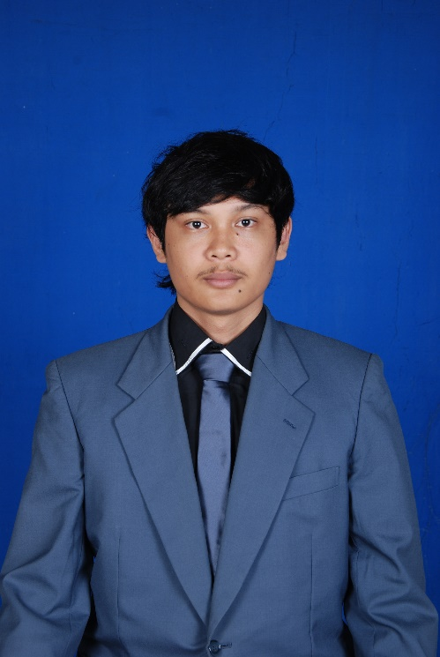 | Jln.Pintu Air Gang Andalas No.48 Simpang Limun
 | Medan 20219
 | Jln. Sayang Ciawi Jatinangor, Pondok joko tarub
 | Phone : 081222730503
 | Email : oyitzhak@ymail.com / oyitzhak12@gmail.com
CURRICULUM VITAE
Yitzhak Nazareth Hutapea, S.P.

Place/DOB | Balikpapan, Dec 28th 1992
Sex | Male
Age | 22 Years Old
Marital Status | Single
Health  Religion | Excellent  Christian
Nationality | Indonesia
GPA | 3,21 of 4,00

Education Background | 2010 – 2014 Agrotechnology, Faculty of Agriculture, Padjadjaran University, Bandung , West Java  2007 – 2010 SMA Harapan Mandiri, Medan  2004 – 2007 SMP Negeri 3, Medan  1998 – 2004 SD/ST Antonius VI, Medan  1997 – 1998 TK Maria Mutiara, Sibolga

Organization Background | 2010 – 2011: Founder of FCBI Jatinangor  2011 – 2012 : Head Division Of FCBI Jatinangor  2011 – 2012 : Staff Of Communication Media Himpunan Mahasiswa Agronomi University Of Padjadjaran  2011 – 2012: Staff Of Jungle and Mountain Division (Perhimpunan Mahasiswa Penempuh Rimba dan Pendaki Gunung MAHATVA)  2013 – 2014 : Head of Jungle and Mountain Division (Perhimpunan Mahasiswa Penempuh Rimba dan Pendaki Gunung MAHATVA)

Training/ Courses | 1999 - 2001 : English Course In MICHIGAN, Jl. Sutomo - Medan  2001 – 2005 : English Course in ESSENTIAL, Jl. SM. Raja - Medan  2006 – 2009 : English Course in ILP (International Language  Programs), JL. SM. Raja - Medan  2011 – 2012 : Verticulture Plant Training, Himpunan Mahasiswa Agronomi University Of Padjadjaran  2013 – 2014 : Training Of Trainer Landscape Photography (Perhimpunan Mahasiswa Penempuh Rimba dan Pendaki Gunung MAHATVA)  2013 – 2014 : Training Of Trainer Pembuatan Artikel dan Publikasi Ilmiah Alam Terbuka (Perhimpunan Mahasiswa Penempuh Rimba dan Pendaki Gunung MAHATVA)

Skills | Able to operate Computer:  - All Microsoft software  - CorelDraw and Adobe Photoshop

Language Skills | - Indonesia  - English

Seminar and Workshop | - Participant In Seminar Agripreneurship At Balai Santika, Unpad 2011  - Participant In Plant Protection Day At Bale Santika, Unpad 2013  - 3. Participant In Seminar Nasional Ilmu Tanah At Bale Sawala Unpad 2013

Committee | - Event Planner For “Pentas Seni” SMA Harapan Mandiri 2007-2009  - 2.Event Planner For Jatinangor Futsal Fans Club Competition 2011  - Event Planner Committee For “Lomba Lintas Lembah Dan Bukit” (Faculty of Agriculture, Unpad) 2011  - Tata Tertib Committee For Penerimaan Anggota Muda (PAM) 2011  - Head Of Keamanan Division For AGROCAMP 2012  - Event Planner For Penerimaan Anggota Muda (PAM) 2012  - Komisi Disiplin Committee For “Masa Bimbingan (MABIM) 2012”  - Operation Commander For Belitung Expedition 2012  - Event Planner For “ Program Latihan dan Pemantapan” PMPR & PG Mahatva University Of Padjadjaran 2013  - Operation Division For “Lomba Lintas Lembah Dan Bukit” (Faculty of Agriculture, Unpad) 2013  - Pre Operation Committee of Seram Safir Expedition 2013  - 13. Head Of Tata Tertib Committee For Penerimaan Anggota Muda (PAM) 2014

Work experience  Event Experience | - Probation warehouse control staff at BULOG DIVRE BALI 2012  - Probation Technician at PT.Terminix Pest control 2012  - Safety, Health and Environment at PT. Satyamitra Surya Perkasa 2014  - Special Brand Ambassador A-Mild Bandung 2014 till now  - Freelance for 18.Comm Event Organizer as creative team and technical event planner  - Safety Officer Djarum Coklat Sangkakala Djiwa 2013  - Communicator and Sharing Person Closing Ceremony L3B 2013  - Communicator and Sharing Person Closing FORSI 2013  - Communicator and Sharing Person Arthuration 2014  - Communicator and Sharing Person Closing Event Agronomy Fair 2014  - Planner Bandung Idea Community Sharing 2015  - Planner BREUK, Vinyl Exhibition 2015  - FOUNDER nepenthes.inc  - Project Leader A Zone ARTNOMALI 2015  - Communicator and Sharing Person , Celebrate 10th Checo Café And Resto 2015  - Project Leader for Exhibition A Zone DIVERSITY 2015  - Project Leader of nepenthes.inc event TON ET L’ART 2015  - Project Leader of A Zone BOUND IN 2015  - Planner of A Zone JOY OF FOLK 2015  - Planner for FASH 2015  - Planner for LOC ART 2015  - Planner for ALIENATION 2015  - Video editor and Videographer for Event  - Owner of YAWN CLUB  - Photographer for YAWNCLUB  - Manager of Putri Indonesia Media Sosial Jawa Barat

Scholarship | 2012-2013 : Program Pengembangan Akademik (PPA)

I declare the details stated to be true and complete
YITZHAK NAZARETH, S.P.

