CURRICULUM VITAE
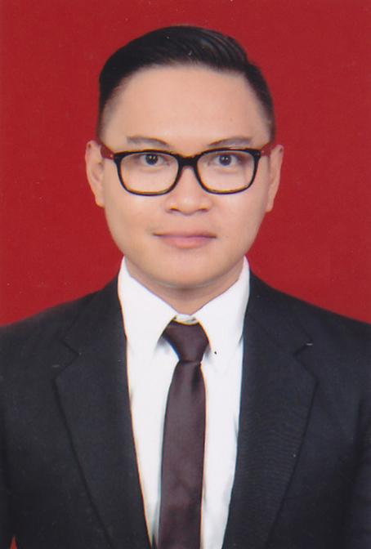

PERSONAL DATA

Name : Pandu Rachman Hakim Setiawan
Address : Jl. Taman Malaka Utara Blok D1 No. 20 RT 011 RW
009 Pondok Kelapa, Jakarta Timur 13460. Indonesia
Contact : 08170053505 & 021 8642649
pandu.hakim@gmail.com
Place / Date of Birth : Jakarta, September 25th 1984
Height / Weight : 171 Cm / 78 Kg
Gender : Male
Marital Status : Single
Nationality : Indonesian

FORMAL EDUCATION

Bina Nusantara University, Jakarta
Management Economic

4 Senior High School, Jakarta

LANGUAGE SKILL

Language | Read | Write | Speak
Bahasa Indonesia | Fluent | Fluent | Fluent
English | Excellent | Excellent | Good

WORKING EXPERIENCES

- Sales Executive at PT. RapidCloud Indonesia.
(Feb 2015 – Present)
- Job Description :
- Responsible for sales in SMB Department
- Work collaboratively with the sales team as well as other business partners in articulating solution to customer
- Be familiar with all of the in house products and able to propose solutions to customers.
- Work with customer to understand their business goals, activities, workflows, and their needs.
- Deliver solution presentation to customers and provide high quality response to customers clarification.
- Prepare quotation, and follow up as business process.
- To support and undertake any other tasks as requested or assigned by the management.
- Developing and managing Digital Marketing campaigns to customer like SEO,SEM, Google Display Network also SMM (Social Media Marketing)

- Micro Finance Sales Officer at PT Bank Mandiri (Persero) Tbk.,
(July 2012 – Feb 2015)
- Job Description :
- Provide advice and solution to our customers on their financial needs.
- Acquire new customers and develop the portfolios & deepen relationship with existing customer.
- Handle micro finance for multi product.

- PT. Surveyor Indonesia
PT. Surveyor Indonesia is a company that the mission was to assist the Government of Republic of Indonesia in expediting the flow of capital goods and equipment from all over the world to Indonesia, to the world class standard Pre-Shipment Inspection.

- Operational Staff (August 2010 – May 2012)
- Job Description :
- Joined the project management has been prepared by head management.
- To assist the head management to operate the project.
- Status as contract employee

- Quality Control (September - December 2010)
Working Area : Bali and Surabaya
- Job Description :
- To do quality control questionnaire survey field surveyor (Project of Ministry of Trade of Republic of Indonesia).
- To do quality control of data.
- Report the individual survey results.

- Human Resources Departement (August - December 2011)
- Job Description :
- Identify staff vacancies and recruit, interview and select applicants.
- Perform difficult staffing duties, including dealing with understaffing, refereeing disputes, firing employees, and administering disciplinary procedures.
- Manages the employees safety, welfare, wellness and health.
- Make a contract for project management employees.
- Pay the salary and overtime project employees.

- Marketing of Administration in PT. FIF (Federal International Finance)
(April - August 2010)
PT. Federal International Finance a subsidiary of PT Astra International, the company originally engaged in a wide variety of financial services including consumer financing, leasing, and factoring.
Division of : Astra Multifinance (Electronical Finance)
- Job Description :
- Make a classification of dealer.
- Make an output and input report.
- Make a good relationship with dealer.

- Marketing of Administration in PT. SPM Marmer dan Granit
(April 2006 - March 2009)
- Job Description :
- Filling and data updating.
- Searching Client.
- Inventory Controller
- Preparation of purchase requirement and purchase order
- Project's data updating

- English Course at LIA Language Institute - Jakarta

PRACTICAL COURSE AND TRAINING
(2000 - 2001)
- English Course at ILP Language Institute - Jakarta

(2004 - 2004)
- Project Management in Pusat Studi Investasi dan Keuangan (PSIK) at PT. Surveyor Indonesia - Jakarta
(April 2011)
- Training Mikro Kredit Sales Batch 2 at Training Center – Jakarta (6-11 October 2014)

ORGANIZATION ACTIVITY

- Member of “OSIS” Organisasi Intra Sekolah as a Head Division of Sports (2000-2001).
- Member of Softball Club in 4 Senior High School (2000-2002).
- Member of “HIMME” Himpunan Mahasiswa Manajemen Ekonomi Universitas Bina Nusantara (2003-2007).

HOBBIES AND INTERESTS

Travelling,Gym,Browsing

SOFTWARE SKILL

- Microsoft Office, Visio and Windows application

