CURRICULUM VITAE

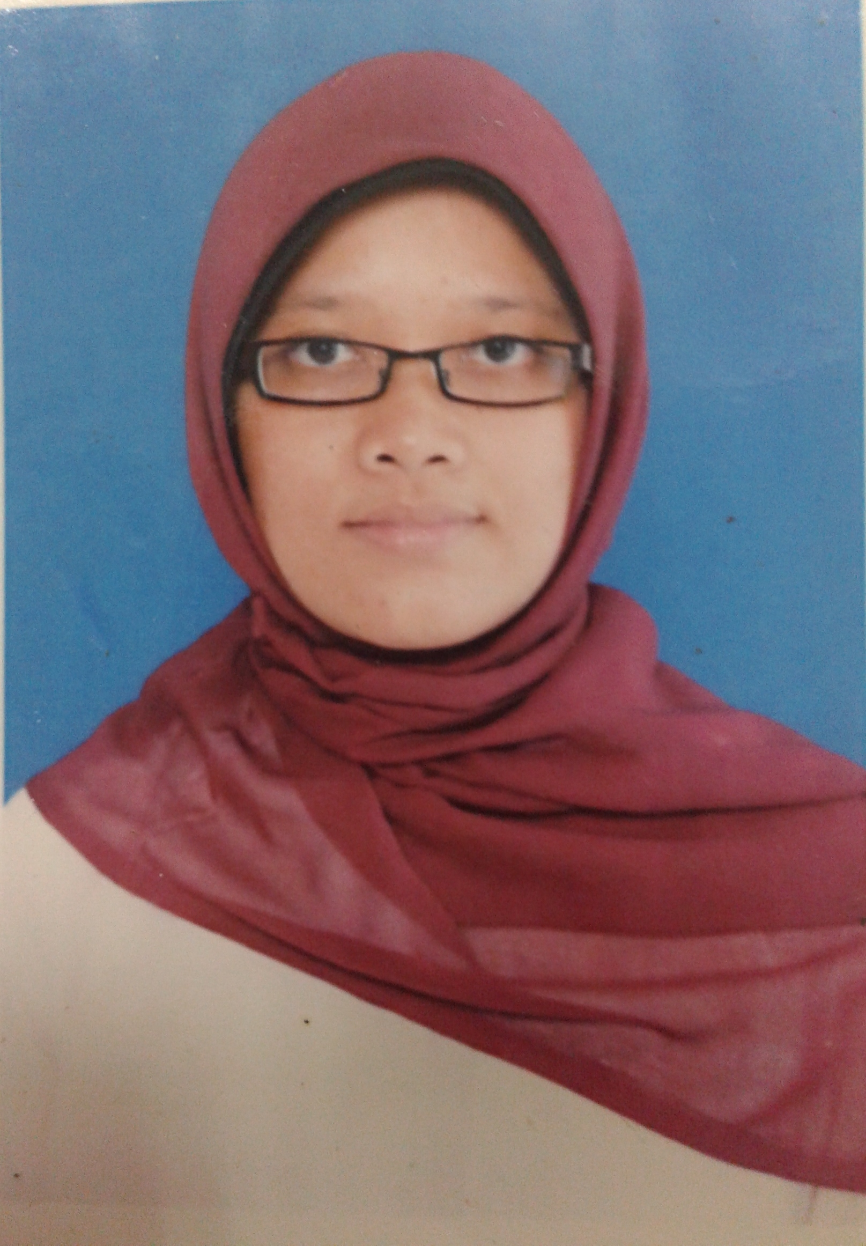
- Personal Data
Full Name : Ristia Nurmalita
Place and Date of Birth : Sleman, May 15th 1989
Nationality : Indonesia
Marital Status : Single
Height / Weight : 158cm, 55kg
Health : Good
Religion : Moslem
Addres : Sermo Rt. 01/Rw.34 Sumberarum
Moyudan Sleman Yogyakarta
55563
Mobile Phone : 081904067450
E-mail : ristialita24@gmail.com

- Educational & Working Background
1994-1995 : ABA Sermo Kindergarten
1995-2001 : Muh Ngijon 2 Elementary School, Moyudan
2001-2004 : State-owened 2 Junior High School, Moyudan
2004-2007 : State-owned 1 Vacational School Godean
2007-2014 : English Education Language Study Program
Sanata Dharma University Yogyakarta
2012-2014 : Working in Ministry of Energy and Mineral Resources
2014-Now : Studying in Sarjanawiyata Tamansiswa University

Sincerely,

Ristia. N

