CURRICULUM VITAE
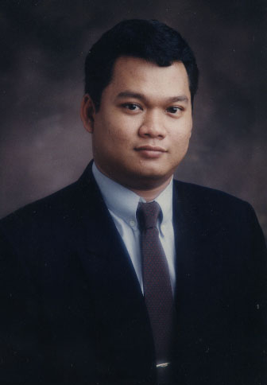
PERSONAL INFORMATION
Name : Sugeng Andrianto ( Andri )
Place, Date of Birth : Jakarta, October 3rd 1974
Gender : Male
Marital status : Maried
Nationality : Indonesia
Residence : Cilandak Tengah II No 3
Jakarta Selatan 12430
Mobile Phone : +62856 790 9933 / +629 2059 119
Email : andry_axis@yahoo.com

EDUCATION
1982-1987 : Elementary School of Yapenka, Jakarta.
1987-1990 : Junior High School of SMPN 12 Wijaya, Jakarta.
1990-1993 : Senior High School of Cenderawasih, Jakarta.
1995-1996 : Maya Gita Institute for Public relations, Diploma.
1996-2001 : Mass Communication, Social and Political Faculty of IISIP Jakarta, majoring Public Relation, Bachelor Degree.

TRAINNING & COURSES EXPERIENCE
2003 : Participants of a month courses that held at the University of Indonesia, Jakarta.
2004 : Paticipants of “Journal of arts”for three months at Jakarta.
PROFESSIONAL EXPERIENCE
The Jakarta Post
March 2011- Present
Senior AE
- Meeting clients to discuss their advertising needs
- Working with account planners to devise a campaign that meets the client's brief and budget
- Presenting campaign ideas and costings to clients
- Briefing the creative team who will produce the adverts
- Negotiating with clients, solving any problems and making sure deadlines are met
- Checking and reporting on the campaign's progress
- Keeping in contact with the client at all stages of the campaign
- Managing the account's budget and invoicing the client
- Making 'pitches' to win new business

Eien Communications
March 2008 - 2010
As Sales & Marketing Manager

- Planning, developing and implementing Sales strategies
- Liaising with colleagues and key spokespeople, liaising with and answering enquiries from clients and, customers, individuals and other organizations.
- Researching, writing and distributing of clients’s product for a media placements.
- Preparing and supervising the production of publicity brochures, handouts, direct mail leaflets, promotional videos, photographs, films and multimedia programs.
- Devising and coordinating photo opportunities.
- Organizing events including press conferences, and exhibitions.
- Maintaining and updating information on the Eien’s website.
- Sourcing and managing speaking and sponsorship opportunities, also commissioning market research.

Bengkel Photo
February 2006 - 2008
As Sales Manager

- Maintain and Grow volume and margins of the company.
- Ensure bussines rate products is maximized.
- Established multi-level relationships with customers and meet regularly to reinforce relationship with the customer.
- Identify and convert sales opportunities into incremental business.
- Prepare correspondence, reports, and materials for publications and presentations.
- Meet with the clients t review their satisfaction with the photo program and to better address their needs.
- Conduct sales presentations that support contract negotiations or the introduction of new products and services.

PT. FEMINA GROUP
January 2001 - September 2005
As Promotion Manager International Licenze Magazine

- Manage the productions of the magazines and do the annual reports.
- Develop and update others publications, including the in house productions of our events leaflet, plus membership and posters.
- Manage the distribution of the magazines publications to reach identified target audiences.
- Develop and implement the publicity and PR strategy for the magazines and devise an annual publicity plan.
- Provide advise and technical input to any campagns, appeals and marketing strategies with the objectives of raising the magazine’s profile.
- Act as first point of contact for all magazines’s dealings with media and press and ensure all magazines activities are publicisied.

PT. INTERNATIONAL DATA NETWORK (CIRCLECOM)
July 2000 - December 2000
As Sales Manager

PT. AXIS FILM
January 1995 - June 2000
As Marketing Manager

