CURRICULUM VITAE

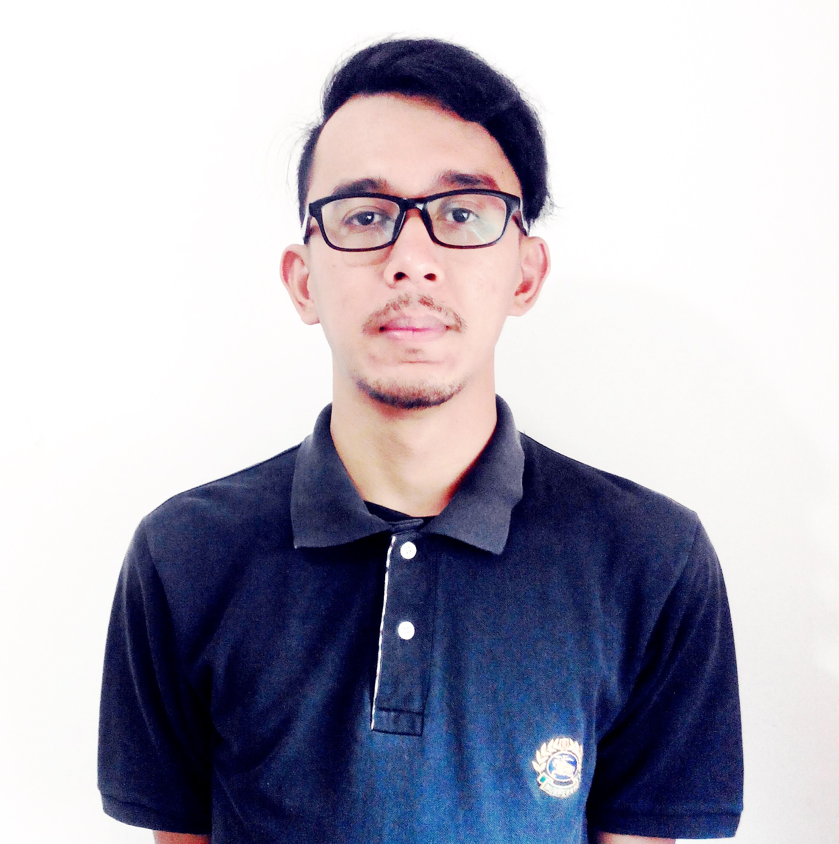
Personal Details
Name : Rommy Arrahman Kawang
Place, date of Birth : Jakarta, 09th of Octber 1988
Sex : Male
Marital Status : Single
Religion : Moslem
Address : Jalan Wadas raya ujung no.16a Rt 05,Rw 03 Jaticempaka,Pondok Gede
Bekasi Indonesia
Phone : +6281315759001
E-mail Address : sundayfolks@gmail.com
Hobbies : Music,Photography, TravellingSocial Media, Broadcasting, Politics, Financial Literacy, Technology, Youth Activity and Community, Film, Digital Marketing, Reading, Writing and Blogging, Social Activity and Charity, News, Global Issues, Entertainment, Education, etc.

Personal Summary
A bright, ambitious, and hardworking
young person and work track record. Possessing a
desire to succeed, target driven,
persuasive, have a curiosity and
willingness to learn about new
things, and big interest to meet a
new people and making relations,travelling jobs

EXPERIENCE
2007-2008 : ( PROJECT OFFICER ) EVENT ORGANIZER -ROOM ON FAMILLY-
2008-2009 : ( PROMOTION ) CV.KAWANG PUTRA
2009- 2010 : ( MANAGER MARKETING ) CV.KAWANG PUTRA
2009-2010 : ( PERSONAL ASSITANT ) PT.TELKOMSEL
2010-2011 : ( COSTUMER SERVICE ) PT.TELKOMSEL
Handling costumer,solve problem,making campaign montly
2011-2012 : ( TEAM LEADER,MARKET SHARE ) PT.TELKOMSEL
Create a program event ,make a campaign for school,briefings with staff school or university,
Responding to audience feedback,managing team sejabodetabek / school or university,
presentations with other company,making plan strategy communication, Supporting the events
for GEO Expansion, Doing inventory planning & merchandising for every event, Doing market & competitor research

2012-2013 : ( PRODUCER ) 99ERS RADIO JAKARTA
Create a show, program content, or campaigns,and manage the whole production process for both live and recorded programs.
Developing content, writing material for scripts, bulletins and links.
Sourcing potential contributors and interviewees.
Producing pre-production briefings for presenters, reporters,technical staff and other contributors.Checking that copyrights are cleared and understanding media law.
Responding to audience and listeners feedback.
2013 -2014 : ( STATION MANAGER,PROGRAM DIRECTOR ) DREAMERSRADIO.COM / PT.Mediaworks Indonesia
Coordinate activities between departments, such as marketing and program.
Ensure the smooth daily operation of college, public,
and commercial radio stations.
Generating and researching ideas for programs and pitching for commissions.
Managing radio planing and maintaining key talent.
Involvement in interviewing, hiring, training, and directing DJs
and other on‐air talent, along with producers.

2014 – day : ( CREATIVE DIRECTOR ) AR INDO PRODUCTIONS
Chief of executive for making plan company,create campaign,responbillity about
project,managing team,create concept,making program,relationship with media, Doing inventory
planning & merchandising for every promo program
2014 – day : ( CONSULTANT *mining ) VELOZ PRODUCTIVITY
Dealing with people company,making method management,system management,conduct
traning,create improvement,create new program for issues company,result oriented,talking
about objective revenue or cost,support employee client, analyst.observation,Doing market
research for every business industry, to get to know their , Do reporting for clients, Compile &
send data report by weekly & monthly needs
2014 – day : ( Freelance Writer ) EBLO.CO.ID
Content writer,observation,analyst

EDUCATION formal
- 2000 – SMP 117
- 2003 - SMA YADIKA 04
- 2006 – UNIVERSITAS ISLAM JAKARTA ( Management Economy )
Non FORMAL
- INTERNASIONAL LANGUAGE PROGRAM ( ILP)
- GANESHA OPERATION
- English First ( EF )
Competencies and Skills
Computer knowledge : Windows, MS Office, Adobe Photoshop, Adobe Audition, SAM Broadcast, Internet Literacy.
Intellectual disposition : Commitment, discipline, hard worker.
Intellectual maturity : Friendly, adaptable, can make a good relation with others.
MY quotes
Focus on good thoughts and good things will happen. Stay positive. Think positive. Do positive

Best Regards,
Rommy arrahman kawang

