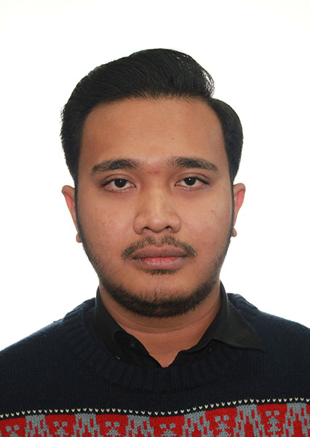
CURRICULUM VITAE

Taufan Pratama Zasya B.A.
Address : Jl. Puskesmas no 35 Jakarta Timur 13330
Mobile : (+61) 415466657
(+62) 81288025565
E-mail : taufanpratamazasya@gmail.com
D.O.B : 25 September 1982

HIGHLIGHT OF QUALIFICATIONS

- Passionate creative to organize an event
- Possess excellent interpersonal, organizational, technological and communication skills
- Love to dealing with people
- Adaptable with new environment
- Responsible with work
- Very calm in handling urgent situation
- Have a good sense of music
- Really passionate with an art

EDUCATIONAL BACKGROUND

2015 – present : Deakin University Masters Degree class of 2015 – Faculty of Arts and Education majoring Media and Communication
2013 – 2015 :Deakin University Bachelor Degree class of 2013 Faculty of Arts and Education majoring Media and Communication.
2010 – 2013 : Universitas Indonesia class of 2010 Faculty of Social and Political Science majoring Public Relation
2009 – 2010 : Ristek Nusantara – Jakarta Pusat
2008 – 2009 : Daruul Qur’an International Boarding School - Tangerang
2007 – 2008 : Al-Azhar Pusat 3 Senior High School – Jakarta
2004 – 2007 :150 Junior High School – Jakarta
1998 – 2004 : 03 Cawang Elementary School – Jakarta

WORKING EXPERIENCE

- 2014: Kopi Toebruk (Indonesia Online Media in Melbourne)

Position : Freelance Production Team

Responsibilities: - Creative Team

- Operational

- Journalist
- 2013 : Lazy Moe’s Restaurant – Oakleigh, Melbourne VIC Australia

Position: Kitchen Hand Job (Part-time)

Responsibilities: - kitchen assistant

- Chef Assistant
- 2014 : Souvaki Express – Chapel Street ,Windsor VIC Australia

Position : Delivery Driver

Responsibilities: - Taking Order

- Delivery

ORGANIZATIONAL ACTIVITIES

- 2014 – 2015 : Indonesian Student Council – Deakin University

Position : Supervisor

Responsibilities: - Supervise internal division
- Managing Human Resources
- Supervising (the relationship) between Universities
- 2013 – 2014 : Deakin University Indonesian Student Council

Position : Head of Media Officer

Responsibilities: - Handling Public Relation
- Building relationsip between university
- Supervising the Communication content for internal and external communication
- Supervising Media Content as well as the media layout
- 2011 – 2012 : BEM FISIP University of Indonesia

Position : Public Relation Staff

Responsibilities: - Handling internal Public Relation in Faculty
- Handling Media and Information in Faculty
- Building relationship between organization intra faculty
- Building relationship between faculty to faculty

- 2011 : Indonesia International Communication Conference

Position : Organizing Committee

Responsibilities: - Liaison Officer of Prof. Bob Craig
- 2012 - 2013 : Komunitas Musik FISIP UI (Music Community Universitas Indonesia)

Position : Head

Responsibilities: - Responsible in internal division
- Responsible in external division
- Responsible in building music culture in Faculty
- Responsible in student scouting talent
- Building Relation with all music community between faculty
- 2012: Menpora (Kementrian Pemuda dan Olah Raga) Youth and Sport Festival

Position : Event Organizer

Responsibilities: - Handling stage
- Handling performer
- Project manager of Partner in Project (Event Organizer)
- Member of Komunitas Musik FISIP UI (Music Community University Indonesia) 2010
- Co - Founder of Beatlemania Indonesia (B.M.I)
- Member of SPEAK (suara pemuda anti korupsi)
- Co-Founder Jejak Mollusca (Hiking and Mountaineering Community in FISIP UI)

SOCIAL ACTIVITIES

- September 2014 : Springnation 2014

Position : Supervisor Media and Logistics

Responsibilities: - supervise in operational division
- supervise media division
- responsible in logistic for the event
- responsible in making media content for internal and external communication
- supervise logistic team for dealing with the vendor
- August 2014 : Pandawa 2014

Position : Co – Project Manager

Responsibilities: - Responsible in Internal Division
- manage the whole team
- supervise event division for the whole event
- supervise media division for content of the event
- networking with the sponsorship
- building relationship between university
- building relationship with team in Indonesia
- supervise operational team in dealing with the vendor
- September 2013 : Jingga Blues Festival 2013

Position : Supervisor

Responsibilities: - Supervise project officer
- supervise financial team
- networking with the sponsor
- supervise operational team
- supervise when dealing with vendor

- 2012 : Universitas Indonesia Art War 2012

Position : PPD Coordinator

Responsibilities: - Responsible in Public Relation team
- Responsible in media relation team
- Building relationship between faculty
- Building relationship with media
- Responsible in publication of the event
- Responsible with concept and content of internal communication
- Responsible with concept and content of external communication
- Responsible in propaganda team
- Moderator at film discussion of US vs John Lennon 2012
- Crew of ICEMA 2012 (indonesia cutting edge music award)
- Field coordinator of gelas fisip 2011
- Project officer of wisuda lokal fisip 2011 “Universe”

Position : Head (Project manager)

Responsibilities : - Responsible the whole team
- responsible with concept of the event
- supervise each division
- building relationship with alumni
- Logistic crew of konser radha sarisha II mataya mirsa buana
- Active speaker at FGD with PT. Jasa Marga
- Delegation from FISIP UI
- Active Speaker from FISIP UI

IMPORTANT CONFERENCES ATTENDED

Indonesia international communication conference 2011

LANGUAGE

- Bahasa Indonesia - Mother Language
- English – active both verbal and written

PERSONAL INTEREST

- Playing Music
- Vespa
- Travelling
- Cooking
- Art and culture
- Outdoor activity

Taufan Pratama Zasya

