Veronika Okthaviani
Komp. Danamon A 11 no. 3
Jatiasih, Bekasi 17426
Mobile: +62 812.94699469
E-mail: veronika.oktha@gmail.com
Attention To:
Human Resources Department

Dear Sir/Madam,
On this good opportunity, I would like to apply my CV to your company. My name is Veronika Okthaviani, 25 years old, female, single, energetic and healthy. I was graduated from Persada Indonesia YAI University on November 2011 for my bachelor degree and now I’m working at PT. Regawa Mobindo Kreasi Nusa (www.regawa.com) as Content Writer.
My personality as a hard worker and fast learner type of person would bring benefit to your company. I will be very appreciated if you could give in opportunity to work in your company. With this background, I certainly believe that I am competent to meet challenging tasks and can make a good contribution to your company.
Enclosed is my resume, which indicates in some detail my experience. I sincerely hope that my qualifications are of interest to you and that an interview might be arranged at your convenience.
Thank you for your consideration. I’m looking forward for your response.

Sincerely yours,

Veronika Okthaviani

CURRICULUM VITAE
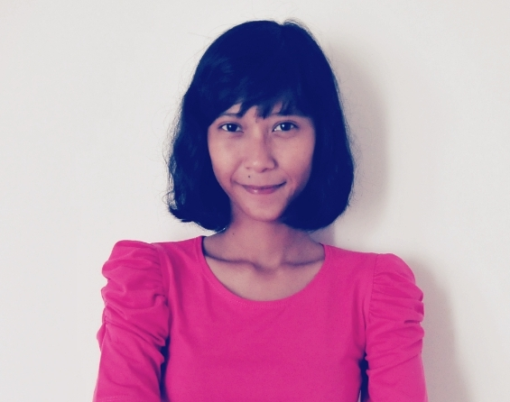

PERSONAL DETAIL

Full Name : Veronika Okthaviani
Place, Date of Birth : Jakarta, October 22th 1989

Marriage Status : Single

Address : Komp. Danamon A11 no. 3
Jatiasih, Bekasi 17426

Phone : +62 812.94699469

Email : veronika.oktha@gmail.com

Nationality : Indonesia

EDUCATION

2007 – 2011 University of Persada Indonesia Y.A.I, Bachelor Degree.
Faculty of Communication, Majoring in Broadcasting.

2004 – 2007 Hutama Senior High School, Pondok Gede – Bekasi.
Majoring in Natural Sciences.

ORGANIZATION EXPERIENCE

2004 – 2006 Chairperson of English Day Program in HUTAMA Senior
High School, Bekasi.
Job Descriptions : Mentoring first and second year students
Position : Mentor

WORKING EXPERIENCE

- 2010 Internship at Radio Republik Indonesia focus on Programa 2
Department.

- 2012 Import Checking Document (Trade Finance Services) at
Bank Danamon Indonesia, Jakarta
- 2013 – Now Content Writer at PT. Regawa Mobindo Kreasi Nusa –
Regawa.com, Jakarta

PERSONAL QUALIFICATION

- Able to write content like articles for website and status update for client’s fanpages

- Able to work in team or individual

- Able to work under pressure

- Easy going, good attitude and hard worker

- Able to communicate in English

PORTFOLIO

- SEO article: http://blog.alfaonline.com

- Fanpage content:
- https://www.facebook.com/BundaCermat
- https://www.facebook.com/GirlsRoomSoftex
- https://www.facebook.com/confidenceadultcare
- https://www.facebook.com/UZoneIndonesia

- Website content: http://sweetycare.com/smart_parenting.php

SOCIAL MEDIA ACCOUNT

- Facebook : Veronika Okthaviani

- Twitter : @NOUNAIKKA

- Instagram : @nounaikka

- LinkedIn : http://id.linkedin.com/in/veronikaoktha

