**Curriculum Vitae**

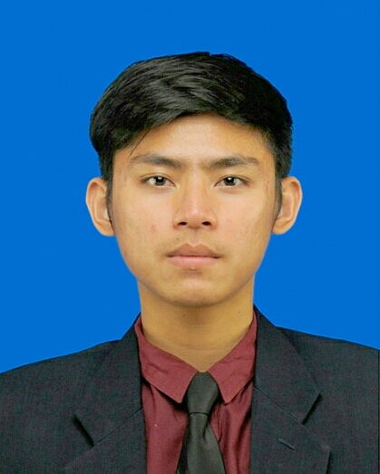

**CONTACT DETAILS**

**Current Address**

Jl Panca Tengah Raya no.5 Cisaranten Kulon, Bandung, 40293 Indonesia

**Mobile Phone**

+6285795310200

**Email**

dhenyrafliandhys@gmail.com

**HOBBIES & INTERESTS**

Football, Traveling, Photography, Environment issues, political issues, common issues

**LANGUANGE & STRENGTH**

**Language**

Native Indonesian, Good English.

**Strength**

Time Management

Positive attitude

Good Team Player

Honesty and Integrity

Quick Learner

Good Communication Skill

Hard Worker

**Personal Data**

Name : Dheny Rafliandhys

Place, Date of Birth : Jakarta, August 23, 1994

Age : 21

Gender : Male

Nationality : Indonesian

Marital Status : Single

Height : 175cm

Weight : 60kg

**Career Objectives**

Seeking a job to enhance and apply my skills along with working for increasing the profit of the company.

**Formal Education**

Public Relations, GPA: 3.37/4.00

Bandung Islamic University 2012 – 2016

SMAN 23 Bandung 2009 – 2012

SMPN 45 Bandung 2006 – 2009

SDN Mohammad Toha 2 Bandung 2003 – 2006

SDN Karang Mekar 2 Banjarmasin 2000 – 2003

**Non Formal Education**

DJ Arie Broadcasting School 2016

LBPP LIA English Course 2006 – 2015

**Computer and Other Skills**

Office ( MS Word, Excel, Power point ) 4/5

Communication ( To Present, To Persuade, To inform ) 4/5

Photography ( Landscape, wildlife, model ) 4/5

**Working Experience**

Worked as a public relations in government agencies 2016

Worked as a freelance photographer 2013 – 2015

Worked as a partner in government agencies 2012

**Organization Experience**

**2006 – 2007**

**2007 – 2008**

**2012 – 2013**

**2013 – Now**

**2015 – 2016**

ESCO Basketball Club Bandung

SSB Sidolig Bandung

Member of Manchester City Fans Club Branch of Bandung

Founder of Secioria Corporation (Indonesian Local Brand)

Staff B Commission DAM FIKOM UNISBA 2015

**I declare that all information above is true.**

Bandung, August 12th 2016

Dheny Rafliandhys