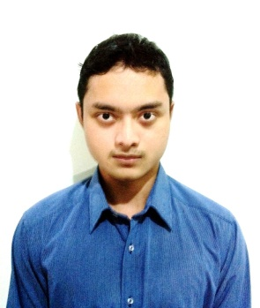

**Curicullum Vitae**

**Personal Informations**

Name : Michael Cornelius Adrian M

Place/Date of Birth : Depok, 04 March 1993

Nationality : Indonesia

Health : Very Healthy

Marital Status : Single

Height/Weight : 169/52

Religion : Catholic

Address : Jl Tanjung 2 No.10 DD3 Perum Sukatani Permai, Cimanggis,Depok 16454, West Java

Mobile : 081210160921/081905120962

Email : adrianna.michaels1@gmail.com

**Educations**  1999-2002 Pemuda Bangsa Elementary

2002-2005 Maria Elementary

2005-2008 Maria Junior High School

2008-2011 Mardi Yuana Senior High School

2011-2013 Politeknik Negeri Media Kreatif, Graphic Design

**Qualifications** Digital Designing (Adobe Photoshop, InDesign, Illustrator)

Microsoft Office(Excel, Word, Powerpoint, Access)

Digital Photography

English (both written and oral)

IT(Hardware and Software)

AutoCAD

Web Development(HTML, CSS, JavaScript)

Content Management System

Google SketchUp

**Experience**

Sept-Nov SukaOutdoor

2015 Web Administrator

*Job desc. : Handling consumer's order, complain and serve answer for faq, putting information into database, managing social media and internet based marketing .*