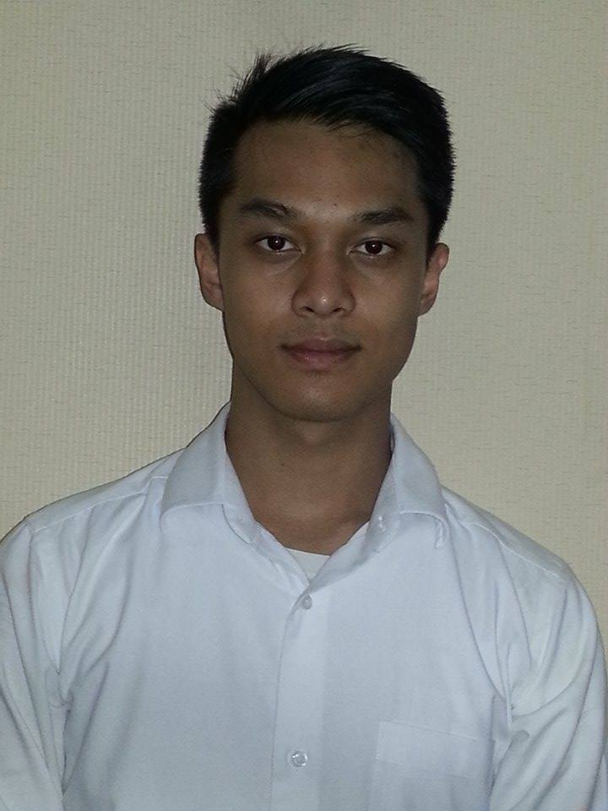Azlan Shah Putra Sofyan

Jl. Wijaya 6 no. 12, Kebayoran Baru

Jakarta Selatan, 12160, DKI Jakarta

[AzlanSofyan@hotmail.com](mailto:AzlanSofyan@hotmail.com)

+62 821 1168 3155

18 May, 2015

Human Resources Department

To Whom It May Concern,

Your recent advertisement for a speculative opening as a copywriter or media planner caught my interest immediately has caught my interest immediately. After reading the job requirements, I believe that I have all the needed criteria for the given role, and I am certain that I can make positive and constructive contributions to the company. I am also fully aware of the invaluable experience that I would earn working with one of the biggest name in the industry.

I have just completed my Bachelor in Business and Economics at Monash University, specializing in the marketing communication department. At the moment, I am scheduled to work part time in PT. Desa Jagorawi, where I will be employed as a marketing trainee. This is a massive opportunity for me to gain invaluable knowledge and experience.

I am a thoroughly committed person who enjoys assimilating new information and applying acquired skills to different circumstances. I have the ability to quickly assess, monitor and appreciate a client’s needs and then work as part of a team to allocate the agency’s resources to satisfy these needs. I have also learned to use Roy Morgan’s Research’s Asteroid and have used it to further understand the target market’s demographics and psychographics. During my course at Monash, my team and I successfully presented an advertising campaign that was based of a portfolio that Leo Burnett developed. Through that experience, I was impressed by the work environment and the appreciation that colleagues have for each other’s work in the agencies.

My CV summarizes my experiences and qualifications, and is attached for your review. I hope that my application is to your satisfaction and I look forward to hearing from you. I am available for an interview at your discretion and, please feel free to contact me should you have any questions.

Best regards,

Azlan Sofyan

**Azlan Sofyan**

Jl. Wijaya 6 no.12, Kebayoran Baru, Jakarta Selatan, 12160g

Tel: +62 821 1168 3155

***Email:*** azlansofyan@hotmail.com

**ACADEMIC HISTORY**

**Monash University**, Melbourne, Australia  *2011 – 2014*

* Bachelor of Business and Economics with a Marketing Communication BA and Quantitative Economics BA (Hons)
* Graduated with Credit
* Received Distinction in Advertising Media Strategy, Economics of Labour Market, and Economics of Money and Banking course unit

**Sekolah Tiara Bangsa – Anglo-Chinese School**, Indonesia

*2008 – 2011*

* International General Certificate of Secondary Education course by Cambridge University - Grade average: B
* Class Representative

**WORK EXPERIENCE**

**Desa Jagorawi,** PT. Desa Jagorawi, Indonesia

*Jul 2014 – May 2014*

* Employed in the Management (operational) & Marketing department

**Seven-Eleven**, **Brain Trust,** Monash University, Australia Aug *2013 – Oct 2013*

* Presented an advertising campaign to Leo Burnett via Monash University course – “Don’t Waste your Life” Campaign

**Honda**, Monash University, Australia Aug *2013 – Oct 2013*

* Presented an advertising campaign to Leo Burnett via Monash University course – “Great Summer Race” Campaign

**ACTIVITIES**

**Football Team Vice-Captain, Sekolah Tiara Bangsa,** School’s Sport Team, Indonesia *2008 – 2011*

* Chosen because of my ability to motivate players and the trust of the team

**Copywriter, Brain Trust,** Monash University, AustraliaAug *2013 – Oct 2013*

* The copywriter of the team
* Presented advertising campaigns (Seven-Eleven and Honda)

**OTHER SKILLS**

**Computer literacy:** Word processors (MS Word), Spreadsheets (MS Excel), Graphics (MS PowerPoint), Asteroid (RoyMorgan Research), Eviews

**Languages**: **English** (fluent**), Indonesian** (fluent)

**REFEREES**

Rizki Sofyan

Director of PT Desa Jagorawi

PT Desa Jagorawi

+62 812 8532 3096

[rizkisofyan@hotmail.com](mailto:rizkisofyan@hotmail.com)

Gary Tate

Department of Marketing, Faculty of Business and Economics

Monash University

[Gary.tate@monash.edu](mailto:Gary.tate@monash.edu)