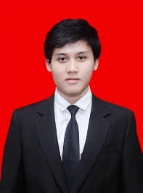

Mohammad Bayu

Jalan Bukit Cinere Komplek Bumi Pusaka Cinere Blok A-2 Cinere Depok

**Mobile:** [089614383533] **E-mail:** [bachsinbayu@gmail.com]

Personal Identity

|  |  |
| --- | --- |
| **Personal identity** | |
| Nama | Mohammad Bayu |
| Tempat / Tanggal lahir | Jakarta, 25 Agustus 1992 |
| Umur | 24 Tahun­ |
| Alamat | Jl. Bukit Cinere Komplek Bumi Pusaka Cinere Blok A-2 Cinere Depok |
| Jenis Kelamin | Pria |
| Status | Belum Menikah |
| Kewarganegaraan | Indonesia |
| Agama | Islam |
| Kondisi Kesehatan | Baik |

Personal Profile Statement / Career Objective

I am a high confident, motivated, Fast learner, articulate and tech-savvy ( Fresh Graduate) Economic General Management from Bunda Mulia University. i love doing something in digital marketing area. I have been knowing Online Marketing especially e-commerce since High School where as merchant and member in Kaskus From. Then because of my previous job as online admin, im taking digital marketing course and start to learn from youtube channel, moz.com and the others digital marketing forum. I consistenly strive to work to the best of my ability and deliver professional standard at all time or all circumstances. My key Strenghts are Communication, social media, Thirsty of knowledge and the ability to relate to customers in a digital marketing area.

Achievements

* Finished bachelor degree for 4 years with Grade 3.14
* Active in organization as project manager by managing some events

Education

**2008 – 2011 (Science)**High School Sumbangsih SHS

**Grade achieved: NEM 8.4**

**2011 – 2015** [Bachelor of Economic] Bunda Mulia University

**Grade achieved: 3.14**

**Employment and Work Experience**

**April 2016– October 2016 Sales Support and PT. Inetindo Infokom**

**Online Admin**

Main duties performed:

* Find and record new potential customers
* Call and follow up customers
* Coordinating with retail crew to drive the customer purchasing at marketplace
* Manage merchant account at market place
* Help marcom team to develop content for uploading in website slider
* Updating blog and manage social media such as facebook

**Professional Training and Qualifications**

* English (English First)
* Digital Marketing ( Dumet School)
* Seo ( Dumet School)

**Skills**

* **Can build website by using wordpress**
* **Know well how to optimize website traffic with SEO tehniques**
* **Know well how to use SEM (facebook ads, Youtube ads, Google ads),Webmastertool, socialbookmarking,**
* **Excellenet communicatioan and intrepersonal skill**
* **Social Media( Facebook, linked-in, twitter)**
* **Administration skills**

**Hobbies and Interests**

I enjoy socialisasing with new friend/friends and family, active and reading in online forum especially kaskus, moz.com, maxmanroe.com, panduenim.com and watching youtube. And I also I do sport likes soccer and futsal

**Portofolio**

Portofolio grosirkemejapria.com

**Facebook page : Grosirkemejapria.com**

**Instagram : bayubachsin**

Front page

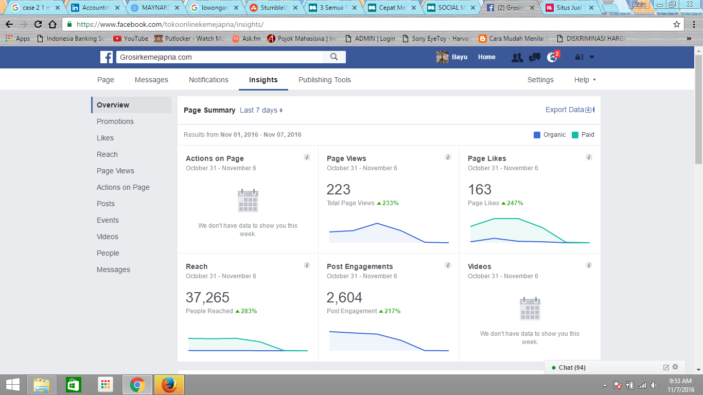

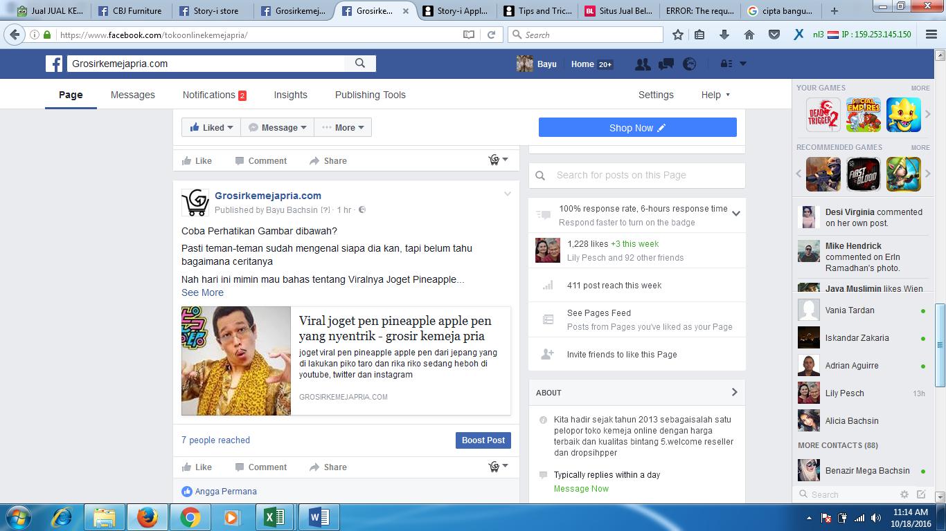

Facebook ads periode oktober

Creating Schedule Post

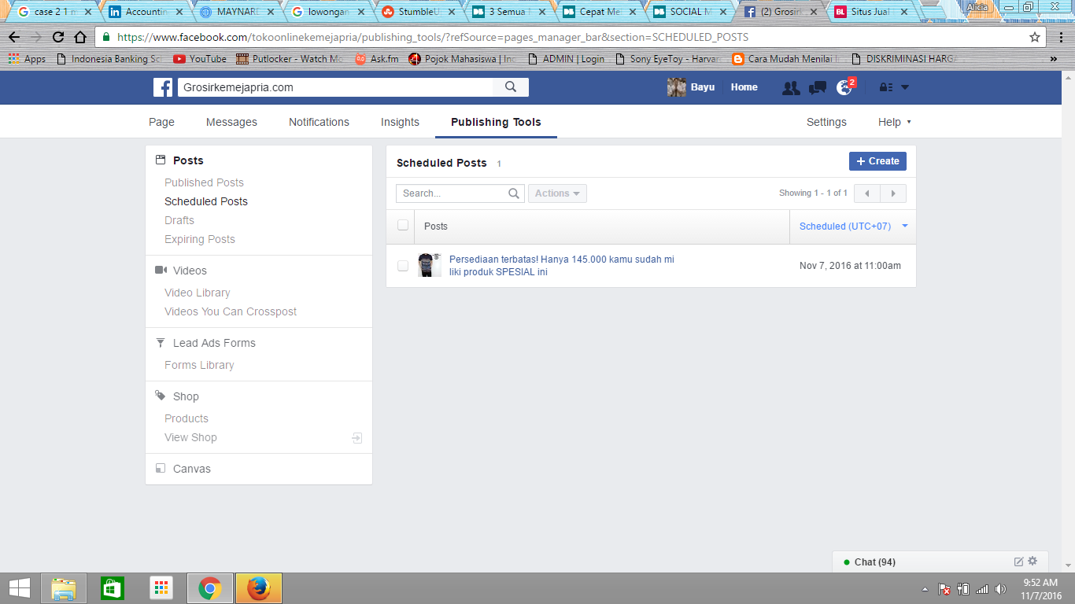

Insight part 1

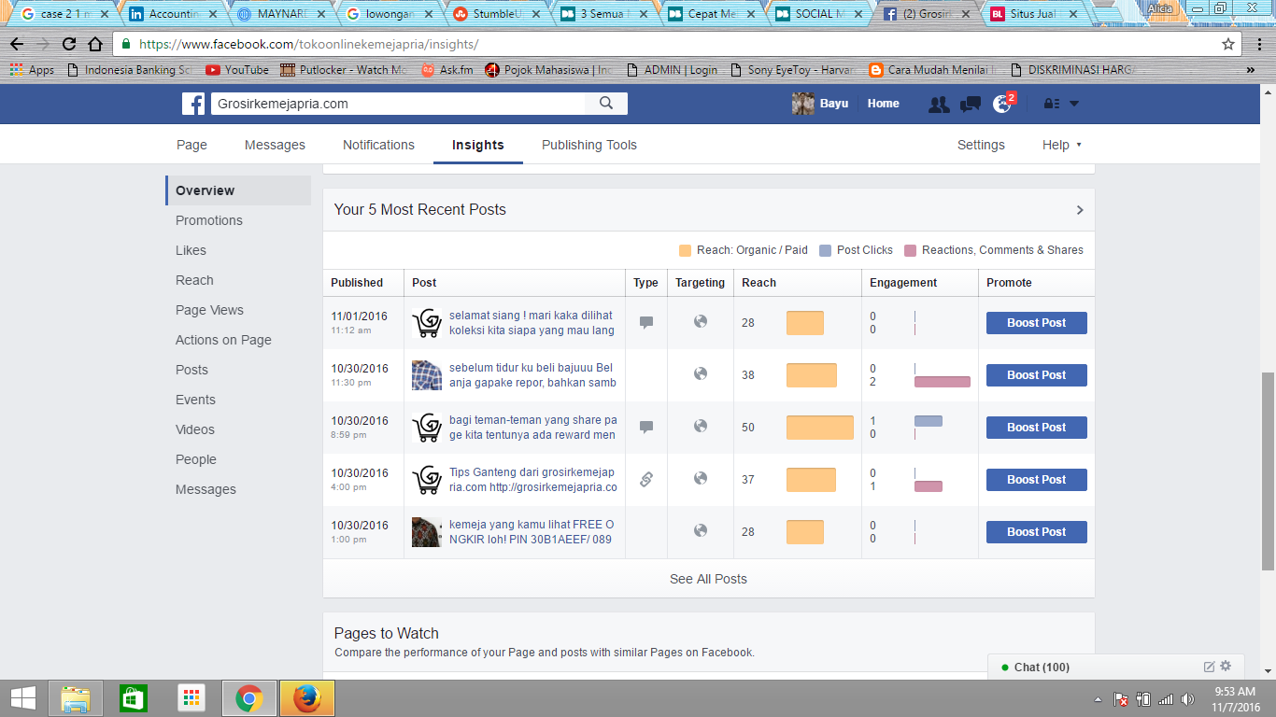

Likes Overview

