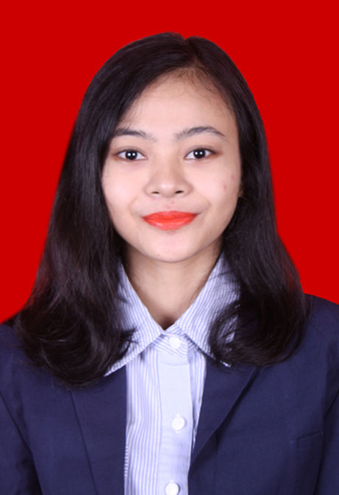

# Endang Setyawati

**Jl.Pangkalan Jati RT 002 RW 04 No.14**

**Mobile phone : 081314540380**

**E-mail :**[**endang.sukimin23@gmail.com**](mailto:endang.sukimin23@gmail.com)

#### CURRICULUM VITAE

|  |  |  |
| --- | --- | --- |
| **PERSONAL DETAILS** | | |
| **Full Name** | : | **EndangSetyawati** |
| **Place of Birth** | : | **DKI Jakarta** |
| **Date of Birth** | : | **August 23st, 1989** |
| **Gender** | : | **Female** |
| **Marital Status** | : | **Single** |
| **Nationality & Citizenship** | : | **Indonesian** |
| **Contact Address** | : | **Jl. Pangkalan Jati RT 002 RW 04 No.14 Cipinang Melayu Kec. Makasar 13620** |
| **Mobile Phone Number** | : | **081314540380** |
| **Email** | : | [**endang.sukimin23@gmail.com**](mailto:endang.sukimin23@gmail.com) |

|  |  |  |
| --- | --- | --- |
| **FORMAL EDUCATION** | | |
| **University/School** | **Discipline** | **Year** |
| S1 Politic Science Program of Airlangga University | Politic Science | 2008 – 2012 |
| High School,  SMAN 54 Jakarta | - | 2004 – 2007 |
| Junior High School,  SMPN 117 Jakarta | - | 2001 – 2004 |
| Elementary School,  SDN CipinangMelayu 07 Jakarta Timur | - | 1995– 2001 |
| Kindergarten, BachteraTrisnaKomp. BEA CUKAI PasarMinggu | - | 1994 – 1995 |

|  |  |  |  |
| --- | --- | --- | --- |
| LANGUAGE SKILL | | | |
| **Languages** | **Speak** | **Read** | **Write** |
| Indonesian | Excellent | Excellent | Excellent |
| English | Good | Good | Good |

|  |  |
| --- | --- |
| **COMPUTER SKILL** | |
| **Software** | MS Office |
| **Operating System** | Windows 98/2000/XP/Vista/Seven |

|  |
| --- |
| **ORGANIZATION EXPERIENCES** |
| * First Winner of Debating Contest on 2K8 Faculty of Social and Political Science, 15-16 November 2008 at Social and Political Science Faculty. * First Winner of Traditional Dancing Contest of PekanSeniMahasiswa Tingkat Regional on May 2010 at Brawijaya University, Malang. * Take a part of Mata Najwa Dialogue with AniesBaswedan “PeranPemimpinMudaDalamPendidikan” at AirlanggaConvension Hall, Airlangga University. * Take a part of “Studium General HakAsasiManusiadanKebijakanPerpolisianMasyarakat” on Thursday, 22 September 2011 at Social and Political Faculty, Airlangga University. * Take a part of Book Review “Obama danAmerika di Mata Nahdliyyin” on 10 June 2010 at AdiSukadana Room, Social and Political Science Faculty. * Take a part of Book Review “Hegemoni Rezim Intelijen, Sisi Gelap Peradilan Kasus Komando Jihad” with BusyroMuqoddas at AdiSukadana Room, Social and Political Science Faculty. * MC of event “MalamSatuSuro UKTK Unair” tahun 2011. |

|  |
| --- |
| **WORK EXPERIENCES** |
| * Junior Planner at Media Agency PT. CURSOR MEDIA Member of Denstu Aegis Network since 18st March 2014 until 27st June 2014. |

* Hobby : Reading, Traveling
* Spent time activity : Reading, learn for something new.
* Strong point : Hardworking, good leadership and communication skill, easy to adapt, creative, confidence, accountability.

I declare the details stated to be true and complete

Jakarta, October 22nd 2015

**Endang Setyawati**