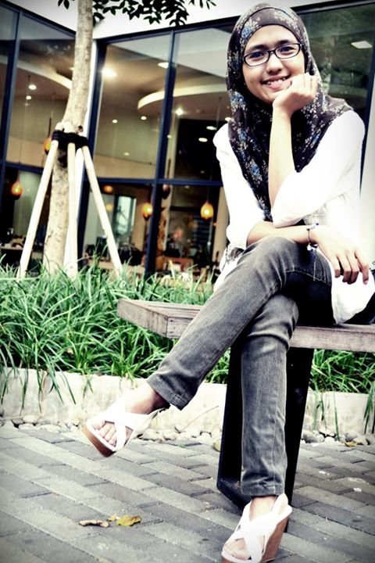**CURRICULUM VITAE**

PERSONAL INFORMATION

Full Name : Firly Pratiwi latif

Age : 21 Years

Date of Birth : 24ND Oktober 1992

Place of Birth : Bantaeng (South Sulawesi)

Gender : female

Marital Status : Single

Contact : +6289656327119 (cell phone number)

Email Adress : [firly.pratiwi@gmail.com](mailto:firly.pratiwi@gmail.com)

Live in : Bandung

ACADEMIC BACKGROUND

1998 – 2004 : SD Inpres Teladan Merpati

2004 – 2007 : SMP Negeri 2 Bantaeng

2007 – 2010 : SMA Negeri 1 Bantaeng

2010 – 2013 : Telkom university, fakultas Telkom applied sience school, prodi manajemen informatika, jurusan Multimedia Creative Content

Now : Universitas Online Bina Nusantara, System Informasi

ORGANIZATION EXPERIENCE

2008-2009 OSIS SMA Negri 1 Bantaeng (As a part of Humas)

2011-2012 UKM Polkomzone Telkom Applied Science School (As a Journalist Coordinator)

2011-2012 UKM Celebes Community of Telkom Politeknik (As a part of Traditional Dance)

2012-2013 UKM Polkomzone Telkom Applied Science Scholl (As a Humas Coordinator)

2012-2013 UKM Celebes Community of Telkom Politeknik (As a Treasurer)

COMMITTEE ORGANIZATION EXPERIENCE

2010 Book Fair (As a Event Coordinator )

2011 Musyawarah Besar UKM POLKOMZONE (As a Secretary)

2011 Pagelaran Celebes Community of Telkom Politeknik (As a Danus)

2012 CSO (Creative Skill Olympiad ) (As a treasurer of Photography)

2012 Ospek Jurusan HMMI (Himpunan Mahasiswa Manajemen Informatika) (As a Pubdosis)

SKILL

Grafis Design : Adobe Photoshop CS5, Movie Maker, Balsamiq Mockup, adobe Flash CS5

Sistem Operasi : Windows XP, Windows 7, Windows 8

Programming language : Adobe flash (Action Script), Java.

Office : MS Office 2013, MS Office 2007, MS Office 2010

Other : Flash, design, Audio Editor, photography, video editor, Writer.

WORK EXPERIENCE

2014 Syndicate73 (As a Project Executive, 8 month)

TRAINING and SEMINARS

2010 ESQ Leadership Training

2011 Seminar Motivasi

2012 Seminar TIK