Haetam Attamimy

haetamattamimy@gmail.com

+6281285314881

///////////////////////////////

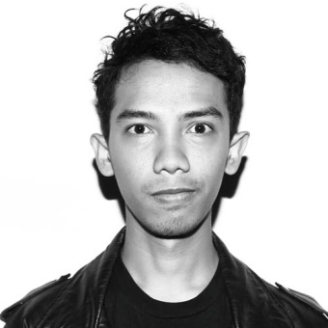Writer/Editor

Primary Skills

Copywriting Translating

Featured Articles Editing

Proofreading Interviews

As a writer, my most essential hobby is reading. Exploring literature is what I do for fun. From Ernest Hemingway to Chuck Palahniuk, there’s always a challenge to it especially since I am not a native English reader/speaker. I like to consider reading as an important investment.

Listening to music and watching films may be a common hobby, but I believe that I’m not just enjoying them but digging deeper into the essence and moral stories.

Experience

**Founder/Editor | Worthless Society – Jakarta**

**February 2015 – Present**

*Responsibilities:*

Personal project. Managing the whole workflow to make the form a struggle in the importance of delivering stories that needed to be heard and read by young and great people. For most people, we are worthless. For some, we are what they want to listen to.

**Customer Support Engineer** | **Influx Inc. – Jakarta   
March 2015 - Present**

*Responsibilities:*

Maintaining communications between the company and clients on a daily basis to reach the appropriate amount of customer support satisfaction between both parties.

**Editor** | **Talkmen.com – Jakarta**

**January 2013 - February 2015**  
  
*Responsibilities:*

Working alongside editor in chief and managing editor to drive the excellence and the quality of writing creativity and contents for Talkmen.com as the leader of one of the men's online media pioneers in Indonesia.

**Graphic Designer** | **Davy Event Organizer – Denpasar**

**October 2009 - December 2009**  
  
*Responsibilities:*

As an intern for graphic design department, Davy Event Organizer was my first breakthrough to the real world. Besides the responsible to deliver my best for the company, Davy EO was the first place where I learned about teamwork and the importance of it in every aspects of workflow.

Education

Graphic Design

Wearnes Education Center – Malang

2010-2011

Languages

English – fluent