**CURRICULUM VITAE**

**HERDIAN WIHARTO, S. HUM.**

Grogol, Jl. Rawa Bahagia Raya I/33

Jakarta Barat

|  |
| --- |
|  |

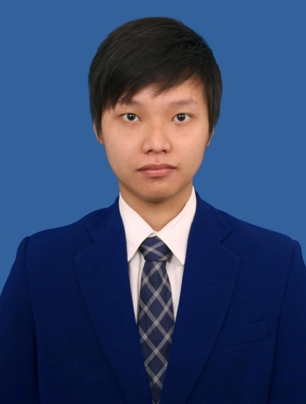**I. Personal Information**

1. Place and Date of Birth : Jakarta, 4 Mei 1992
2. Nationality : Indonesia
3. Sex : Male
4. Marital Status : Single
5. Religion : Christian
6. Telephone/Cell Phone : 081223839113
7. Email : [herdianwiharto@gmail.com](mailto:herdianwiharto@gmail.com)

**II. Education**

|  |  |  |  |  |
| --- | --- | --- | --- | --- |
| LEVEL | PERIOD | SHOOL NAME | CITY | MAJOR |
| Bachelor’s Degree | 2010-2015 | Universitas Padjadjaran | Sumedang | Department of English |
| Senior High School | 2007-2010 | SMA Negeri 2 Jakarta | Jakarta | Social |
| Junior High School | 2004-2007 | Sekolah Kristen Triana | Jakarta |  |
| Elementary School | 1998-2004 | Sekolah Kristen Triana | Jakarta |  |

**III. Work Experience**

1. Working a part time job at PT Telephone Cell Nusantara Perkasa which located in BEC (Bandung Electronic Center) as Frontliner for one month.
2. Kerja Kuliah Nyata (KKN) in Desa Babakan Kareo, Kec. Rajagaluh. Majalengka, Jawa Barat.

**IV. Skills**

* + - 1. Text analysis in any form.
      2. Verbal and nonverbal communication (including debate).
      3. Translation.
      4. Googling skills.
      5. Mastering Microsoft Office: Ms. Word, Ms. Excel and Ms. Power Point.

Jakarta, April 9, 2015

Hormat saya,