Dear Sir/Madam,

My name is Lucky Herlambang Tanumiharja. I want to apply for a job in your company. I’m graduated from Perbanas Institute Faculty of Management Banking Finance and Marketing Management. I’m cooperative to work both as individual or with team, interest to know people in personality.

I feel sure that I can give you complete satisfaction and loyal service to this company. Along with this letter, I give you my curriculum vitae as my further information.

I highly appreciate if you could consider invite me for the interview at anytime at your convenience. Thank you for your kindly attention.

Sincerely,

( Lucky Herlambang T. )

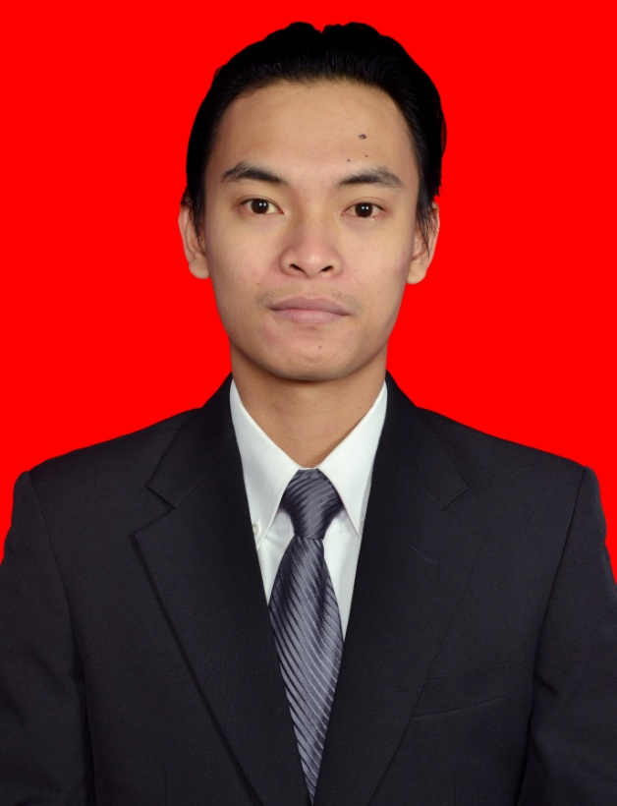

**Lucky Herlambang Tanumiharja, S.E.**

Jl. Camar No.2, Komplek Bumi Makmur RT 004/RW 003

Jati Makmur, Pondok Gede Bekasi 17413

Mobile : 08551008789

Phone : (021) 846-1141

Email : [herlambang_lucky@yahoo.com](mailto:herlambang_lucky@yahoo.com)

**Personal Information**

Full Name : Lucky Herlambang Tanumiharja

Sex : Male

Date of Birth : Feb 7th 1989

Marital Status : Single

Religion : Christian Protestant

Nationality : Indonesian

**Educational Attainment**

1994 – 2001 : SD Pamardi Yuwana Bhakti

2001 – 2004 : SLTP Pamardi Yuwana Bhakti

2004 – 2007 : SMAN 5 Bekasi

2007 – 2012 : Faculty of Management Banking Finance and Marketing, ABFI Perbanas Institute

**Thesis**

Pengaruh *Brand Equity* dan peran Ade Rai sebagai *Brand Ambassador*  terhadap Minat Beli Konsumen Pada Produk Kartu Perdana Esia.

**Jobs Experiences**

|  |  |
| --- | --- |
| Desember 2012 – April 2014 | PT. Asuransi Sinarmas as Marketing Officer |
| Oktober 2014 – Desember 2014 | PT. Bank Multiarta Sentosa |

**Commitee Experiences**

|  |  |
| --- | --- |
| 2010 | Produced Photography Seminar at GBI Glow Fellowship Centre as Vice Chairman |
| 2012 | Produced Kebayoran Baru Competition at GKI Kebayoran Baru |
| 2012 | Become an usher at Don Moen live in concert |
| 2014 | Freelance photography for “Rusuh Resah” exhibition |

**Courses & Seminar Attended**

|  |  |
| --- | --- |
| 2007 | Seminar with topic “Human Readiness in Facing the Dynamics of TI” at ABFII PErbanas – Jakarta |
| 2010 | Viral Marketing Seminar at ABFII Perbanas - Jakarta |

**Interest**

Organizing, Reading, Travelling, Sport, Music, Watching Movie, Photography, Outdoor Activities

**Skills**

* Speak passable in English
* Good interpersonal communication and presentation skill
* Able to work well as part of a team, as well as work independently
* Able to work under deadline pressure and well-adapted

▪ Attractive, Energetic, Optimistic, Reliable, Discipline, Strong Motivated

▪ Good Leadership and Problem Solving

▪ Computer literate: Microsoft Office (Word, Excel and Microsoft Power Point)

**Activities**

* Youth Church Organization – active member, activities and events organizer, MC (Master of Ceremony)
* Photography