**PERSONAL INFORMATION**

|  |  |  |
| --- | --- | --- |
| **No** | **Keterangan** | |
|  | Name | Kahya Ashad Aulia |
|  | Adress | Jl. Gelatik Dalam 420/151A, Bandung |
|  | Cellphone Number | +628997582263 |
|  | E-mail | [kahyaaulia@gmail.com](mailto:kahyaaulia@gmail.com) |
|  | Born Place / Date | Garut / 11 Juli 1992 |
|  | Gender | Laki - laki |
|  | Status | Single |
|  | Religion | Islam |
|  | Kewarganegaraan | Indonesia |
|  | GPA | 3.39 ( Ilmu Hukum) |
|  | No. ID (KTP) | 3205011107920003 |
| **Short Description About Me** | | |
| **Great about writting**, I was experienced as a reporter and videographer at one of big media fans base of Persib Bandung **( Simamaung.com)**. Sometimes I also made an opinion or critic at mass media like Pikiran-Rakyat, Hukumonline.com, DetikTravel.com. I have been internship at **Kejaksaan Tinggi Jawa Barat** as co.ass Prosecutor 2 months, in there I made “surat dakwaan, surat tuntutan, duplik” at the real case. It was based on the concentration I choose the criminal law at collage. was experienced as a researcher at **Central for detention studies** about fulfillment of the rights of prisoners in Lapas Bandung (sukamiskin,wanita dan anak) | | |

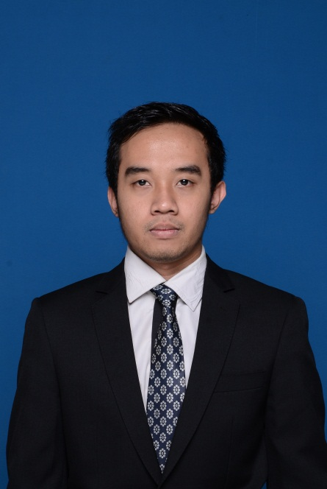

**ACADEMIC BACKGROUND**

|  |  |  |  |  |
| --- | --- | --- | --- | --- |
| **No** | **Institution** | **Specialization / Department** | **Period (Year)** | |
| **Since** | **Until** |
| **FORMAL** | | | | |
|  | TK Musadaddiyah Garut | - | 1997 | 1998 |
|  | SDN Regol XIII Garut | - | 1998 | 2004 |
|  | SMPN 2 GARUT | - | 2004 | 2007 |
|  | SMAN 1 Garut | Ilmu Pengetahuan Sosial | 2007 | 2010 |
|  | Universitas Padjadjaran Bandung | Ilmu Hukum | 2010 | 2014 |
| **NON FORMAL** | | | | |
|  | Pencak Silat SDN Regol XIII | Bela Diri | 2002 | 2003 |
|  | Ganesha Operations | BimbinganBelajar | 2009 | 2010 |
|  | Seminar *Public Speaking*  (FH Unpad) | Seminar | 2012 | 2012 |
|  | Reformasi Penegakan Hukum (FH Unpad-USAID-The Asia Foundation) | Seminar | 2014 | 2014 |

**ORGANIZATION AND INTERNSHIP EXPERIENCE**

|  |  |  |  |
| --- | --- | --- | --- |
| **No** | **Organization** | **Position** | **Periode Tahun** |
|  | Pecinta Alam STRATEJI | **Ketua UMUM** | 2008-2010 |
|  | Paguyuban Mahasiswa Garut Intan (Pamasagi) | Staff Acara | 2011-2012 |
|  | Paguyuban Mahasiswa Garut Intan (Pamasagi) | **Wakil Ketua Umum** | 2012-2013 |
|  | PT.Panenmaya Simamaung (simamaung.com) | Reporter | 2012 |
|  | Kejaksaan Tinggi Jawa Barat | **Asisten Jaksa Pidana Umum** | 2013 |
|  | Cleo Guest House | Resepsionis | 2014 |
|  | PT.Panenmaya Simamaung (simamaung.com) | Videografer | 2014 |

**COMMITTEE AND VOLUNTEERING EXPERIENCE**

|  |  |  |  |  |
| --- | --- | --- | --- | --- |
| **No** | **Event** | **Institution** | **Position** | **Year** |
|  | MAPAK FH UNPAD (Masa Orientasi) | FH UNPAD | Divisi Medik | 2012 |
|  | *University Festival 2012* (4 Rangkaian acara, Highschool Roadshow, SNMPTN *Simulations*, *Super Sunday*, “Penanaman” Tong Sampah di Garut Kota | Pamasagi | Koordinator Divisi Acara | 2012 |
|  | Sosialisasi Antikorupsi di SMAN 1 Garut | Klinik Anti-Korupsi FH Unpad | Pemateri | 2013 |
|  | *Public Service Days* | FH Unpad-E2J | Koordinator Divisi Transportasi | 2014 |
|  | CDS (Center for Detentions Studies) | Kementrian Hukum dan HAM | Enumeurator | 2014 |

**ACHIEVMENT**

|  |  |  |  |  |
| --- | --- | --- | --- | --- |
| **No** | **Event** | **Institution** | **Position** | **Year** |
|  | Olimpiade Ekonomi SMA Kabupaten Garut | Kemendikbud | Juara 1 | 2010 |
|  | *Moot Court Intern* | FH Unpad | Juara 1 | 2011 |
|  | Piala Deans Jurnalistik FH Unpad | FH Unpad | Juara 2 | 2012 |
|  | Legal Opinion Competition of Law | FH Unpad | Juara 2 | 2013 |
|  | Lomba Artikel | Hukumonline | Juara 1 | 2014 |