***CURRICULUM VITAE***

**PERSONAL DETAIL**

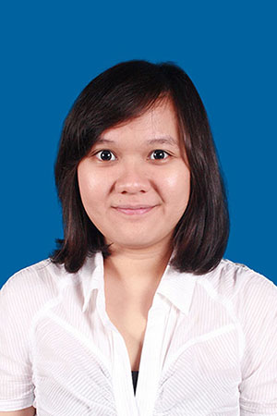

Name : Khairunnisa Lubis

Place/Date of Birth : Medan / August 23rd, 1990

Address : Jl. Karya Baru, no.16A Tj. Rejo

Medan, Indonesia

Gender : Female

Nationality : Indonesian

Religion : Islam

Phone : (62)821 6285 2977

E-mail : [khairunnisa.lubis@yahoo.com](mailto:adrianzalta@live.com)

Online Portfolio : http:/www.coroflot.com/nisalubis

**PROFILE**

I consider myself as a dedicated and motivated individual who enjoys challenges and taking responsibility. I am an experienced creative designer, graduated from Multimedia University, Malaysia, and achieved degree of Bachelor of Multimedia (Honours) (Film and Animation).

**FORMAL EDUCATION**

**2007 – 2012** **Multimedia University, Malaysia**

Bachelor of Multimedia (Honours) (Film and Animation)

**WORK EXPERIENCE & HISTORY**

* **May – Present : Creative Designer at Galeri Songket Deli, Medan**

*Description:*

* Create brand logo and identity
* Design promotional material such as banner, brochure, catalogue, etc
* Design pattern for songket
* **January – October 2014 : Owner / Chef of Pop Cho’p, Bandung**

*Description:*

* Store Management, managed day-to-day store operational
* Team Leader, supervised 8 employees
* Products / Menu Development, created unique and distinguished menus (beverages, desserts, etc)
* **January – July 2013 : Render Artist at Infinite Frameworks Studios, Batam**

*Description :*

* Render and composite animation
* Check and QC on animation before finalizing render
* Touch up for final look of animation
* **July – December 2012 : Creative Design Staff at XL, Medan**

*Description :*

* Design promotional material such as banner, flyers, poster, etc
* **2012 – Present : Freelance Designer**

*Description :*

* Create brand logo and identity by order
* Design promotional material such as banner, flyers, name card, etc
* Design product and packaging

**SKILLS & QUALIFICATIONS**

* 3 years of experience as creative designer
* Advanced in 2D and 3D software such as Adobe Illustrator, Adobe Photoshop, Autodesk Maya
* Familiar working with video editing software such as Adobe After Effects and Adobe Premiere
* Familiar working with software such as Microsoft Word, Excel, PowerPoint
* Good communication skill, with fluent English both written & oral

**PERSONAL INTEREST**

* Watch movies and interested in movie making
* Enjoy music and arts
* Enjoy meeting and socialize with new people