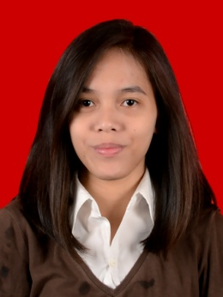

MELANIE SASKIA YUSUF

SOCIAL MEDIA CONTENT

My name is Melanie Saskia Yusuf. Now, I work as a social media content at Detik.com as one of portal media in Indonesia. I am able to work in any field related to my educational background.

Diploma Program of Bogor Agricultural Universty (2014)

SMA 2 Bogor (2011)

SMPN 5 Bogor (2008)

SD Papandanyan 1 (2005)

Personal Information

InFormal Education

TBI Teenager (2007-2009) Name : Melanie Saskia Yusuf

TBI – Conversation (2010-2011) Birthday : 24 Oct 1993

Eden – Conversation (2011) Phone : +6287870916319

Email : melmelsaskia@gmail.com

Address : Samiaji 1 No.7, Bogor, 16153

Working Experience

Internship as Marketing Communication (Juli-Agustus 2013)

Global TV, Jakarta

Social Media Content (November 2014-Present) \*

Detikcom, Jakarta

\* Provide content for Detikcom’s Social Media (Facebook, Twitter, Google+, BBM Channel, Instagram)

\* Analyze content for push notification in mobile application

\* Analyze content that has been advertised on Facebook ads

Achievement

* Got an interesting news in social media and became “FOCUS” on detikcom’s website

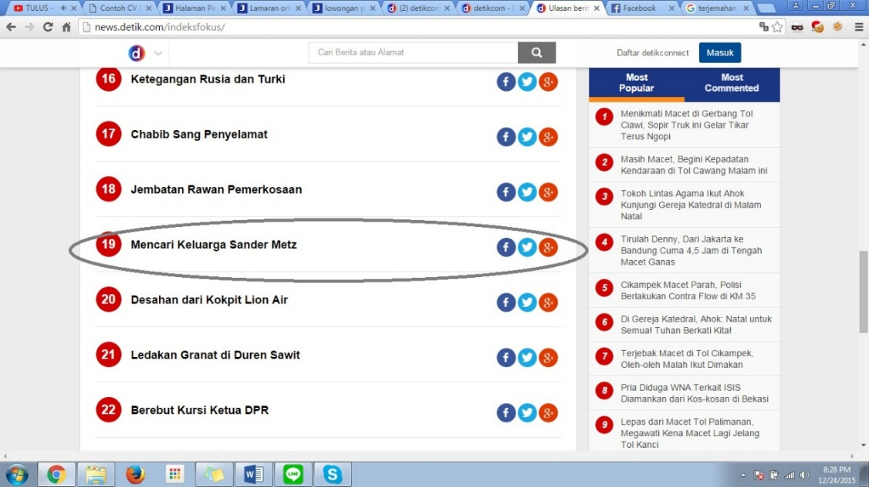

* One of conceptor for Detik’s new product: 20detik.com (October-Januari 2016)

