**Michelle Jeremya**

**michellejeremya@gmail.com**

**085891172611**

Dear,

I am writing this to you to show you my interest and motivation for participation on social media internship at your company. I am a second year student at Atma Jaya Univeristy, studying in English Department. I have some experience working in different field as I mention on my CV. I am actively using social media, such as: Facebook, Twitter, Path, Instagram and Blogspot.

I'll be very excited to be an intern in your company and I am sure I'll be useful in your team.

Thank you for considering my application.

Sincerely,

Michelle Jeremya

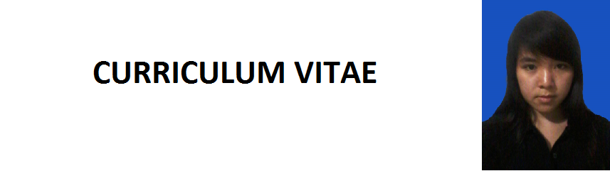**Data Pribadi**   
Nama                              : Michelle Jeremya   
Tempat, Tanggal Lahir : Jakarta ,17 Juni 1994  
Jenis Kelamin                 : Perempuan  
Agama                            : Kristen  
Kewarganegaraan        : Indonesia  
Alamat                            : Jl. Jelambar Utama 3 nomor G12,Jelambar,

Grogol Petamburan,Jakbar  
Telepon                    : 085891172611

Email : michellejeremya@gmail.com  
  
**Latarbelakang Pendidikan**  
Formal

1999-2000 : TK Tarsisius Vireta Tangerang

2000-2004 : SD Tarsisius Vireta Tangerang

2004-2006 : SD Bunda Hati Kudus Jakarta

2006-2009 : SMP Bunda Hati Kudus Jakarta

2009-2012 : SMA Negri 2 Jakarta  
2012-2013 : Fakultas Psikologi Universitas Atma Jaya Jakarta

2013- : FKIP Inggris Universitas Atma Jaya Jakarta  
  
Non Formal  
2003-2004 : Kursus Bahasa Inggris di JATC, Tangerang

2005-2007 : Kursus Bahasa Inggris di CNN, Jakarta

**Kualifikasi**

-Komputer

-Internet

-Bahasa Inggris pasif dan aktif

**Pengalaman Kerja**

1. Bimbel Scientia (2012)

2. Foursides tour and travel (2013)

3. PAD28 Jakarta, bistro and lounge (2014)

**Media Sosial**

1. Thealmightymjads.blogspot.com

2. Twitter.com/michellejeremya

3. Instagram.com/michellejeremya

4. Soundcloud.com/michellejrmyadriaansz

Demikian riwayat hidup ini saya buat dengan sebenarnya.  
  
  
Jakarta, 23 Januari 2015  
Michelle Jeremya