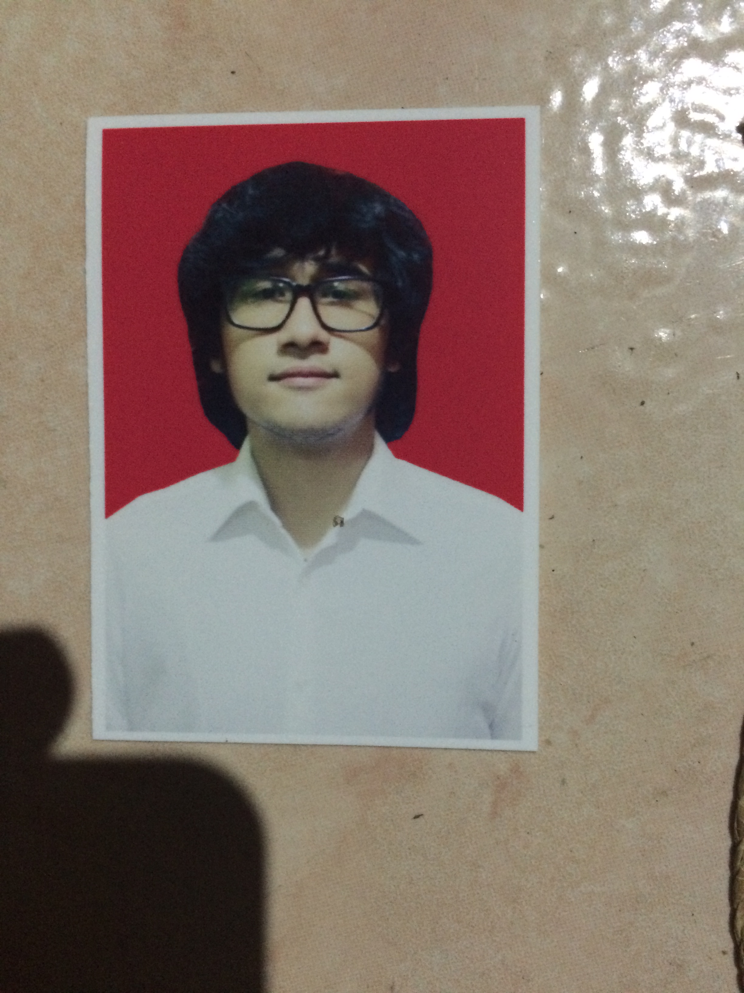Muhammad Rifqy Syauqi

Jl. Kelapa Tiga No.14A Jagakarsa, South Jakarta

+6281932721903

[rifqysyauqi@live.com](mailto:rifqysyauqi@live.com)

OBJECTIVE

To employ in creative position within international working environment under Marketing specialization. A business disciplines position that emphasize on professionalism, innovation and multi-cultural environment with a foundation by Marketing competencies, knowledge and experience needed to achieve organizational objectives.

Organizational Activities

Indonesian Youth Society – Sunway University 2014

* Documentation Committee
* General Event Committee
* Responsible in media documentation for sporting event and election of committee president

Sunway Music Society 2015

* Conduction event in Sunway University (Malaysia)
* Music Performance Act

**Past Experiences**

Employee at Global Dispo Medika - 2010

* IT department assistant
* Contribution in in Hospital / Healthcare based office as IT intern
* Office Address : Gedung Bersaudara Lantai 2, JL Penjernihan Raya, No. 38, Bendungan Hilir, Tanah Abang, 10210, Indonesia

Owner at Sniff’d Dry Jeans

* Establishment of dry Jeans based company
* Sniff’d : Company supplies of Dry jeans in Prior to Online Shopping
* Office Address : Jl. Kelapa Tiga No.14a Jagakarsa

Sunway College : Applied Business Challenge Program

* DRIVE 2 GO : Business proposal project
* The program successfully pitch upcoming investor from Infinite Ventures (http://www.ivmalaysia.com/)

**Education**

* Victoria University Malaysia 2015 / Bachelor of Business Marketing
* Binus School Simprug / 2009 - 2011

**Technical Skills**

* Microsoft Word
* Microsoft Excel
* Microsoft Powerpoint
* Adobe Photoshop
* Adobe Illustrator